Filed by Lockheed Martin Corporation

and Abacus Innovations Corporation

Pursuant to Rule 425 under the Securities Act of 1933,

as amended, and deemed filed pursuant to Rule 14a-12

under the Securities Exchange Act of 1934, as amended

Subject Company: Lockheed Martin Corporation

Commission File No.: 001- 11437

Abacus Innovations Corporation

Commission File No. 333-210797

The following is the text of a website that is being maintained at www.edocumentview.com/LockheedMartinExchange in connection with Lockheed Martin Corporation’s offer to exchange all shares of common stock of Abacus Innovations Corporation for common stock of Lockheed Martin Corporation.
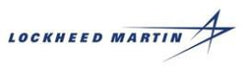

EXCHANGE OFFER

Last Updated: July 11, 2016 4:30 p.m.

Lockheed Martin Corporation Exchange Offer-Investor Information

On July 11, 2016, Lockheed Martin Corporation (“Lockheed Martin”) commenced an exchange offer related to the split-off of its Information Systems & Global Solutions Business. Lockheed Martin is offering to exchange all issued and outstanding shares of common stock of Abacus Innovations Corporation (“Splitco common stock”) for shares of Lockheed Martin common stock validly tendered and not properly withdrawn, as described in further detail in the Prospectus of Abacus Innovations Corporation (“Splitco”), dated July 11, 2016 (the “Prospectus”), which forms a part of Splitco’s registration statement on file with the Securities and Exchange Commission (“SEC”).

In the transactions explained in the Prospectus, immediately following the consummation of the exchange offer a special purpose merger subsidiary of Leidos Holdings, Inc. (“Leidos”) will be merged with and into Splitco, and Splitco, as the surviving company, will become a wholly-owned subsidiary of Leidos (the “Merger”). In the Merger, each issued and outstanding share of Splitco common stock will be converted into the right to receive one share of common stock of Leidos (“Leidos common stock”). Accordingly, shares of Splitco common stock will not be transferred to participants in the exchange offer; participants instead will receive shares of Leidos common stock in the Merger. No trading market currently exists or ever will exist for shares of Splitco common stock.

The value of Lockheed Martin common stock and Splitco common stock (by reference to Leidos common stock) will be determined by Lockheed Martin by reference to the simple arithmetic average of the daily volume-weighted average prices (“VWAP”), on each of the last three trading days ending on and including the third trading day preceding the expiration date of the exchange offer as described in the Prospectus (“Valuation Dates”), of Lockheed Martin common stock and Leidos common stock on The New York Stock Exchange (“NYSE”). In the case of Leidos common stock and correspondingly the Splitco common stock, the value will be reduced by $13.64 per share, which equals the amount of the special dividend that Leidos will declare prior to the closing of the Merger. Based on an expiration date of August 16, 2016, the Valuation Dates are expected to be August 9, 10 and 11, 2016.

Lockheed Martin will provide on this website the daily VWAP of Lockheed Martin common stock and Leidos common stock, together with indicative calculated per-share values for shares of Lockheed Martin common stock, Splitco common stock and Leidos common stock, the indicative exchange ratio, the upper limit for the exchange ratio and whether the upper limit is in effect, for each of the trading days that the exchange offer is open. Since the exchange ratio is based on the average daily VWAP over a period of three days, the indicative exchange ratio will be listed on this website commencing on the third business day of the exchange offer period.

The information on this website is being provided solely in connection with the exchange offer and should not be used for any other purpose. You should refer to the Prospectus for important information about the exchange offer and the contemplated transactions. A copy of the Prospectus, which includes a “Questions and Answers” section beginning at Page 6 and other related information, is available through the links below.

Date: |  | July 11, 2016 4:30 PM ET
Lockheed Martin Daily VWAP: | $ | 254.4899
Calculated Lockheed Martin per-share value (Lockheed Martin 3-
Day Avg. VWAP): |  | N/A
Leidos Daily VWAP: | $ | 47.7108
Calculated Leidos per-share value (Leidos 3-Day Avg. VWAP): |  | N/A
Calculated Leidos dividend-adjusted per-share value:* |  | N/A
Calculated Splitco per-share value:* |  | N/A
Indicative Exchange Ratio: |  | N/A
Exchange Ratio Upper Limit: |  | 8.2136
Exchange Ratio Upper Limit in Effect: |  | N/A
- The calculated Leidos dividend-adjusted per-share value and the Splitco per-share value for purposes of the exchange offer will equal the single arithmetic average of the Leidos Daily VWAP on the NYSE on each of the Valuation Dates, minus the Leidos per-share special dividend of $13.64.

Table of Historical Indicative Calculated Per-Share Values

The table below shows the calculated per-share values on a given day, calculated as though that day were the last Valuation Date of this exchange offer.

During the period of the actual Valuation Dates during the exchange offer period, when the values of Lockheed Martin common stock, Splitco common stock and Leidos common stock are calculated for purposes of the exchange offer, this website will show the indicative exchange ratio based on indicative per-share values calculated by Lockheed Martin, which will equal (i) on the first Valuation Date, the VWAP for that day, (ii) on the second Valuation Date, the arithmetic average of the actual daily VWAP on the first and second Valuation Dates and (iii) on the third Valuation Date, the arithmetic average of the actual daily VWAP on the first, second and third Valuation Dates. In the case of Splitco and Leidos common stock, the value will be reduced by $13.64 per share, which equals the amount of the special dividend that Leidos will declare prior to the closing of the Merger.

During the exchange offer period, the indicative exchange ratios and calculated per-share values will be updated by 4:30 p.m., New York City time, on each day through the second Valuation Date. The calculated per-share values and the final exchange ratio will be available by 9:00 a.m., New York City time, on the first trading day following the last Valuation Date.

 |  |  |  |  |  |  |  |  |  |  |  |  |  |  |  |  |  |  | Shares of |  | Shares of
 |  |  |  |  |  |  |  |  |  |  |  |  |  |  |  |  |  |  | Splitco |  | Leidos
 |  |  |  |  |  |  |  | Calculated |  |  |  |  |  |  | Calculated |  |  |  | common |  | common
 |  |  |  |  |  |  |  |  |  |  |  |  | Calculated |  | dividend |  | Calculated |  | stock to be |  | stock to be
 |  |  |  |  |  |  |  | per-share |  |  |  |  | Calculated |  | adjusted |  |  |  | received per |  | received per
 |  |  |  |  | Lockheed |  |  | value |  |  |  |  | per-share |  | per-share |  | per-share |  | share of |  | share of
 |  |  |  |  |  |  |  | of Lockheed |  | Leidos |  |  | value of |  | value of |  | value of |  | Lockheed |  | Lockheed |  | Exchange Ratio
Business |  |  |  |  | Martin |  |  | Martin |  |  |  |  | Leidos |  | Leidos |  | Splitco |  | Martin |  | Martin |  | Exchange Ratio
 |  |  |  |  | Daily |  |  | common |  | Daily |  |  | common |  | common |  | common |  | common |  | common |  | Upper Limit in
 | Day |  | Date |  | VWAP |  |  | stock (1) |  | VWAP |  |  | stock (2) |  | stock (3) |  | stock (4) |  | stock (5) |  | stock (6) |  | Effect
 | 1** |  | July 11, 2016 |  | $254.4899 |  |  | N/A |  | $47.7108 |  |  | N/A |  | N/A |  | N/A |  | N/A |  | N/A |  | N/A
 | 2** |  | [●], 2016 |  | $ |  | $ |  |  | $ |  | $ |  | $
 | 3 |  | [●], 2016 |  | $ |  | $ |  |  | $ |  | $ |  | $
 | 4 |  | [●], 2016 |  | $ |  | $ |  |  | $ |  | $ |  | $
 | 5 |  | [●], 2016 |  | $ |  | $ |  |  | $ |  | $ |  | $
 | 6 |  | [●], 2016 |  | $ |  | $ |  |  | $ |  | $ |  | $
 | 7 |  | [●], 2016 |  | $ |  | $ |  |  | $ |  | $ |  | $
 |  |  |  |  |  |  |  |  |  |  |  |  |  | 2

8 | [●], 2016 | $ | $ | $ | $ | $
9 | [●], 2016 | $ | $ | $ | $ | $
10 | [●], 2016 | $ | $ | $ | $ | $
11 | [●], 2016 | $ | $ | $ | $ | $
12 | [●], 2016 | $ | $ | $ | $ | $
13 | [●], 2016 | $ | $ | $ | $ | $
14 | [●], 2016 | $ | $ | $ | $ | $
15 | [●], 2016 | $ | $ | $ | $ | $
16 | [●], 2016 | $ | $ | $ | $ | $
17 | [●], 2016 | $ | $ | $ | $ | $
18 | [●], 2016 | $ | $ | $ | $ | $
19 | [●], 2016 | $ | $ | $ | $ | $
20 | [●], 2016 | $ | $ | $ | $ | $
21 | [●], 2016 | $ | $ | $ | $ | $
22 | [●], 2016 | $ | $ | $ | $ | $
23 | [●], 2016 | $ | $ | $ | $ | $
24 | [●], 2016 | $ | $ | $ | $ | $
25 | [●], 2016 | $ | $ | $ | $ | $
26 | [●], 2016 | $ | $ | $ | $ | $

- The calculated per-share value of Lockheed Martin common stock for purposes of the exchange offer will equal the simple arithmetic average of the daily VWAP of Lockheed Martin common stock on the NYSE on each of the Valuation Dates.

- The calculated per-share value of Leidos common stock shown in this column represents the simple arithmetic average of the daily VWAP of the Leidos common stock on the NYSE on each of the Valuation Dates.
- The calculated dividend adjusted per-share value of Leidos common stock for purposes of the exchange offer will equal the simple arithmetic average of the daily VWAP of the Leidos common stock on the NYSE on each of the Valuation Dates, minus $13.64.
- The calculated per-share value of Splitco common stock for the purposes of the exchange offer will equal the simple arithmetic average of the daily VWAP of Leidos common stock on the NYSE on each of the Valuation Dates, minus $13.64.
- Determined by dividing the calculated per-share value of Lockheed Martin common stock by 90% of the calculated per share value of Splitco common stock. Subject to the exchange ratio upper limit and proration. See the section in the Prospectus entitled “This Exchange Offer – Terms of this Exchange Offer – Proration: Tenders for Exchange by Holders of Fewer than 100 Shares of Lockheed Martin Common Stock.”
- Determined by multiplying the shares of Splitco common stock to be received per share of Lockheed Martin common stock by 1.0 (which is the number of Leidos shares to be received for each share of Splitco common stock in the Merger). Subject to receipt of cash in lieu of fractional shares of Leidos common stock. See the section in the Prospectus entitled “This Exchange Offer – Terms of this Exchange Offer – Fractional Shares.” Note that in the exchange offer shares of Lockheed Martin will be exchanged for shares of Splitco common stock and in the Merger each share of Splitco common stock will be converted into the right to receive one share of Leidos common stock.

- No indicative calculated per-share values or indicative exchange ratios are provided for the first two days of the exchange offer period as such values require daily VWAP data for three trading days.

Source: Bloomberg Finance L.P.

Bloomberg Screen Images of Lockheed Martin VWAP and Leidos VWAP

The screen images below depict the daily VWAP (as described in the section of the Prospectus entitled “Questions and Answers About This Exchange Offer and the Transactions”) on the NYSE, as published by Bloomberg Finance L.P. on Bloomberg pages “LMT UN<Equity>VWAP” and “LDOS UN<Equity>VWAP.”

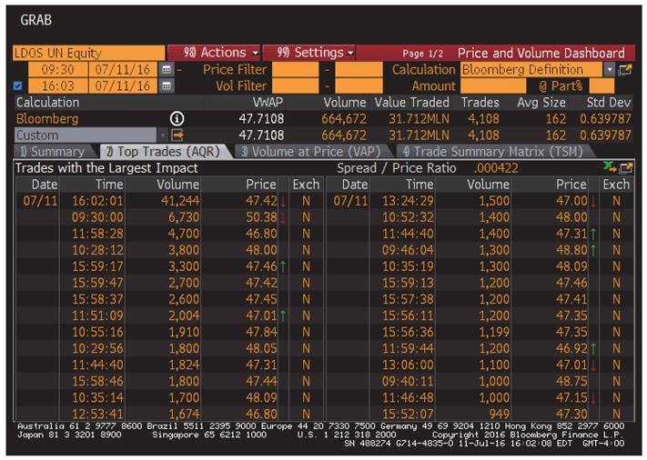

3

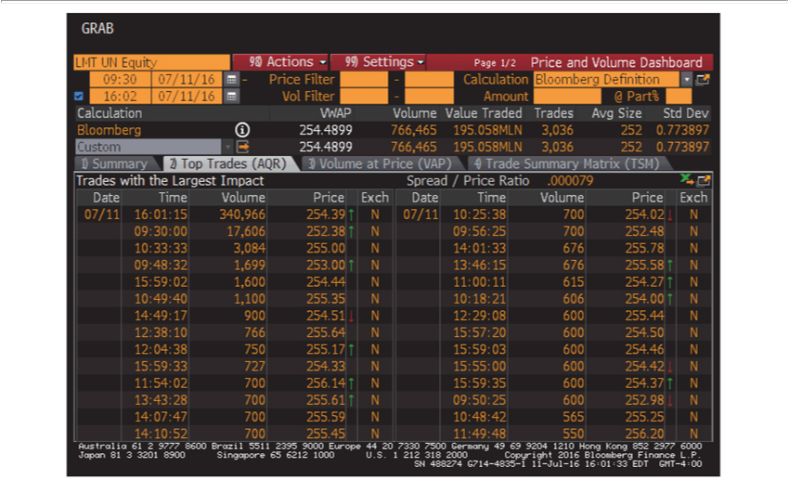

Used with permission of Bloomberg Finance L.P.

4

Other Related Information
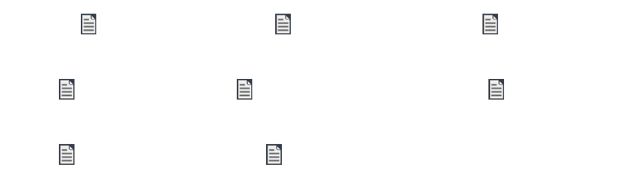

Prospectus |  | Letter of Transmittal | Notice of Guaranteed
 |  |  | Delivery
Notice of Withdrawal |  | Exchange and Transmittal Information | Notice to LM Plan
 |  | Booklet | Participants
Notice to Sandia Plan |  | Press Release – Exchange
Participants |  | Offer Launch

The information agent for the exchange offer is:
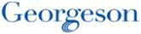

Georgeson LLC

1290 Avenue of the Americas, 9th Floor

New York, New York 10104

1-866-482-4931 (toll-free)

5

Forward-Looking Statements

The forward looking statements contained in the links included in this website involve risks and uncertainties that may affect Lockheed Martin’s and Leidos’ operations, markets, products, services, prices and other factors as discussed in filings with the SEC. These risks and uncertainties include, but are not limited to, economic, competitive, legal, governmental and technological factors. Accordingly, there is no assurance that the expectations of either company will be realized. Some of the documents linked to this website also contain statements about Lockheed Martin’s agreement to separate a substantial portion of its government information technology infrastructure services business and its technical services business, which have been realigned in the Information Systems & Global Solutions (IS&GS) business segment, and combine this business with Leidos in a Reverse Morris Trust transaction (the “Transaction”). Many factors could cause actual results to differ materially from these forward-looking statements with respect to the Transaction, including risks relating to the completion of the transaction on anticipated terms and timing, including obtaining stockholder and regulatory approvals, anticipated tax treatment, the dependency of the exchange offer on market conditions and the value to be received in any exchange offer, unforeseen liabilities, future capital expenditures, revenues, expenses, earnings, synergies, economic performance, indebtedness, financial condition, losses, future prospects, business and management strategies for the management, expansion and growth of the new combined company’s operations, Leidos’ ability to integrate the businesses successfully and to achieve anticipated synergies, and the risk that disruptions from the Transaction will harm Lockheed Martin’s or Leidos’ business. While the list of factors presented here is considered representative, no such list should be considered to be a complete statement of all potential risks and uncertainties. Unlisted factors may present significant additional obstacles to the realization of forward-looking statements. Consequences of material differences in results as compared with those anticipated in the forward-looking statements could include, among other things, business disruption, operational problems, financial loss, legal liability to third parties and similar risks, any of which could have a material adverse effect on Lockheed Martin’s or Leidos’ consolidated financial condition, results of operations or liquidity. For a discussion identifying additional important factors that could cause actual results to vary materially from those anticipated in the forward-looking statements, see Lockheed Martin and Leidos’ filings with the SEC, including “Management’s Discussion and Analysis of Financial Condition and Results of Operations” and “Risk Factors” in Lockheed Martin’s annual report on Form 10-K for the year ended December 31, 2015 and in Leidos’ transition report on Form 10-K for the 11-month period ended January 1, 2016 and quarterly reports on Form 10-Q which are available on the respective companies websites at http://www.leidos.com (Leidos) and http://www.lockheedmartin.com (Lockheed Martin) and at the SEC’s website at http://www.sec.gov. Neither Lockheed Martin nor Leidos assumes any obligation to provide revisions or updates to any forward-looking statements should circumstances change, except as otherwise required by securities and other applicable laws.

Important Notices and Additional Information

This document is for informational purposes only and is neither an offer to sell or the solicitation of an offer to sell or the solicitation of an offer to buy any securities or a recommendation as to whether stockholders should participate in the exchange offer, nor shall this be considered a sale of securities in any jurisdiction in which such offer, solicitation or sale would be unlawful prior to registration or qualification under the securities laws of any such jurisdiction. In connection with the proposed transaction, Splitco has filed with the SEC, and the SEC declared effective on July 11, 2016, a registration statement on Form S-4/S-1 containing the Prospectus, and Leidos has filed with the SEC, and the SEC declared effective on July 11, 2016, a registration statement on Form S-4 containing the Prospectus. Lockheed Martin has filed a Tender Offer Statement on Schedule TO which more fully describes the terms and conditions of the exchange offer. The exchange offer is being made solely by the Prospectus. None of Splitco, Leidos or Lockheed Martin, or any of their respective directors or executive officers, makes any recommendation as to whether any stockholder should participate in the exchange offer. INVESTORS AND SECURITY HOLDERS ARE ADVISED TO READ THE REGISTRATION STATEMENTS/PROSPECTUS AND ANY FURTHER AMENDMENTS WHEN THEY BECOME AVAILABLE AS WELL AS ANY OTHER RELEVANT DOCUMENTS INCLUDING FILINGS WITH THE SEC INCORPORATED INTO THE REGISTRATION STATEMENTS/PROSPECTUS BEFORE MAKING AN INVESTMENT DECISION, BECAUSE THEY CONTAIN IMPORTANT INFORMATION ABOUT THE PARTIES AND THE PROPOSED TRANSACTION. Investors and security holders may obtain a free copy of the Prospectus and other documents filed by Lockheed Martin, Splitco and Leidos with the SEC at the SEC’s web site at http://www.sec.gov. Free copies of these documents and each of the companies’ other filings (without exhibits, unless requested) with the SEC also may be obtained from the respective companies by directing a written request to Leidos at Leidos Holdings, Inc., 11951 Freedom Drive, Reston, Virginia 20190. Attention: Corporate Secretary, or to Lockheed Martin or Splitco at Lockheed Martin Corporation, 6801 Rockledge Drive, Bethesda, Maryland 20817, Attention: Corporate Secretary. Holders of Lockheed Martin common stock also will be able to obtain a copy of the Prospectus by clicking on the appropriate link on this website. Alternatively, Georgeson LLC, the information agent for the exchange offer, will, upon request, arrange to send the Prospectus to holders of Lockheed Martin common stock who call (866) 482-4937 (toll-free).

6

