UNITED STATES

SECURITIES AND EXCHANGE COMMISSION

Washington, D.C. 20549

SCHEDULE 14A

Proxy Statement Pursuant to Section 14(a) of the

Securities Exchange Act of 1934 (Amendment No. )

☑ Filed by the Registrant ☐ Filed by a Party other than the Registrant

CHECK THE APPROPRIATE BOX:

- Preliminary Proxy Statement

- Confidential, For Use of the Commission Only (as permitted by Rule 14a-6(e)(2))
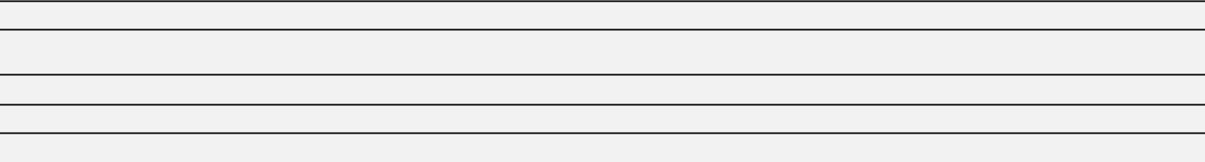

- Definitive Proxy Statement

- Definitive Additional Materials

- Soliciting Material Pursuant to Section 240.14a-12


Lockheed Martin Corporation

(Name of Registrant as Specified In Its Charter)

(Name of Person(s) Filing Proxy Statement, if Other Than the Registrant)

PAYMENT OF FILING FEE (CHECK THE APPROPRIATE BOX):

- No fee required.
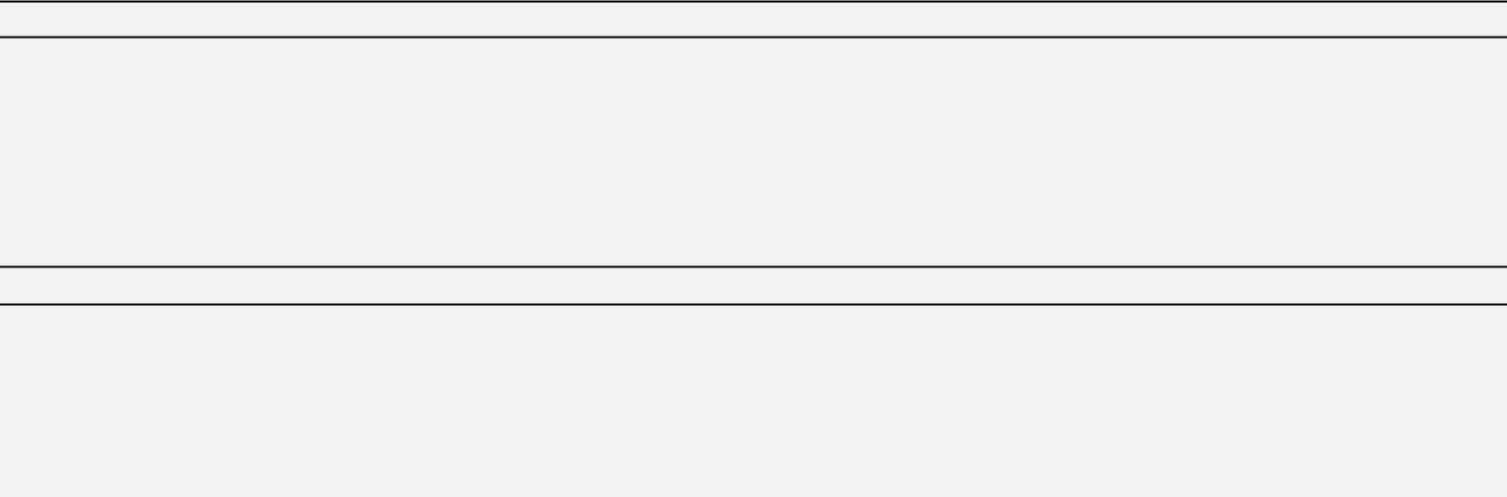

- Fee computed on table below per Exchange Act Rules 14a-6(i)(1) and 0-11.

  - Title of each class of securities to which transaction applies:

  - Aggregate number of securities to which transaction applies:

  - Per unit price or other underlying value of transaction computed pursuant to Exchange Act Rule 0-11 (set forth the amount on which the filing fee is calculated and state how it was determined):

  - Proposed maximum aggregate value of transaction:

  - Total fee paid:

- Fee paid previously with preliminary materials.

- Check box if any part of the fee is offset as provided by Exchange Act Rule 0-11(a)(2) and identify the filing for which the offsetting fee was paid previously. Identify the previous filing by registration statement number, or the form or schedule and the date of its filing.

  - Amount previously paid:

  - Form, Schedule or Registration Statement No.:

  - Filing Party:

  - Date Filed:

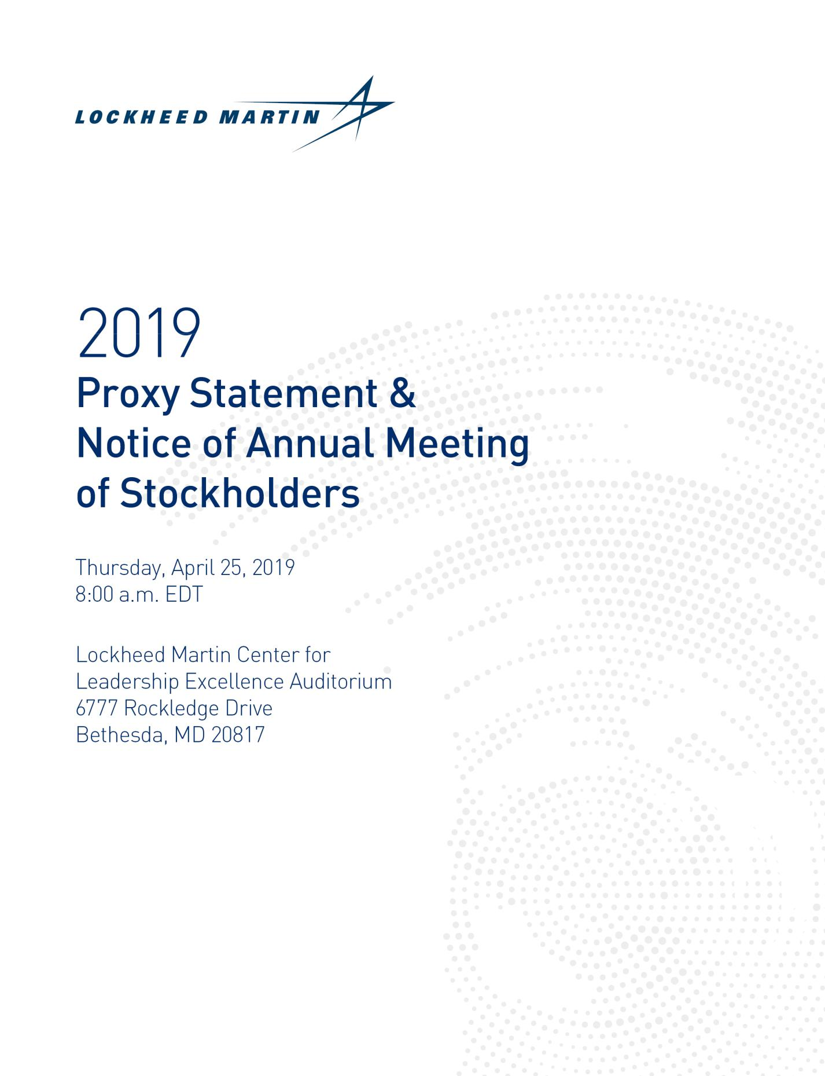



March 15, 2019

Dear Fellow Stockholders:

You are cordially invited to attend Lockheed Martin’s 2019 Annual Meeting of Stockholders on Thursday, April 25, 2019, at 8:00 a.m. EDT.

Below are some highlights about our financial performance, key actions, and important decisions in 2018. For more information, please review this Proxy Statement and the enclosed 2018 Annual Report.

Lockheed Martin achieved outstanding financial results in 2018. Our annual net sales of $53.8 billion were eight percent higher than last year and the highest sales in our corporation's history. Our earnings per share of $17.59 in 2018 were also an increase over 2017. We set a record for orders of $79 billion and ended the year with a record backlog of $130.5 billion. Also, in 2018, we generated $3.1 billion in cash from operations (after making $5.0 billion of annual pension contributions) and returned $3.8 billion in cash to stockholders through dividends and share repurchases. These impressive results, along with our operational accomplishments and new business awards, demonstrate the strength of our broad portfolio and the consistency of our performance across the corporation.

In 2018, we built upon our solid foundation and expanded our existing portfolio to profitably grow our business and create value for our stockholders, customers, and employees. We led our industry in mission focus and performance. And we attracted and retained the best talent in our industry and offered them opportunities to grow.

As we work to maintain our performance and growth, we continue to strengthen our leadership and accountability. We tie our executive pay programs to performance through a mix of short- and long-term incentives that align with our stockholders' interests. Our executive compensation programs are intended to promote decision-making that supports a pay-for-performance philosophy while mitigating risk for the corporation.

Over the past five years, we also added six new independent directors. Most recently, Vicki Hollub joined the Lockheed Martin Board in July 2018. Prior to last year's Annual Meeting, Jeh Johnson and James Taiclet joined the Board in January 2018. We are committed to recruiting experienced directors who offer diverse perspectives, professional expertise, and unique skills that align to our long-term corporate strategy and business needs.

We are deeply grateful to Nolan Archibald and Joseph Ralston who will retire from the Board at the 2019 Annual Meeting. Nolan has served as our Lead Director since 2015, and both he and Joe have made many valuable contributions to the Board. Our independent directors elected Daniel Akerson to serve as the new independent Lead Director following the Annual Meeting. Dan is a proven leader who will provide continued independent leadership to the Board.

On behalf of the entire Board, I want to thank you for your continued investment in Lockheed Martin. Even if you plan on attending the Annual Meeting in person, we urge you to cast your vote promptly in accordance with the Board of Directors’ recommendations. Lockheed Martin has a bright future ahead—and we look forward to continuing to deliver to our customers and our stockholders through strong performance, innovation, and growth for decades to come.

Sincerely,
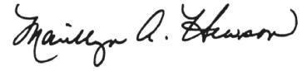

Marillyn A. Hewson

Chairman, President and

Chief Executive Officer

www.lockheedmartin.com 2019 Proxy Statement 1

Notice of 2019 Annual Meeting of Stockholders

 | Agenda | Board Recommendation
Item 1 | Election of 10 directors | FOR
Item 1 |  | each of the director-
 |  | nominees
Item 2 | Ratification of the appointment of Ernst & | FOR
Item 2 | Young LLP as our independent auditors for
 | 2019
Item 3 | Advisory vote to approve the | FOR
Item 3 | compensation of our named executive
 | officers (Say-on-Pay)
Item 4 | Consideration of a stockholder proposal, if | AGAINST
Item 4 | properly presented
 | Consideration of any other matters that
 | may properly come before the meeting

We have enclosed our 2018 Annual Report to Stockholders. The report is not part of the proxy soliciting materials for the Annual Meeting. The Proxy Materials or a Notice of Internet Availability were first sent to stockholders on or about March 15, 2019.

Please vote at your earliest convenience to ensure the presence of a quorum at the meeting. Promptly voting your shares in accordance with the instructions you receive will save the expense of additional solicitation. Submitting your proxy now will not prevent you from voting your shares at the meeting, as your proxy is revocable at your discretion.

Sincerely,
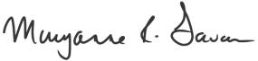

Maryanne R. Lavan

Senior Vice President, General Counsel
and Corporate Secretary
March 15, 2019

Important Notice Regarding the Availability of Proxy Materials for the 2019

Annual Meeting:
The 2019 Proxy Statement and 2018 Annual Report are available at www.edocumentview.com/LMT.

Logistics

When:

Thursday, April 25, 2019, 8:00 a.m. EDT

Where:

Lockheed Martin Center for Leadership Excellence Auditorium 6777 Rockledge Drive
Bethesda, MD 20817

Who Can Vote:

You can vote if you were a stockholder of record on February 22, 2019.

How:


Via the Internet:

www.investorvote.com

By Telephone:

In the United States, Canada and Puerto Rico, call 1-800-652-8683; other locations call 1-781-575-2300.

By Mail:

Mark, date and sign your proxy card or voting instruction form and return it in the accompanying postage prepaid envelope.


In Person:

Attend the meeting to vote in person.

Admission to Meeting and Meeting Security:

To obtain an admission ticket to attend the meeting, follow the advance registration instructions on page 82 of the Proxy Statement. Valid, government-issued photo identification is required at the meeting. All hand-carried items are subject to inspection and must be screened at the door. Cameras, cell phones, electronic devices, bags and briefcases will not be permitted in the meeting.

2

Proxy Summary

The Board of Directors (Board) of Lockheed Martin Corporation (the Corporation) located at 6801 Rockledge Drive, Bethesda, Maryland, 20817, is providing the Notice of 2019 Annual Meeting of Stockholders, this Proxy Statement and proxy card (the Proxy Materials) in connection with the Corporation's solicitation of proxies for the 2019 Annual Meeting (the Annual Meeting) to be held on April 25, 2019, at 8:00 a.m. EDT, at the Lockheed Martin Center for Leadership Excellence Auditorium, 6777 Rockledge Drive, Bethesda, Maryland 20817, and at any adjournment or postponement thereof.

This proxy summary highlights information contained elsewhere in our Proxy Statement. The summary does not contain all the information that you should consider, and we encourage you to read the entire Proxy Statement carefully.

Voting Matters and Board Recommendations


Proposal

1

Election of 10 Director-Nominees

The Board recommends a vote FOR each of the director-nominees.

- Diverse slate of directors with broad leadership and customer experience.

- All nominees are independent, except the Chairman.

- Average director tenure is six years with six new directors in five years.

See pages 9-13 for further

information.

 |  |  |  | Current Committees *
Name, Age, Independence and Position | Tenure | Current Public Boards | A | CBS | MDC | NCG | SA
Daniel F. Akerson, 70, Independent Lead Director* |  |  | ● | ● | ○
Retired, Chairman and | 2014 | None | ● | ● | ○
Chief Executive Officer of General Motors Company
David B. Burritt, 63, Independent |  |  | ● |  |  |  | ●
President and Chief Executive Officer of | 2008 | United States Steel Corporation | ● |  |  |  | ●
United States Steel Corporation
Bruce A. Carlson, 69, Independent | 2015 | Benchmark Electronics Inc. |  | ● |  | ●
Retired United States Air Force General | 2015 | Benchmark Electronics Inc. |  | ● |  | ●
James O. Ellis, Jr., 71, Independent |  |  |  | ● |  |  | ○
Retired, President and Chief Executive Officer of | 2004 | Dominion Energy, Inc. |  | ● |  |  | ○
Institute of Nuclear Power Operations
Thomas J. Falk, 60, Independent |  |  | ○ |  | ●
Executive Chairman of | 2010 | Kimberly-Clark Corporation | ○ |  | ●
Kimberly-Clark Corporation
Ilene S. Gordon, 65, Independent |  |  | ● |  | ●
Retired Chairman and Chief Executive Officer of | 2016 | International Paper Company | ● |  | ●
Ingredion Incorporated
Marillyn A. Hewson, 65 |  | DowDuPont Inc. (until March 31,
Chairman, President and Chief Executive Officer of | 2012 | DowDuPont Inc. (until March 31,
Chairman, President and Chief Executive Officer of | 2012 | 2019)
Lockheed Martin Corporation |  | 2019)
Vicki A. Hollub, 59, Independent |  |  |  |  | ● | ●
President and Chief Executive Officer of | 2018 | Occidental Petroleum Corporation |  |  | ● | ●
Occidental Petroleum Corporation
Jeh C. Johnson, 61, Independent |  |  |  | ● |  | ●
Partner, Paul, Weiss, Rifkind, Wharton & Garrison LLP | 2018 | None |  | ● |  | ●
Former Secretary of Homeland Security
James D. Taiclet, Jr., 58, Independent |  |  |  |  |  | ● | ●
Chairman, President and Chief Executive Officer of | 2018 | American Tower Corporation |  |  |  | ● | ●

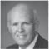


American Tower Corporation

Member: ● Chair: ○

- Effective after the Annual Meeting and assuming their re-election, Mr. Akerson will serve as the Lead Director and chair of the NCG Committee and Mr. Ellis and Ms. Gordon will chair the CBS and MDC Committee, respectively.

www.lockheedmartin.com 2019 Proxy Statement 3

Proxy Summary

Board Composition, Skills and Qualifications (10 Director-Nominees)


CEO Leadership Experience

Directors are current or former public company CEOs who add to the effectiveness of

- the Board through leadership experience in large, complex organizations and expertise in corporate governance, strategic planning and risk management.

Global Experience

Directors have board leadership experience with multinational companies or
- internationally.

Financial Experts

Directors meet the Securities and Exchange Commission’s (SEC) criteria as “audit
- committee financial experts.”

Government Experience

Directors have served in senior government or military positions and provide industry
- experience and insight into our core customers and governments around the world.

Veterans of the U.S. Armed Forces
- Directors are military veterans.

Board Effectiveness

Our Board takes a multi-faceted approach to continually assess Board composition and evaluate effectiveness.

Practices Contributing to Board Effectiveness


Identification of Diverse Board Candidates

Rotation of Board Committee Assignments

Annual Performance Assessment

Robust Onboarding and Continuing Education

Tenure and Overboarding Guidelines

Meaningful Refreshment


The Board has added six new directors in the past five years. Messrs. Archibald and Ralston will retire in April 2019, providing further opportunity for refreshment.

Skills added in past 5 years:

- Enterprise risk management

- Environment, safety and health and sustainability expertise

- Global organization experience

- Information technology and cybersecurity

4

Proxy Summary

Board Leadership and Effectiveness

On February 21, 2019 the independent members of the Board of Directors elected Daniel F. Akerson to serve as the Lead Director effective immediately following the Annual Meeting. Mr. Akerson succeeded Nolan D. Archibald who, along with Joseph W. Ralston, reached our mandatory retirement age for directors of 75. In addition, based upon the recommendation of the Nominating and Corporate Governance Committee (Governance Committee), the Board has approved the consolidation of the Strategic Affairs Committee into the Audit Committee following the Annual Meeting. This is in addition to the consolidation of the Governance Committee and the Ethics and Sustainability Committee effective April 2018. These actions streamline our committee structure, making meetings more efficient and providing more time for Board discussion. In light of these changes, the Board also made changes to the Committee memberships and elected new chairs of the Governance Committee (Mr. Akerson), Management Development and Compensation Committee (Compensation Committee) (Ilene S. Gordon) and Classified Business and Security (CBS) Committee (James O. Ellis) effective following the Annual Meeting.

Stockholder Engagement

Board’s Responsiveness to Stockholder Feedback

During 2018, as a part of our active stockholder engagement program, we invited many of our largest stockholders to engage with us and we had 18 engagements by telephone conference or written correspondence. Topics discussed as part of our 2018 engagement included board composition and diversity, human capital management, executive and director compensation and environmental, social and governance (ESG) matters. At the 2018 annual meeting, an advisory, non-binding stockholder proposal to adopt stockholder action by written consent received 40.9 percent of the votes cast. While the majority of our voting stockholders rejected the proposal, we strive to understand the issues that are important to our stockholders to ensure that we address their interests in a meaningful and effective way. The Board reviewed the voting results and investor feedback collected during our outreach, and assessed public company market practices and the effectiveness of the Corporation's existing avenues for responding to stockholder input and direct feedback from investors. The Board continues to believe that stockholders have an effective suite of rights to express their views and ensure Board accountability, including the rights to call a special meeting, to nominate director candidates in the Corporation's proxy materials (proxy access), and to amend the bylaws.

Corporate Governance Highlights

We believe that good governance is integral to achieving long-term stockholder value, and our Board has a history of thoughtful consideration and adoption of best practices.


Accountability to Stockholders

- Annual election of directors

- Majority voting for directors with resignation policy

- Proxy access with market standard provisions

- Stockholder right to call special meeting

- No poison pill and commitment to seek stockholder vote within one year if poison pill adopted

Effective Board Structure

- Refreshment ongoing – six new directors in five years

- Board composition balances government/customer/industry experience with public company experience

- NYSE-mandated committees (governance, compensation, audit) comprised of independent directors

- Overboarding policy

- Annual board self-assessment

Responsiveness to Stockholders

- Effective, year-round engagement with stockholders

- Recent adoption of stockholder right to amend the Bylaws

- Annual Say-on-Pay advisory vote

- Policy prohibiting hedging and pledging of company stock by directors, officers and employees

- Adopted the Commonsense Principles 2.0

Strong, Independent Board Leadership

- Independent Lead Director with defined duties

- All directors are independent except the Chairman

Incentive Compensation Structures Align With Strategy

- Short-term and long-term incentive targets derived from long-range plan

Voting Rights are Proportional to Economic Interests

- One class of stock

- One share, one vote

www.lockheedmartin.com 2019 Proxy Statement 5

Proxy Summary


Proposal

2

Ratification of Ernst & Young LLP as the Independent Auditors for 2019

The Board recommends a vote FOR ratification of Ernst & Young LLP for 2019.

- Independent accounting firm with the breadth of knowledge, support and expertise of its national office.

- Significant industry and government contracting expertise.

- Periodic mandated rotation of the audit firm’s lead engagement partner.


See pages 30-31 for further information.

Proposal

3

Advisory Vote on the Compensation of the Named Executive Officers (Say-on-Pay)

The Board recommends a vote FOR our Say-on-Pay proposal.

- Independent oversight by Management Development and Compensation Committee with the assistance of an independent consultant.

- Executive compensation targets are set by reference to 50th percentile of peers with actual payouts dependent on performance.

- More than 93% of votes cast at the 2018 annual meeting approved Say-on-Pay.


See page 33 for further information.

Proposal

4

Stockholder Proposal to Amend the Proxy Access Bylaw

The Board recommends a vote AGAINST proposal 4.

- Existing proxy access bylaw adopted following extensive stockholder engagement.

- Proxy access bylaw provision provides stockholders with meaningful proxy access.

- Proxy access bylaw reflects current best practices.

- Stockholder aggregation limit is consistent with market practice and appropriate.

See page 74-75 for further information.

6

Compensation Highlights


Best Practices in Our Programs


- Pay aligns with performance

- Market-based (50th percentile) approach for determining NEO target pay levels

- Caps on annual and long-term incentives, including when Total Stockholder Return (TSR) is negative

- Enhanced clawback policy on variable pay

- Double-trigger provisions for change in control

- Robust stock ownership requirements

- Low burn rate

- Incentive payouts deteriorate more rapidly between minimum and target as compared to target and maximum

Proxy Summary


Practices We Do Not Engage In or Allow


- No employment agreements

- No option backdating, cash out of underwater options or repricing

- No excise tax assistance upon a change in control

- No individual change in control agreements

- No automatic acceleration of unvested incentive awards in the event of termination

- No enhanced retirement formula or inclusion of long-term incentives in pensions

- No enhanced death benefits for executives

2018 Pay and Performance

A substantial portion of compensation paid to our named executive officers (NEOs) is performance-based. We use the 50th percentile of our comparator group to set target compensation but allow for payments to exceed or fall below the target level based upon actual performance. This outcome is consistent with our pay-for-performance philosophy to set pay and targets at market levels, but pay incentive compensation to reflect actual performance.

Based on our strong short- and long-term financial and operational performance, as manifested in record sales, orders, backlog, segment operating profit, and earnings per share for the year, our 2018 annual and 2016-2018 long-term incentive plans paid out above the targets.
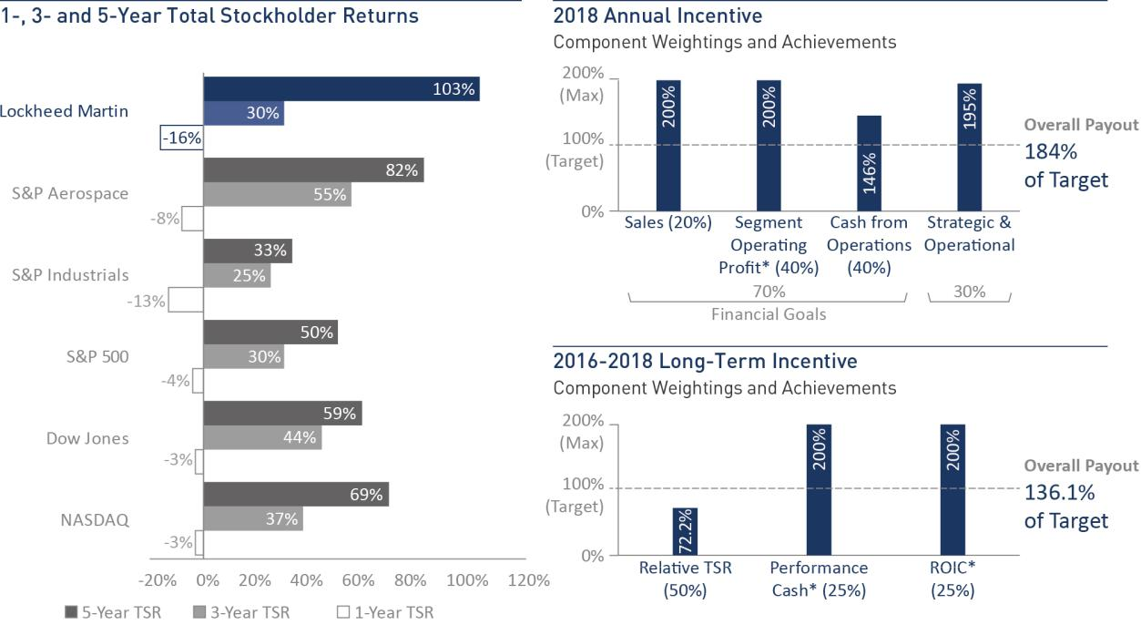

- See Non-GAAP terms in Appendix A for an explanation of “Segment Operating Profit,” “Return on Invested Capital (ROIC),” and “Performance Cash” and our forward-looking statements concerning future performance or goals for future performance.

www.lockheedmartin.com 2019 Proxy Statement 7

Table of Contents

PROPOSAL 1: ELECTION OF DIRECTORS | 9
Board Composition, Qualifications and Diversity | 9
Board Attendance | 9
Director-Nominees | 10
Board Effectiveness, Evaluations and Refreshment | 14

CORPORATE GOVERNANCE | 16
Board Structure | 16
Executive Sessions | 17
Committees of the Board of Directors | 17
Board Role and Responsibilities | 21
Board Policies and Processes | 22
Director Independence | 23

ENTERPRISE RISK AND SUSTAINABILITY | 27
AUDIT MATTERS | 30
PROPOSAL 2: RATIFICATION OF APPOINTMENT OF INDEPENDENT AUDITORS | 30
Audit Committee Report | 32
EXECUTIVE COMPENSATION | 33
PROPOSAL 3: ADVISORY VOTE TO APPROVE THE COMPENSATION OF OUR NEOs (SAY-ON-PAY) | 33
Compensation Committee Report | 33
Compensation Discussion and Analysis (CD&A) | 34
Summary Compensation Table | 52
2018 Grants of Plan-Based Awards | 56
Outstanding Equity Awards at 2018 Fiscal Year-End | 58
Option Exercises and Stock Vested During 2018 | 59
2018 Pension Benefits | 59
2018 Nonqualified Deferred Compensation | 61
Potential Payments Upon Termination or Change in Control | 64
CEO Pay Ratio | 69
DIRECTOR COMPENSATION | 70
SECURITY OWNERSHIP OF MANAGEMENT AND CERTAIN BENEFICIAL OWNERS | 72
SECTION 16(a) BENEFICIAL OWNERSHIP REPORTING COMPLIANCE | 73
PROPOSAL 4: STOCKHOLDER PROPOSAL TO AMEND THE PROXY ACCESS BYLAW | 74
QUESTIONS AND ANSWERS ABOUT THE ANNUAL MEETING | 76
ATTENDING THE ANNUAL MEETING | 82
ADDITIONAL INFORMATION AND OTHER MATTERS | 83
Appendix A: Definition of Non-GAAP (Generally Accepted Accounting Principles) Measures | 83
Disclosure Regarding Forward-Looking Statements | 85

8

Proposal

1

Election of Directors


- Diverse slate of directors with broad leadership and customer experience.

- All nominees are independent, except the Chairman.

- Average director tenure is six years with six new directors in five years.

The Board unanimously

recommends a vote FOR
each of the director-
nominees.

Board Composition, Qualifications and Diversity

We have no agreements obligating the Corporation to nominate a particular candidate as a director, and none of our directors represents a special interest or a particular stockholder or group of stockholders.


At Lockheed Martin, we recognize diversity and inclusion as a business imperative. We believe that our business accomplishments are a result of the efforts of our employees around the world, and that a diverse employee population will result in a better understanding of our customers’ needs. Our success with a diverse workforce also informs our views about the value of a board of directors that has persons of diverse skills, experiences and backgrounds. To this end, the Board seeks to identify candidates with areas of knowledge or experience that will expand or complement the Board’s existing expertise in overseeing a technologically advanced global security and aerospace company. Diversity in skills and backgrounds ensures that the widest range of options and viewpoints are expressed in the boardroom.

Consistent with the Corporate Governance Guidelines (the Governance Guidelines), the Board desires a diverse group of candidates who possess the background, skills, expertise and time to make a significant contribution to the Board, the Corporation and its stockholders. The Governance Committee makes recommendations to the Board concerning the composition of the Board and its committees, including size and qualifications for membership. The Governance Committee evaluates prospective nominees against the standards and qualifications set forth in the Corporation’s Governance Guidelines, as well as other relevant factors it deems appropriate.

The directors’ biographies beginning on page 10 note each director’s relevant experience, skills and qualifications.

Board Attendance

In 2018, the Board met a total of nine times. All directors on the Board during 2018 attended more than 75 percent of the total Board and committee meetings to which they were assigned. All then incumbent directors attended the 2018 annual meeting. Ms. Hollub joined the Board in July 2018.

www.lockheedmartin.com 2019 Proxy Statement 9

Proposal 1: Election of Directors

Director-Nominees

Daniel F. Akerson | Independent Director | Director since 2014

Biography
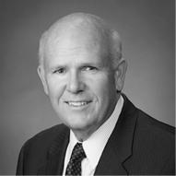

Vice Chairman of The Carlyle Group from March 2014 to December 2015. Mr. Akerson was Chairman of the Board of Directors and Chief Executive Officer of General Motors Company from January 2011 until his retirement in January 2014. Prior to joining General Motors, he was a Managing Director of The Carlyle Group, serving as the Head of Global Buyout from July 2009 to August 2010 and as Co-Head of U.S. Buyout from June 2003 to June 2009.

Age 70

Current Committees
- Audit
- Classified Business and Security
- Executive
- Management Development and Compensation, Chair

Other Current Public Boards

None

Skills and Qualifications

- Core leadership skills and experience with the demands and challenges of the global marketplace

- Extensive operating, marketing and senior management experience in a succession of major companies in challenging, highly competitive industries
- Enterprise risk management, financial, investment and mergers and acquisitions expertise

- The Board has determined that Mr. Akerson meets the SEC’s criteria of an “audit committee financial expert”

David B. Burritt

Independent Director | Director since 2008

Biography
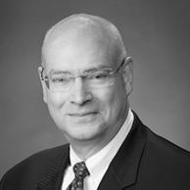

President and Chief Executive Officer of United States Steel Corporation since May 2017. Mr. Burritt also was named to United States Steel Corporation's board of directors at that time. Mr. Burritt previously served as President and Chief Operating Officer of United States Steel Corporation from February 2017 to May 2017; Chief Financial Officer from September 2013 to May 2017; and Executive Vice President from September 2013 to February 2017. Prior to joining U.S. Steel, Mr. Burritt served as Chief Financial Officer of Caterpillar Inc. until his retirement in 2010, after more than 32 years with the company. Mr. Burritt formerly served as a director of Global Brass & Copper Holdings, Inc. from 2011 until June 2014.

Age 63

Current Committees
- Audit
- Strategic Affairs

Other Current Public Boards

United States Steel Corporation

Skills and Qualifications

- Expertise in public company accounting, risk management, disclosure, financial system management, manufacturing and commercial operations and business transformation from roles as CEO and CFO at United States Steel Corporation and CFO and Controller at Caterpillar Inc.
- Nearly 40 years’ experience with the demands and challenges of the global marketplace from his positions at United States Steel Corporation and Caterpillar Inc.
- The Board has determined that Mr. Burritt meets the SEC’s criteria of an “audit committee financial expert”

Bruce A. Carlson

Independent Director | Director since 2015

Biography
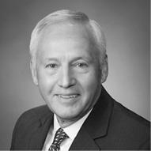

Retired U.S. Air Force General, Mr. Carlson has been chairman of the Utah State University Space Dynamics Laboratory’s Guidance Council since June 2013. Previously, Mr. Carlson served as the 17th Director of the National Reconnaissance Office from 2009 until 2012. He retired from the U.S. Air Force in January 2009 after more than 37 years of service, including as Commander, Air Force Materiel Command at Wright-Patterson AFB, Ohio, Commander, Eighth Air Force at Barksdale AFB, Louisiana; and Director for Force Structure, Resources and Assessment (J-8) for the Joint Staff.

Age 69

Current Committees

- Classified Business and Security
- Nominating and Corporate Governance

Other Current Public Boards

Benchmark Electronics Inc.

Skills and Qualifications

- Industry-specific expertise and knowledge of our core customer, including aircraft and satellite development and acquisition experience from his service in senior leadership positions with the military
- Experience with the demands and challenges associated with managing large organizations from his service as a Commander and Joint Staff Director of the Joint Chiefs
- Skilled in executive management, logistics and military procurement

10

James O. Ellis, Jr.

Proposal 1: Election of Directors

Independent Director | Director since 2004

Biography


Admiral Ellis has served as an Annenberg Distinguished Fellow at the Hoover Institution at Stanford University since 2014. Previously, he served as President and Chief Executive Officer of Institute of Nuclear Power Operations from May 2005 until his retirement in May 2012. Mr. Ellis retired from active duty in July 2004 after serving as Admiral and Commander, United States Strategic Command, Offutt Air Force Base, Nebraska. He formerly served as a director of Inmarsat plc from June 2005 to March 2014, and Level 3 Communications, Inc., from March 2005 to November 2017.

Age 71

Current Committees

- Classified Business and Security
- Executive
- Strategic Affairs, Chair

Other Current Public Boards

Dominion Energy, Inc.

Thomas J. Falk


Age 60

Current Committees
- Audit, Chair
- Executive
- Management Development and Compensation

Other Current Public Boards

Kimberly-Clark Corporation

Ilene S. Gordon


Age 65

Current Committees
- Audit
- Management Development and Compensation

Other Current Public Boards

International Paper Company

Skills and Qualifications

- Industry-specific expertise and knowledge of our core customers from his service in senior leadership positions with the military
- Expertise in aeronautical and aerospace engineering, information technology and emerging energy issues
- Skilled in enterprise risk management

- Over 40 years’ experience in managing and leading large and complex technology-focused organizations, in large part as a result of serving for 35 years as an active duty member of the United States Navy

Independent Director | Director since 2010

Biography

Executive Chairman of Kimberly-Clark Corporation since January 2019. Having served 35 years at Kimberly-Clark Corporation, Mr. Falk was Chairman of the Board and Chief Executive Officer from 2003 until December 2018; Chief Executive Officer from 2002 and President and Chief Operating Officer from 1999 to 2002.

Skills and Qualifications

- Experience with the demands and challenges associated with managing global organizations from his experience as Chairman and Chief Executive Officer of Kimberly-Clark Corporation
- Knowledge of financial system management, public company accounting, disclosure requirements and financial markets
- Manufacturing, human capital management, compensation, governance and public company board experience
- The Board has determined that Mr. Falk meets the SEC’s criteria of an “audit committee financial expert”

Independent Director | Director since 2016

Biography

Executive Chairman of the Board of Ingredion Incorporated from January 2018 through July 2018. Previously, Ms. Gordon was Chairman of the Board, President and Chief Executive Officer of Ingredion Incorporated from May 2009 through December 2017.

Skills and Qualifications

- Experience with the demands and challenges associated with managing global organizations from her experience as Chairman, President and Chief Executive Officer of Ingredion Incorporated
- Knowledge of financial system management, public company accounting, disclosure requirements and financial markets
- Marketing, human capital management, compensation, governance and public company board experience
- The Board has determined that Ms. Gordon meets the SEC’s criteria of an “audit committee financial expert”

www.lockheedmartin.com 2019 Proxy Statement 11

Proposal 1: Election of Directors

^{Marillyn A. Hewson}Chairman, President & CEO | Director since 2012

Biography


Chairman, President and Chief Executive Officer of Lockheed Martin since January 2014. Having served 35 years at Lockheed Martin in roles of increasing responsibility, Ms. Hewson held the positions of Chief Executive Officer and President from January 2013 to December 2013; and President and Chief Operating Officer from November 2012 to December 2012.

Age 65

Current Committees

- Executive, Chair

Other Current Public Boards

DowDuPont Inc. (until March 31, 2019)

Skills and Qualifications

- Broad insight and knowledge into the complexities of global business management, strategic planning, finance, supply chain and leveraged services based on more than three decades of experience in executive and operational roles with the Corporation and in our industry
- Expertise in government relations, government contracting, manufacturing, marketing and human capital management
- Corporate governance and audit expertise derived from service on boards of other multinational corporations and nonprofit organizations

Vicki A. Hollub

Independent Director | Director since 2018

Biography


President and Chief Executive Officer of Occidental Petroleum Corporation (Occidental), an international oil and gas exploration and production company since April 2016. Having served more than 30 years at Occidental, Ms. Hollub served as President and Chief Operating Officer from 2015 to 2016; Senior Executive Vice President, Occidental and President, Oxy Oil and Gas - Americas from 2014 to 2015, and Executive Vice President, Occidental and Executive Vice President, U.S. Operations and Oxy Oil and Gas from 2013 to 2014.

Age 59

Current Committees

- Management Development and Compensation
- Nominating and Corporate Governance

Other Current Public Boards

Occidental Petroleum Corporation

Skills and Qualifications

- Broad insight and experience with the demands and challenges associated with managing global organizations from her experience as President and Chief Executive Officer of Occidental and more than three decades in executive and operational roles
- Expertise in the Middle East region and Latin America

- Skilled in enterprise risk management, environmental, safety and health, and sustainability

- The Board has determined that Ms. Hollub meets the SEC’s criteria of an “audit committee financial expert”

12

Jeh C. Johnson

Proposal 1: Election of Directors

Independent Director | Director since 2018

Biography
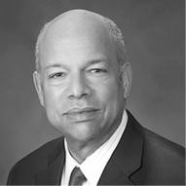

Partner at the international law firm of Paul, Weiss, Rifkind, Wharton & Garrison LLP since January 2017. Previously, Mr. Johnson served as U.S. Secretary of Homeland Security from December 2013 to January 2017; and as General Counsel of the U.S. Department of Defense and as General Counsel of the U.S.

Department of the Air Force. Mr. Johnson formerly served as a director of PG&E Corporation from May 2017 to March 2018.

Age 61

Current Committees

- Classified Business and Security
- Nominating and Corporate Governance

Other Current Public Boards

None

Skills and Qualifications

- Expertise in national security, leadership development and organizational preparedness from his service as U.S. Secretary of Homeland Security
- Industry-specific expertise and insight into our core customers, including requirements for acquisition of products and services, from prior senior leadership positions with the military
- Experience with large organization management and assessing human resources, equipment, cybersecurity, and financial requirements, as well as reputational risks

^{James D. Taiclet, Jr.} Independent Director | Director since 2018

Biography


Chairman, President and Chief Executive Officer of American Tower Corporation. Mr. Taiclet was appointed President and Chief Operating Officer in September 2001; named Chief Executive Officer in October 2003; and selected as Chairman of the Board in February 2004. Previously, Mr. Taiclet served as President of Honeywell Aerospace Services, a unit of Honeywell International and Vice President, Engine Services at Pratt & Whitney, a unit of United Technologies Corporation.

Age 58

Current Committees

- Nominating and Corporate Governance
- Strategic Affairs

Other Current Public Boards

American Tower Corporation

www.lockheedmartin.com

Skills and Qualifications

- Effective leadership and executive experience as Chairman, President and CEO of American Tower Corporation
- Expertise in management at large-scale, multinational corporations, including regulatory compliance, corporate governance, capital markets and financing, strategic planning and investor relations
- Industry-specific expertise from service as a U.S. Air Force officer and pilot as an executive at Honeywell Aerospace Services and Pratt & Whitney
- The Board has determined that Mr. Taiclet meets the SEC’s criteria of an “audit committee financial expert”

2019 Proxy Statement | 13

Proposal 1: Election of Directors

Board Effectiveness, Evaluations and Refreshment

Board composition is one of the most critical areas of focus for the Board. Having the right mix of people who bring diverse perspectives, business and professional experiences and competencies as well as professional integrity, sound judgment and collegiality, provides a foundation for robust dialogue, informed advice and collaboration in the boardroom. We consider current Board skills, background, experience, tenure and anticipated retirements to identify gaps that may need to be filled through the Board refreshment process. The Board strives to ensure an environment that encourages diverse critical thinking and values innovative, strategic discussions to achieve a higher level of success for the Corporation.

The Governance Committee screens and recommends candidates for nomination by the full Board. The Governance Committee uses a variety of methods to help identify potential board candidates with the desired skills and background needed for the Corporation’s business, including informal networks, third party search firms, internal resources and other channels. Subsequent to the 2018 annual meeting, the Board appointed Vicki A. Hollub to the Board (see Ms. Hollub's biography on page 12). Using publicly available data and director networks, our internal executive search team compiled a list of prospective director candidates reflecting the Board's criteria, qualifications and experience, which was focused on identifying directors with relevant public company experience, global expertise and diverse perspectives given the anticipated retirements of Messrs. Archibald and Ralston at the Annual Meeting. Ms. Hollub was identified from this source pool by the Chairman and the Governance Committee and was interviewed by the Governance Committee and other Board members.

Board Refreshment Elements


Governance Committee Review of Board Candidates

The Board seeks a diverse group of candidates who, at a minimum, possess the background, skills, expertise, competencies and time to make a significant contribution to the Board. The Governance Guidelines list criteria against which candidates may be judged. In addition, the Governance Committee considers, among other things:

- input from the Board’s self-assessment process to prioritize areas of expertise that were identified;

- investor feedback and perceptions;

- the candidates’ skills and competencies to ensure they are aligned to the Corporation’s future strategic challenges and opportunities;

- the needs of the Board in light of recent and anticipated Board vacancies; and

- a balance between public company and government customer-related experience.

During the process of identifying and selecting director nominees, the Governance Committee screens and recommends candidates for nomination by the full Board. The Bylaws currently provide that the size of the Board may range from 10 to 14 members.

Director candidates also may be identified by stockholders and will be evaluated under the same criteria applied to other director nominees and considered by the Governance Committee. Information on the process and requirements for stockholder nominees may be found in Sections 1.10 and 1.11 of our Bylaws on the Corporation’s website at www.lockheedmartin.com/corporate-governance.

Board Committee Assignments

In February of each year, the Governance Committee reviews the membership, tenure, leadership and commitments of each of the committees and considers possible changes given the qualifications and skill sets of members on the Board or a desire for committee rotation or refreshment. The Governance Committee also takes into consideration the membership requirements and responsibilities set forth in each of the respective committee charters and the Governance Guidelines as well as any upcoming vacancies on the Board due to our mandatory retirement age. The Governance Committee recommends to the Board any proposed changes to committee assignments and leadership to be made effective at the next annual meeting of stockholders. The Governance Committee also reviews the operation of the Board generally and based upon its recommendation, the Board approved the consolidation of the Governance Committee and the Ethics and Sustainability Committee effective immediately following the 2018 annual meeting and the consolidation of the Strategic Affairs Committee into the Audit Committee effective immediately following the 2019 Annual Meeting.

14

Proposal 1: Election of Directors


Annual Performance Assessment

The Board conducts a self-assessment of its performance and effectiveness as well as that of its committees on an annual basis. The self-assessment helps the Governance Committee to track progress in certain areas targeted for improvement from year-to-year and to identify ways to enhance the Board’s and its committees’ effectiveness. For 2018, each director completed a written questionnaire. The questions were open-ended to solicit candid feedback. The collective ratings and comments are compiled and summarized and the Lead Director leads a discussion with the Governance Committee and the full Board.

Robust Onboarding and Continuing Education

New directors are provided a robust orientation about the Corporation, including our business operations, strategy and governance. New directors have one-on-one sessions with the CEO, other directors and other members of senior management. Members of our senior management regularly review with the Board the operating plan of each of our business segments and the Corporation as a whole. The Board also conducts periodic site visits to our facilities as part of its regularly scheduled Board meetings and directors are encouraged to visit sites on an ad hoc basis and meet one-on-one with members of senior management and other employees. Directors are encouraged to attend outside director continuing education programs sponsored by educational and other institutions to assist them in staying abreast of developments in corporate governance and critical issues relating to the operation of public company boards.

Our Tenure Guidelines

Mandatory Retirement Age | th
Mandatory Retirement Age | A director must retire at the annual meeting following his or her 75 birthday.
Term Limits | We do not have term limits for directors as we believe implementing term limitations may prevent the Board from
 | taking advantage of insight that longer tenure brings.
Employment Change | Directors should expect to resign upon any significant change in principal employment or responsibilities.
Failed Election | Directors must offer to resign as a result of a failed stockholder vote.
www.lockheedmartin.com | 2019 Proxy Statement | 15

Corporate Governance

Lockheed Martin believes good governance is integral to achieving long-term stockholder value. The Board’s primary role is to oversee management and represent the interests of stockholders. Directors are expected to attend Board meetings, the meetings of the committees on which they serve and the annual meeting of stockholders. The Board and its committees regularly schedule and hold executive sessions without any members of management present. Between meetings, directors interact with the Chairman, President and Chief Executive Officer (CEO), the Lead Director and other members of management and are available to provide advice and counsel to management.

Board Structure

Positions of Chairman and CEO

The Board believes that it must be independent and must provide strong and effective oversight. The Board also believes that the independent Board members should have the flexibility to respond to changing circumstances and choose the model that best fits the then-current situation. As a result, the roles of Chairman and CEO have been split from time to time to facilitate leadership transitions, while at other times the roles have been combined. The Board believes that, at the present time, the Corporation is best served by allocating governance responsibilities between a combined Chairman and CEO and an independent Lead Director with robust responsibilities. This structure allows the Corporation to present a single face to our customers through the combined Chairman and CEO position while at the same time providing an active role and voice for the independent directors through the Lead Director.

In connection with the retirement of the current Lead Director at the Annual Meeting, the Governance Committee reviewed the current leadership structure and determined that it continues to provide effective independent oversight and meet the needs of the Corporation. The independent directors will continue to review the leadership structure on an ongoing basis to effectively oversee risk management and ensure that it continues to meet the needs of the Corporation and support the generation of stockholder value over the long-term.

Independent Lead Director

In accordance with our Bylaws and Governance Guidelines, the independent members of the Board annually elect one of the independent directors to serve as the Lead Director by the affirmative vote of a majority of the directors who have been determined to be “independent” for purposes of the New York Stock Exchange (NYSE) listing standards. The Board has structured the role of the Lead Director with sufficient authority to serve as a counter-balance to management. The responsibilities specified in our Bylaws for the Lead Director are to:

- preside as chair at Board meetings while in executive sessions of the non-management members of the Board or executive sessions of the independent directors or if the Chairman is not present;

- determine the frequency and timing of executive sessions of non-management directors and report to the Chairman on all relevant matters arising from those sessions;

- consult with the Chairman and committee chairs regarding the topics for and schedules of the meetings of the Board and committees and approve the topics for and schedules of Board meetings;

- review and approve all Board and committee agendas and provide input to management on the scope and quality of information sent to the Board;

- assist with recruitment of director candidates and, along with the Chairman, extend invitations to potential directors to join the Board;

- act as liaison between the Board and management and among the directors and the committees of the Board;

- serve as a member of the Executive Committee of the Board;

- serve as an ex-officio member of each committee if not otherwise a member of the committee;

- serve as the point of contact for stockholders and others to communicate with the Board;

- recommend to the Board and committees the retention of advisors and consultants who report directly to the Board;

- call a special meeting of the Board or of the independent directors at any time, at any place and for any purpose; and

- perform all other duties as may be assigned by the Board from time to time.

16

Corporate Governance

The committee chairs also review and discuss the agendas for the meetings in advance of distribution of the agendas and related Board or committee material.
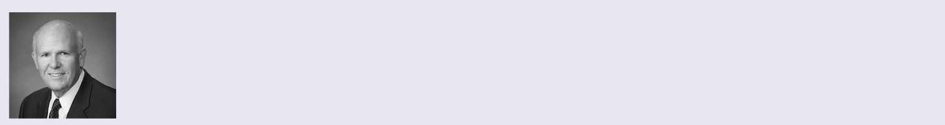

Assuming his re-election at the Annual Meeting, the independent directors have elected Daniel F. Akerson to serve as Lead Director upon Mr. Archibald's retirement from the Board following the Annual Meeting. Under the Governance Guidelines, Mr. Akerson also will serve as chairman of the Governance Committee. Mr. Akerson has served on our Board since 2014 and currently chairs our Compensation Committee and has served on the Audit Committee, the Classified Business and Security Committee and the Executive Committee. He is an audit committee financial expert. Mr. Akerson was selected as Lead Director as a result of a selection process


overseen by the Governance Committee which included discussions between the current Lead Director and each of the independent Board members to seek input and reach alignment. These discussions and selection took into account independent directors’ tenures, committee membership experience, understanding and knowledge of the Corporation’s business and strategy, independent judgment, ability to work collegially and build consensus, and willingness and ability to serve in light of the significant time commitment.

Stockholders and other interested parties may communicate with the Lead Director by email at Lead.Director@lmco.com.

Executive Sessions

Generally, each meeting agenda of the Board and each committee includes an executive session of the non-management directors. The Governance Guidelines require that at least three Board meetings per year will include an executive session of the non-management directors. In each case, these sessions include a discussion of the performance of the Chairman and CEO. The Lead Director presides during the executive sessions of the Board, and will report the results to the Chairman and CEO on all relevant matters, or invite the Chairman and CEO to join the executive session for further discussion, as appropriate. If the group of non-management directors includes directors who are not independent directors, at least one executive session including only independent directors will be scheduled each year. The respective chairman of each committee presides during the committee executive sessions.

Committees of the Board of Directors

The table on page 18 lists our Board committees, the chairs of each committee, the directors who served on them following the 2018 annual meeting and the number of committee meetings held in 2018. Charters for each committee are available on the Corporation’s website at
www.lockheedmartin.com/corporate-governance.

Committee Consolidations

Effective immediately following the 2018 annual meeting, the Governance Committee and the Ethics and Sustainability Committee were consolidated into one committee under the name Nominating and Corporate Governance Committee. Effective immediately following the 2019 Annual Meeting, the Strategic Affairs Committee will be consolidated into the Audit Committee. These committee restructurings are aimed at making meetings more efficient, eliminating redundancies and providing more time for discussion. In addition, certain matters involving strategy that were previously covered by the Strategic Affairs Committee were determined to be matters that would be best covered by the full Board. In making these consolidation decisions, the Board considered survey data which showed that Lockheed Martin had three more committees than the three committees required by the NYSE listing standards whereas most public companies had at most one additional committee beyond the three NYSE-required committees. The Board also considered the workload of the various committees. The consolidation of the committees has not and will not result in any less coverage of items within the jurisdiction of the committees or the Board or overburden any committee; in fact the Board believes the Board oversight and strategic guidance of the respective issues will be enhanced. The Board will continue to review ways to enhance the Board's effectiveness in fulfilling its oversight responsibilities. In connection with the retirement of Messrs. Archibald and Ralston, the consolidation of the Strategic Affairs Committee and the Audit Committee effective following the 2019 Annual Meeting, and the election of a new Lead Director, the Board made changes to the committee memberships and elected new chairs of the Governance Committee (Mr. Akerson), Compensation Committee (Ms. Gordon) and CBS Committee (Mr. Ellis).

www.lockheedmartin.com 2019 Proxy Statement 17

Corporate Governance

2018 Membership on Board Committees *
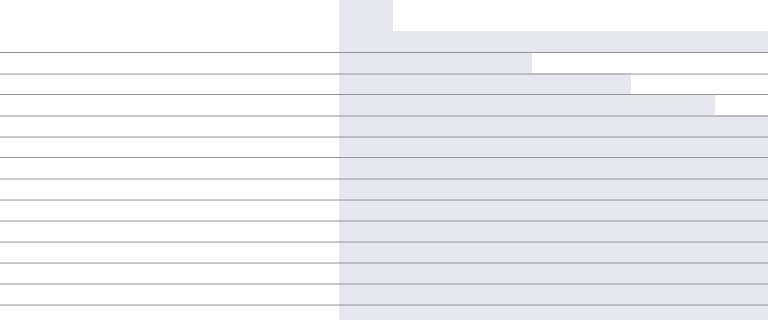

 |  | Classified |  | Management | Nominating | Strategic
Director | Audit | Business and | Executive | Development | and Corporate | Strategic
Director | Audit | Security | Executive | and Compensation | Governance | Affairs

Daniel F. Akerson

Nolan D. Archibald

David B. Burritt

Bruce A. Carlson

James O. Ellis, Jr.

Thomas J. Falk

Ilene S. Gordon

Marillyn A. Hewson

Vicki A. Hollub

Jeh C. Johnson

James M. Loy**

Joseph W. Ralston

James D. Taiclet, Jr.

● | ● | ● | ○
 |  | ● | ● | ○
● |  |  |  |  | ●
 | ● |  |  | ●
 | ● | ● |  |  | ○
○ |  | ● | ●
● |  |  | ●
 |  | ○
 |  |  | ● | ●
 | ● |  |  | ●
 | ● | ● |  |  | ●
 | ○ | ● |  |  | ●
 |  |  |  | ● | ●

Meetings held in 2018 | 6 | 3 | 0 | 4 | 4 | 1
Member: ● Chair: ○

- Messrs. Loy, Carlson, and Ralston and Ms. Gordon also served on the Ethics and Sustainability Committee until its consolidation with the Governance Committee in April 2018. The Ethics and Sustainability Committee met twice in 2018.

** Mr. Loy retired in April 2018.

Audit Committee


Thomas J. Falk, Chair

Daniel F. Akerson

David B. Burritt

Ilene S. Gordon

All the members of the Audit Committee are independent within the meaning of the NYSE listing standards, applicable SEC regulations and our Governance Guidelines.

The Board has determined that each member of the committee is a qualified audit committee financial expert within the meaning of applicable SEC regulations and each has accounting and related financial management expertise sufficient to be considered financially literate within the meaning of the NYSE listing standards.

^{2018 Focus Areas} Meetings in 2018: 6

- Enterprise Risk Management and Internal Audit Plan Implementation

- Adoption of New Accounting Standards Related to Revenue Recognition and Post-Retirement Benefit Plan Expenses

- Oversight of Corporation's Independent Auditors

Roles and Responsibilities of the Committee

The Audit Committee is responsible for assisting the Board in fulfilling its oversight responsibilities relating to the financial condition of the Corporation, the integrity of the Corporation’s financial statements and the Corporation’s compliance with legal and regulatory requirements. In addition, the Audit Committee has oversight of the Corporation’s internal audit plan and enterprise risk management processes. It is directly responsible for the appointment, compensation, retention, oversight and termination of the Corporation’s independent auditors. The Audit Committee also is responsible for reviewing the allocation of resources, the Corporation’s financial condition and capital structure and policies regarding derivatives and capital expenditures. The Audit Committee meets privately with the Senior Vice President, Ethics and Enterprise Assurance, and the Corporation’s independent auditors, Ernst & Young LLP. The functions of the Audit Committee are further described under the heading “Audit Committee Report” on page 32.

18

Corporate Governance

Classified Business and Security Committee


Joseph W. Ralston, Chair Daniel F. Akerson Bruce A. Carlson James O. Ellis, Jr. Jeh C. Johnson James M. Loy*

All members of the CBS Committee are independent within the meaning of NYSE listing standards and hold high-level security clearances.

* Served until his retirement in April 2018

^{2018 Focus Areas} Meetings in 2018: 3

- Classified Business and Related Financials

- Risks Related to Classified Programs

- Security of Personnel and Facilities

Roles and Responsibilities of the Committee

The CBS Committee assists the Board in fulfilling its oversight responsibilities relating to the Corporation’s classified business activities and the security of personnel, facilities and data (including classified cybersecurity matters). The CBS Committee consists of directors who possess the appropriate security clearance credentials, at least one of whom must be a member of the Audit Committee, and none of whom are officers or employees of the Corporation and are free from any relationship that, in the opinion of the Board, would interfere with the exercise of independent judgment as a member of the CBS Committee.

Management Development and Compensation Committee


Daniel F. Akerson, Chair Nolan D. Archibald Thomas J. Falk Ilene S. Gordon Vicki A. Hollub

All members of the Compensation Committee are independent within the meaning of the NYSE listing standards, applicable SEC regulations and our Governance Guidelines.

^{2018 Focus Areas} Meetings in 2018: 4

- Human Capital Management

- Alignment to Competitive and Best Practices

- Incentive Pay Linkage to Stockholder Interests and Long-Term Value Creation

Roles and Responsibilities of the Committee

The Compensation Committee reviews and approves the corporate goals and objectives relevant to the compensation of the CEO and other elected officers, evaluates the performance of the CEO and, either as a committee or together with the other independent members of the Board, determines and approves the compensation philosophy and levels for the CEO and other executive officers. The Compensation Committee does not delegate its responsibilities with respect to compensation that is specific to the executive officers. For other employees and for broad-based compensation plans, the Compensation Committee may delegate authority to the CEO or the Senior Vice President, Human Resources, subject to certain annual limits.

Additional information regarding the role of the Compensation Committee and our compensation practices and procedures is provided under the captions “Compensation Committee Report” on page 33, “Compensation Discussion and Analysis (CD&A)” beginning on page 34 and “Other Compensation Matters” on page 48.

www.lockheedmartin.com 2019 Proxy Statement 19

Corporate Governance

Nominating and Corporate Governance Committee


Nolan D. Archibald, Chair Bruce A. Carlson Vicki A. Hollub Jeh C. Johnson James D. Taiclet, Jr.

All members of the Governance Committee are independent within the meaning of the NYSE listing standards, applicable SEC regulations and our Governance Guidelines.

^{2018 Focus Areas} Meetings in 2018: 4

- Board Responsiveness to Investor Feedback

- Board Composition and Diversity

- Board and Committee Effectiveness and Performance

- Ethics and Sustainability Oversight

Roles and Responsibilities of the Committee

The Governance Committee is responsible for developing and implementing policies and practices relating to corporate governance, including our Governance Guidelines. The Governance Committee assists the Board by selecting candidates to be nominated to the Board, making recommendations concerning the composition of Board committees and overseeing the evaluation of the Board and its committees.

The Governance Committee reviews and recommends to the Board the compensation of directors. Our executive officers do not play a role in determining director pay other than to gather publicly available information.

In addition, the Governance Committee assists the Board in fulfilling its oversight efforts in corporate responsibility, corporate culture, human rights, environmental stewardship, political contributions, ethical business practices, community outreach, philanthropy, diversity and inclusion and equal opportunity, sustainability, and employee safety and health. The Governance Committee monitors compliance and recommends changes to our Code of Conduct.

Strategic Affairs Committee


James O. Ellis, Jr., Chair David B. Burritt James M. Loy* Joseph W. Ralston James D. Taiclet, Jr.

* Served until his retirement in April 2018

^{2018 Focus Areas} Meetings in 2018: 1

- Technology Strategy and Innovation

- Corporation's Strategy and Long-Range Plan

- Enterprise Risk Mitigation Plans

Roles and Responsibilities of the Committee

The Strategic Affairs Committee reviews management’s long-term strategy for the Corporation and reviews risks and opportunities to the strategy as identified by the Corporation’s Enterprise Risk Management processes. The Strategic Affairs Committee reviews and recommends to the Board certain significant strategic decisions regarding exit from and entry into lines of business, material acquisitions, joint ventures, investments or dispositions of businesses and assets and the financing of related transactions.

20

Corporate Governance

Board Role and Responsibilities

Board Role in Strategic Planning

The Board is involved in strategic planning and review throughout the year. In 2018, the Board met in a half-day session dedicated to a discussion of the Corporation’s strategy and one-year and three-year long-range plans. During 2018, the Chairman, President and CEO regularly reviewed developments against the Corporation’s strategic framework at Board meetings. This schedule corresponds to management’s annual schedule for developing the long-range plan and provides the Board with the opportunity to provide input while the long-range plan is being developed and to monitor progress on the plan.

In addition:

- the Board (or the appropriate committee) reviews the progress and challenges to the Corporation’s strategy and approves specific initiatives, including acquisitions and divestitures over a certain monetary threshold;

- the Board (or the appropriate committee) reviews trends identified as significant risks and topical items of strategic interest such as human capital strategy and cybersecurity on a regular basis;

- at least annually, the Board meets at a Corporation facility where directors can tour the operations and engage directly with employees; during 2018, the Board had the opportunity to visit the F-35 production line and the Sikorsky Aircraft production line; and

- each business segment executive vice president presents an operations review to the Board and each business segment financial officer presents a financial review to the Audit Committee on a rotating basis.

Enterprise Risk Management

Our risk management philosophy is to balance risk and reward within the risk tolerance of management and the Board, taking into account the Corporation's operations and long-term strategy. This is accomplished through risk management practices, our core values and our Code of Conduct, each of which reinforces a risk transparent culture. The Board and its committees receive risk updates throughout the year. Executive management provides updates on risks managed at the Enterprise level. Business segment management provides updates on risks to individual business segment objectives. Additional information regarding the Board's role in enterprise risk management in provided on page 28.

Management Succession Planning

Management has established semi-annual talent reviews. During these reviews, the executive leadership team discusses succession plans for key positions and identifies top talent for development in future leadership roles. The Board of Directors maintains a succession plan for the CEO and other key members of management and has a contingency plan if the CEO were to depart unexpectedly.

The Corporation has a corporate policy imposing a mandatory retirement age of 65 for all executive officers other than the CEO. The CEO’s tenure is at the discretion of the Board, which is free to consider all relevant factors.

Board Oversight of Human Capital Management

The Board also is actively engaged in human capital management. Annually, the Board meets to review our succession strategy and leadership pipeline for key roles, including the CEO, taking into account the Corporation’s long-term corporate strategy. CEO succession planning discussions are led by the independent Lead Director and the directors have direct access to and interaction with members of senior management as part of this succession planning. More broadly, the Board is regularly updated on key talent indicators for the overall workforce, and is updated on the Corporation’s human capital strategy which is refined based on business drivers, the changing internal or external environment and the future of work. Board members also are active partners, engaging and spending time with our high potential leaders throughout the year at Board meetings and other events.

www.lockheedmartin.com 2019 Proxy Statement 21

Corporate Governance

Effective Stockholder Engagement

Accountability to our stockholders is an important component of the Corporation’s success. We recognize the value of building informed relationships with our investors that promote further transparency and accountability. In September 2018, we amended our Governance Guidelines to explicitly memorialize our stockholder engagement program.

While proxy voting is one direct way to influence corporate behavior, proactive engagement with our investors can be effective and impactful. Investor views are continuously communicated to the Board and are instrumental in the development of our governance, compensation and sustainability policies and inform our business strategy. The Board will continue to seek investor input on a range of ESG issues and practices in furtherance of enhancing long-term stockholder value.

Investor Engagement Cycle
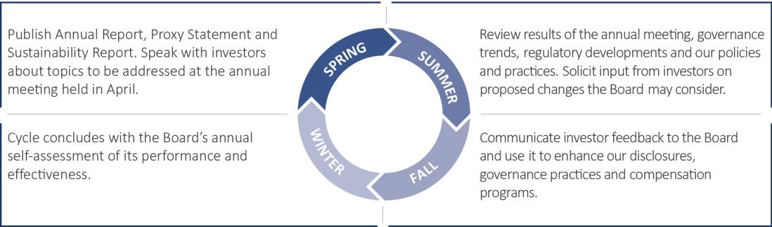

Board Policies and Processes

Corporate Governance Guidelines

The Board has adopted Governance Guidelines that describe the framework within which the Board and its committees oversee the governance of the Corporation. The current Governance Guidelines are available on the Corporation’s website at www.lockheedmartin.com/corporate-governance.

The Governance Committee regularly assesses our governance practices considering emerging trends and practices and implements best governance practices that it believes enhance the operation and effectiveness of the Board.

Our Governance Guidelines cover a wide range of subjects, including:

- the role of the Board and director responsibilities;

- the role and responsibilities of the Lead Director;

- application of our Code of Ethics and Business Conduct (the Code of Conduct) to the Board;

- director nomination procedures and qualifications;

- director independence standards;

- director overboarding limits;

- policies for the review, approval and ratification of related person transactions;

- director orientation and continuing education;

- review by the Governance Committee of any change in job responsibilities of an incumbent director;

- procedures for annual performance evaluations of the Board and its committees;

- director stock ownership guidelines (currently, an amount equal to five times the cash portion of the annual retainer);

- a clawback policy for executive incentive compensation;

- a policy prohibiting hedging and pledging of company stock;

22

Corporate Governance

- majority voting for the election of directors and resignation procedures for directors who fail to receive a majority vote;

- process for director compensation review, specifically use of competitive data and input from independent compensation consultant; and

- formalizing our stockholder engagement program; our Lead Director will consider requests to speak to investors and will designate (in consultation with the Senior Vice President, General Counsel and Corporate Secretary) a director to engage with the requesting investors, if appropriate.

Director Overboarding Policy

The Board recognizes that its members benefit from service on the boards of other companies and it encourages such service. The Board also believes, however, that it is critical that directors are able to dedicate sufficient time to their service on the Corporation’s Board. Therefore, the Governance Guidelines provide that, without obtaining the approval of the Governance Committee:

- A director may not serve on the boards of more than four other public companies.

- If the director is an active chief executive officer or equivalent of another public company, the director may not serve on the boards of more than two other public companies.

- No member of the Audit Committee may serve on more than two other public company audit committees.

- No member of the Compensation Committee may serve on more than three other public company compensation committees.

Directors must notify the CEO, Lead Director and Senior Vice President, General Counsel and Corporate Secretary before accepting an invitation to serve on the board of any other public company. The Governance Committee reviews and determines whether the position would affect the director’s ability to serve on the Corporation’s Board.

Director Independence

All of our directors are independent under applicable NYSE listing standards, except Ms. Hewson. Under the NYSE listing standards and our Governance Guidelines, a director is not independent if the director has a direct or indirect material relationship with the Corporation. The Governance Committee annually reviews the independence of all directors and reports its findings to the full Board. To assist in this review, the Board has adopted director independence guidelines that are included in our Governance Guidelines, which are available on the Corporation’s website at www.lockheedmartin.com/corporate-governance.

Our director independence guidelines set forth certain relationships between the Corporation and directors and their immediate family members or affiliated entities, which the Board, in its judgment, has deemed to be material or immaterial for purposes of assessing a director’s independence. In the event a director has a relationship with the Corporation that is not addressed in the independence guidelines, the independent members of the Board determine whether the relationship is material.

The Board has determined that the following directors are independent: Daniel F. Akerson, Nolan D. Archibald, David B. Burritt, Bruce A. Carlson, James O. Ellis, Jr., Thomas J. Falk, Ilene S. Gordon, Vicki A. Hollub, Jeh C. Johnson, Joseph W. Ralston and James D. Taiclet, Jr. The Board determined that James M. Loy who retired in April 2018 was independent while he served on the Board. Marillyn A. Hewson is an employee of the Corporation and is not independent under the NYSE listing standards or our Governance Guidelines. In determining that each of the non-management directors is independent, the Board considered the relationships described under “Certain Relationships and Related Person Transactions of Directors, Executive Officers and 5 Percent Stockholders,” on page 24, which it determined were immaterial to each individual’s independence.

The Governance Committee and Board considered that the Corporation in the ordinary course of business purchases products and services from, or sells products and services to, companies or subsidiaries or parents of companies at which some of our directors (or their immediate family members) are or have been directors or officers and to other institutions with which some of these individuals have or have had relationships. These relationships included: Mr. Akerson (The Carlyle Group and Northrop Grumman Corporation (family member’s employer)); Mr. Carlson (Benchmark Electronics Inc., Johns Hopkins University's Applied Physics Lab and Utah State University Research Foundation); Mr. Ellis (Dominion Energy Inc., Draper Corporation, Stanford University and Blue Origin, LLC (family member’s employer)); Ms. Gordon (International Paper Company and The MIT Corporation); Mr.

Johnson (PG&E Corporation); Mr. Loy (PAE); and Mr. Ralston (Lynden Air Cargo and The Timken Company). In determining that these relationships did not affect the independence of those directors, the Board considered that none of the directors had any direct or indirect material interest in, or received any special compensation in connection with, the Corporation’s business relationships with those entities. In addition to their consideration of these ordinary course of business transactions, the Governance Committee and the Board relied upon the director

www.lockheedmartin.com 2019 Proxy Statement 23

Corporate Governance

independence guidelines included in our Governance Guidelines to conclude that contributions to a tax-exempt organization by the Corporation did not create any direct or indirect material interest for the purpose of assessing director independence.

The Governance Committee also concluded that all members of each of the Audit Committee, the Compensation Committee and the Governance Committee are independent within the meaning of our Governance Guidelines and NYSE listing standards, including the additional independence requirements applicable to members of the Audit Committee, Compensation Committee and Governance Committee.

Related Person Transaction Policy

The Board has approved a written policy and procedures for the review, approval and ratification of transactions among the Corporation and its directors, executive officers and their related interests. A copy of the policy is available on the Corporation’s website at www.lockheedmartin.com/corporate-governance. Under the policy, all related person transactions (as defined in the policy) are to be reviewed by the Governance Committee. The Governance Committee may approve or ratify related person transactions at its discretion if deemed fair and reasonable to the Corporation. This may include situations where the Corporation provides products or services to related persons on an arm’s length basis on terms comparable to those provided to unrelated third parties. Any director who participates in or is the subject of an existing or potential related person transaction may not participate in the decision-making process of the Governance Committee with respect to that transaction.

Under the policy, and consistent with applicable SEC regulations and NYSE listing standards, a related person transaction is any transaction in which the Corporation was, is or will be a participant, where the amount involved exceeds $120,000, and in which a related person had, has, or will have a direct or indirect material interest. A related person includes any director or director-nominee, any executive officer of the Corporation, any person who is known to be the beneficial owner of more than five percent of any class of the Corporation’s voting securities, or an immediate family member of any person described above.

Our policy requires each director and executive officer to complete an annual questionnaire to identify his or her related interests and persons, and to notify the Corporation of changes in that information. Based on that information, the Corporation maintains a master list of related persons for purposes of tracking and reporting related person transactions.

Because it may not be possible or practical to pre-approve all related person transactions, the policy contemplates that the Governance Committee may ratify transactions after they commence or pre-approve categories of transactions or relationships. If the Governance Committee declines to approve or ratify a transaction, the related person transaction is referred to management to make a recommendation to the Governance Committee concerning whether the transaction should be terminated or amended in a manner that is acceptable to the Governance Committee.

Certain Relationships and Related Person Transactions of Directors, Executive Officers and 5 Percent Stockholders

The following transactions or relationships are considered to be “related person” transactions under our corporate policy and applicable SEC regulations and NYSE listing standards.

Two of our directors, Mr. Loy (who retired in April 2018) and Mr. Ralston (who is retiring at the Annual Meeting), are employed as Senior Counselor and Vice Chairman, respectively, of The Cohen Group, a consulting business that performs services for the Corporation. In 2018, we paid The Cohen Group $630,271 for consulting services and related expenses. Neither Mr. Loy nor Mr. Ralston’s compensation earned at The Cohen Group is impacted by the consulting services delivered to the Corporation. The Board annually assesses and reviews the Corporation’s relationship with The Cohen Group and has determined that the breadth of military experience coupled with Messrs. Loy and Ralston’s high-level security clearances bring a unique value to the Board, particularly with respect to the oversight of our classified programs. Neither Mr. Loy nor Mr. Ralston served or served on our Audit, Compensation or Governance Committees.

We currently employ approximately 105,000 employees and have an active recruitment program for soliciting job applications from qualified candidates. We seek to hire the most qualified candidates and consequently do not preclude the employment of family members of current directors or executive officers. William J. Drennen, III, the brother-in-law of our chief accounting officer, is employed by the Corporation as a senior staff systems engineer. Mr. Drennen’s 2018 base salary was $159,000 and he received an annual cash incentive award of $19,080. His base salary was increased to $166,155 for 2019 and he is eligible to earn an incentive award applicable to employees at his level. Bruce Carlson's son, Dr. Scott Carlson, is employed by the Corporation as a senior staff aeronautical engineer. Dr. Carlson began his employment on August 13, 2018 and his 2018 base salary was $142,000 (his actual salary paid during 2018 was $52,383) and he received an annual cash incentive award of $2,769. His base salary was increased to $144,840 for 2019 and he may be eligible to earn an incentive award applicable to employees at his level. Mr. Drennen and Dr. Carlson may participate in other employee

24

Corporate Governance

benefit plans and arrangements that generally are made available to other employees at the same level (including health, welfare, vacation, and retirement plans). Their respective compensation was established in accordance with the Corporation’s employment and compensation practices applicable to employees with equivalent qualifications, experience, and responsibilities. Neither Mr. Drennen nor Dr. Carlson served as an executive officer of the Corporation during 2018.

From time to time, the Corporation has purchased services in the ordinary course of business from financial institutions that beneficially own five percent or more of our common stock. In 2018, the Corporation paid approximately $10,972,421 to State Street Corporation and its affiliates (including State Street Bank and Trust Company) (collectively, State Street) for investment management, custodial, benefit plan administration fees and credit facility fees; approximately $927,285 to BlackRock, Inc. and its affiliates for investment management fees; approximately $3,796,206 to Capital Guardian, an affiliate of Capital World Investors, for investment management fees; and approximately $147,834 to The Vanguard Group, Inc., for investment management fees. A portion of the fees included in the amounts paid to State Street, BlackRock, Inc. and Capital Guardian are estimated based on a percentage of net asset value under management.

Other Governance Practices

Majority Voting Policy for Director Elections

The Corporation’s Charter and Bylaws provide for simple majority voting. Pursuant to the Governance Guidelines, in any uncontested election of directors, any incumbent director who receives more votes “AGAINST” than votes “FOR” is required to offer his or her resignation for Board consideration.

Upon receipt of a resignation of a director tendered as a result of a failed stockholder vote, the Governance Committee will make a recommendation to the Board as to whether to accept or reject the resignation, or whether other action is recommended. In considering the tendered resignation, the Board will consider the Governance Committee’s recommendation as well as any other factors it deems relevant, which may include:

- the qualifications of the director whose resignation has been tendered;

- the director’s past and expected future contributions to the Corporation;

- the overall composition of the Board and its committees;

- whether accepting the tendered resignation would cause the Corporation to fail to meet any applicable rule or regulation (including NYSE listing standards and the federal securities laws); and

- the percentage of outstanding shares represented by the votes cast at the annual meeting.

The Board will act on a tendered resignation within 90 days following certification of the stockholder vote for the annual meeting and will promptly disclose its decision and rationale as to whether to accept the resignation (or the reasons for rejecting the resignation, if applicable) in a press release, in a filing with the SEC, or by other public announcement, including a posting on the Corporation’s website.

If a director’s resignation is accepted by the Board, or if a nominee for director who is not an incumbent director is not elected, the Board may fill the resulting vacancy or may decrease the size of the Board pursuant to the Corporation’s Bylaws. The Board may not fill any vacancy so created with a director who was nominated but not elected at the annual meeting by the vote required under the Corporation’s Bylaws.

Stockholder Right to Amend Bylaws

Following a dialogue with many of our largest investors and a deliberative review of the issue, the Board pro-actively changed the Bylaws in December 2017 to give the Corporation’s stockholders the right to amend the Bylaws. The authority of the stockholders and the Board to amend the Bylaws is subject to the provisions of the Corporation’s Charter and applicable statutes. Our Bylaws can be found on the Corporation’s website at www.lockheedmartin.com/corporate-governance.

Proxy Access

Our Bylaws permit a stockholder or a group of up to 20 stockholders who together have owned at least three percent of the Corporation’s outstanding common stock continuously for three years to nominate for election by the Corporation’s stockholders and include in the Corporation’s proxy solicitation materials for its annual meeting up to the greater of two directors or 20 percent of the number of directors in office at the time of the proxy access deadline described on page 81.

www.lockheedmartin.com 2019 Proxy Statement 25

Corporate Governance

Stockholder Right to Call Special Meeting

Any stockholder who individually owns 10 percent, or stockholders who in the aggregate own 25 percent, of the outstanding common stock may demand the calling of a special meeting to consider any business properly brought before the stockholders. Our Bylaws do not restrict the timing of a request for a special meeting. The only subject matter restriction is that we are not required to call a special meeting to consider a matter that is substantially the same as a matter voted on at a special meeting within the preceding 12 months unless requested by stockholders entitled to cast a majority of the votes at the special meeting.

No Poison Pill

The Corporation does not have a Stockholder Rights Plan, otherwise known as a “Poison Pill.” Through our Governance Guidelines, the Board has communicated that it has no intention of adopting one at this time and if it were to adopt a Stockholder Rights Plan, the Board would seek stockholder ratification within 12 months of the date of adoption.

26

Enterprise Risk and Sustainability

Enterprise Risk and Sustainability

Sustainability Governance Structure

We take an integrated approach to managing a spectrum of corporate culture, ethics and business integrity, governance and sustainability through a risk management lens. Oversight of environmental, social and governance (ESG) matters follows our formal sustainability governance structure. This structure includes our Governance Committee, the executive leadership team and a working group of key functional leaders who partner to implement sustainability policies and processes across our operations. The Governance Committee is chartered by the Board of Directors to lead its oversight responsibilities relating to the Corporation’s ethical conduct, environmental stewardship, corporate culture, philanthropy, workforce diversity, health and safety.

Relevant Issues and Strategic Priorities

We focus on five core sustainability issues and objectives. These five core issues include ESG topics that represent stakeholder priorities and drivers of long-term value creation.
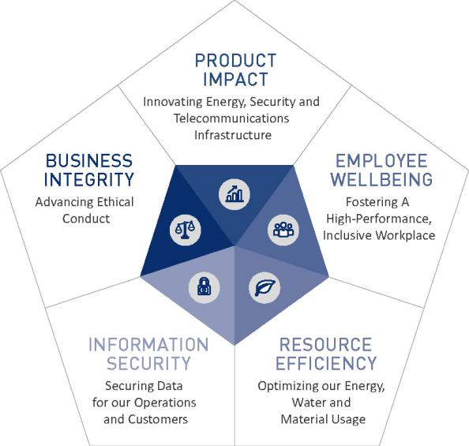

Sustainability Mission


Our sustainability mission is to foster innovation, integrity and security to protect the environment, strengthen communities and propel responsible growth.
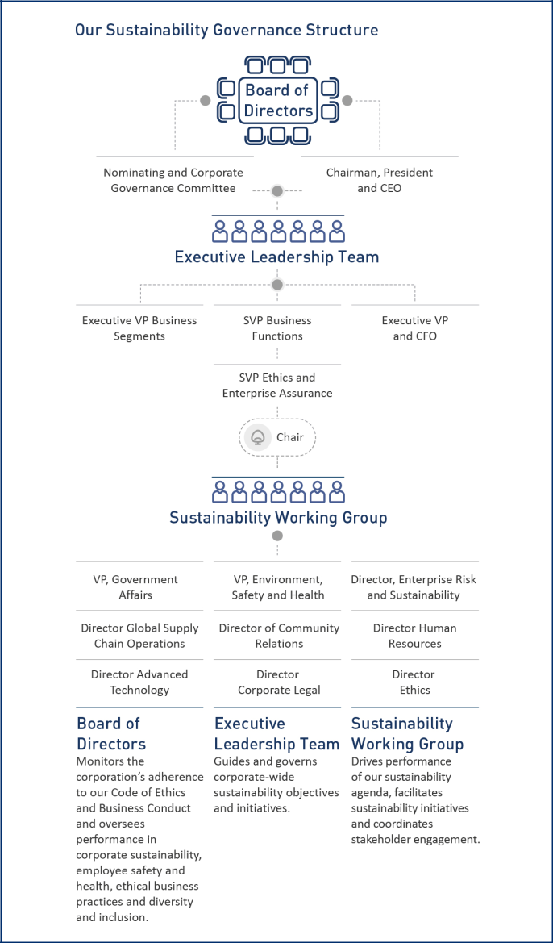

Our independent directors who serve on the Governance Committee review performance against the Sustainability Management Plan (SMP), a set of targets that correspond to objectives associated with our five core issues listed above. The Governance Committee also approves the Corporation’s Code of Conduct (www.lockheedmartin.com/en-us/who-we-are/ethics/code-of-ethics.html) and annual Sustainability Report (www.lockheedmartin.com/en-us/who-we-are/sustainability.html).

Led by our Chairman and CEO, the executive leadership team guides and governs corporate-wide sustainability objectives and initiatives. Our lead sustainability executive is the Senior Vice President, Ethics and Enterprise Assurance, who reports to the Chairman and CEO and the Governance Committee. This role chairs our cross-functional working group chartered by company policy to implement sustainability.

www.lockheedmartin.com 2019 Proxy Statement 27

Enterprise Risk and Sustainability

Sustainability Program Highlights

In 2018, Lockheed Martin published its seventh annual Sustainability Report which discloses our ESG performance results, and is prepared in accordance with the Global Reporting Initiative (GRI) Standards: Core option.

Also in 2018, Lockheed Martin:

- met 78 percent of our SMP targets, which included 17 new goals and 11 continuing goals aimed at improving enterprise performance in each of our core issues: business integrity, product impact, employee wellbeing, resource efficiency and information security;

- was the only U.S. aerospace and defense company to be named to the RobecoSAM Dow Jones Sustainability World Index. DJSI World represents the top 10 percent of companies globally for excellence in sustainability performance;

- placed 13th on CR Magazine's list of the 100 Best Corporate Citizens for sustainability performance, with our rankings improving in the areas of climate change, corporate governance and human rights;

- earned an A rating from MSCI for ESG management and performance; and

- was recognized by the Climate Disclosure Project (CDP) within its Climate A List.


Enterprise Risk and Sustainability Priorities

Our sustainability strategy aligns stakeholder priorities with our Corporation’s ESG impacts. To build integrated assurance, enterprise risk and sustainability are managed jointly in one department and mutually reinforced through the following processes:

- Risk Identification: We monitor a dynamic risk universe that includes ESG topics prevalent in voluntary frameworks, mandatory regulations, and internally identified sources.

- Risk Assessment: We prioritize and evaluate assumptions from a diverse set of risk topics that are relevant to strategic and operational objectives. This includes examining environmental and social factors applicable to risk topics in our business.

- Risk Controls and Mitigation: Through the Risk Audit Strategy Board (a periodic, rigorous examination of intersection between our Enterprise Risk heat map index and our internal audit plan) we mitigate risk related to several ESG factors, and we track, measure and report our performance for greater transparency. This process also informs how we evaluate the effectiveness of controls for risk elements identified through our enterprise risk assessments, corporate policies and internal audits.

These linkages extend to operational elements of our business. Our Employee Wellbeing core issue emphasizes talent recruitment and talent development, two factors essential to identifying critical skills and helping employees reach their full potential. In alignment with our Information Security core issue, we educate and direct suppliers to resources to strengthen their abilities to counter data security and privacy threats, which are integral to our buying decisions. We teach small and disadvantaged businesses how to increase operational efficiency, secure contracts and manage

ethics and sustainability impacts as stressed in our Business Integrity core issue.

Enterprise Risk Management Highlights

A prominent oversight responsibility of the Board concerns management of corporate risk-taking to achieve strategic objectives and monitoring of risk mitigation effectiveness. The Audit Committee reviews the state of enterprise risk governance; assessments of risks that may impact achievement of strategy and business objectives; risk disclosures and reporting; and management evaluations of risk mitigation performance. Other Board committees also supervise management's execution of additional subject-specific risk elements relevant to their responsibilities, such as cybersecurity and ethical business conduct.

Risk Governance

Board Committee | Risk Mitigation Purview
Audit | Financial and compliance risks and risk identification process
Classified Business and Security | Classified programs and security of personnel, facilities and data-related risks including cybersecurity
Nominating and Corporate | Board composition, corporate governance, employee safety and health, ethical conduct, culture, human capital
Governance | and environmental risks
Compensation | Talent, workforce and incentive compensation risks
Strategic Affairs* | Risks related to business strategy and identified enterprise risk
* To be included in the Audit Committee purview following the committee consolidation effective following the Annual Meeting.

28

Enterprise Risk and Sustainability

Our enterprise risk management process involves providing the Board with regular, periodic reports on:

- The categories of risks the Corporation faces, including any significant drivers or inter-relationships to meeting strategic objectives or compliance standards;

- A clear framework for accountability that illustrates mitigating measures and action plans, and how the Chairman and CEO and the executive leadership team are involved in reviewing and executing such activities;

- The ways in which risks are measured on an enterprise basis, the setting of aggregate and subject-specific risk indicators, and related policies and procedures in place to control risks;

- The analysis underpinning prioritizations of key risks and the tools for risk observation to ensure that new or shifting risks are readily identified and addressed by management. This includes understanding risks inherent in the Corporation’s strategic plans, risks arising from the competitive landscape and the potential for technology and other ESG developments to impact profitability and prospects for sustainable, long-term value creation;

- The steps taken by management to ensure adequate independence of the internal audit function and accountability mechanisms designed to encourage risk-informed decision making; and

- The design of the new Ethics and Enterprise Assurance organization (joining energy and environment, safety and health (ESH) corporate functions to Internal Audit, Ethics, and Sustainability) and how it encourages the prompt and coherent flow of risk-related information within and across the Corporation.

Supplier and Community Engagement

Lockheed Martin partners with suppliers, the community and nongovernmental organizations (NGOs) to strengthen our communities and foster responsible growth. Lockheed Martin's efforts and accomplishments in these areas in 2018 include the following:


Earned an "exceptional" rating | >$574 thousand | Announced 200 renewable STEM | Shaped new standard, IPC 1754
from the Defense Contract | directed towards disaster relief and | scholarships of $10,000 per year | for Materials and Substances
Management Agency for small | recovery efforts, including matching | for college students majoring in | Declaration for the Aerospace,
business performance on | $161 thousand in employee | STEM fields | Defense and other industries
Department of Defense Contracts | donations
with a strategic focus on advancing
STEM education and supporting
military and veteran causes

>$716 million | >$4.46 billion | >$233 million | >$268 million
spent with more than 1,311 woman- | spent with over 8,400 small | spent with more than 174 HUB | spent with 230 service-disabled,
owned small businesses | businesses | Zone businesses | veteran-owned small businesses
>20.5 percent | >$595 million | >$11.0 million | >$110.9 million
of supplier partnerships selected | spent with more than 899 veteran- | recorded in employee donations | spent with Alaskan Native and
were small businesses | owned small businesses |  | Tribally Owned Corporations
www.lockheedmartin.com |  |  | 2019 Proxy Statement 29

Audit Matters


Proposal Ratification of

- Appointment of Independent Auditors

  - Independent accounting firm with the breadth of knowledge, support and expertise of its national office.

  - Significant industry and government contracting expertise.

  - Periodic mandated rotation of the audit firm’s lead engagement partner.

The Board unanimously recommends that you vote FOR the ratification of the appointment of Ernst & Young as independent auditors for 2019.

The Audit Committee has appointed Ernst & Young LLP (Ernst & Young), an independent registered public accounting firm, as the independent auditors to perform an integrated audit of the Corporation’s consolidated financial statements and internal control over financial reporting for the year ending December 31, 2019. The services provided to the Corporation by Ernst & Young for the last two fiscal years are described under the caption “Fees Paid to Independent Auditors” on page 31.

The Audit Committee is directly responsible for the appointment, compensation, retention, oversight and termination of the Corporation’s independent auditors in accordance with the NYSE listing standards. The Audit Committee also is responsible for the audit fee negotiations associated with the retention of Ernst & Young. The Audit Committee and its Chairman are involved in the selection of Ernst & Young’s lead engagement partner. The Audit Committee regularly meets with Ernst & Young without management present.

Ernst & Young has served as the Corporation’s independent auditors since 1994. The Audit Committee reviews the engagement of Ernst & Young annually following completion of Ernst & Young’s audit of the prior year’s financial statements. The Audit Committee also conducts a mid-year assessment of the quality of Ernst & Young’s work. As part of its annual and mid-year assessment of Ernst & Young, the Audit Committee has considered:

- the materials on independence provided by Ernst & Young;

- work quality;

- management’s level of satisfaction with its services;

- the adequacy of Ernst & Young’s staffing;

- the breadth of knowledge, support and expertise of its national office;

- the length of time Ernst & Young has been engaged;

- external data regarding Ernst & Young’s audit quality and performance, including recent Public Company Accounting Oversight Board (PCAOB) reports on Ernst & Young and its peer firms;

- Ernst & Young’s institutional knowledge and expertise with respect to the Corporation’s business and government contracting practices, quality and cost-effective services;

- familiarity with the Corporation’s account;

- level of expertise in accounting issues relating to government contracts; and

- Ernst & Young’s performance in providing independent analysis of management positions.

30

Audit Matters

Stockholder approval of the appointment is not required. However, the Board believes that obtaining stockholder ratification of the appointment is a sound corporate governance practice. If the stockholders do not vote on an advisory basis in favor of Ernst & Young, the Audit Committee will reconsider whether to hire the firm and may retain Ernst & Young or hire another firm without resubmitting the matter for stockholders’ approval. The Audit Committee retains the discretion at any time to appoint a different independent auditor.

Representatives of Ernst & Young are expected to be present at the Annual Meeting, and such representatives will be available to respond to appropriate questions and will have the opportunity to make a statement if they desire.

Pre-Approval of Independent Auditors Services

The Audit Committee pre-approves all audit, audit-related, tax and other services performed by the independent auditors. The Audit Committee pre-approves specific categories of services up to pre-established fee thresholds. Unless the type of service has previously been pre-approved, the Audit Committee must approve that specific service before the independent auditors may perform such service. In addition, separate approval is required if the amount of fees for any pre-approved category of service exceeds the fee thresholds established by the Audit Committee. The Audit Committee also has delegated to the Committee Chairman or any member pre-approval authority with respect to permitted services up to $500,000, provided that the Committee Chairman or any committee member must report any pre-approval decisions to the Audit Committee at its next scheduled meeting.

Fees Paid to Independent Auditors

The following table sets forth the fees billed by Ernst & Young, the Corporation’s independent auditors, for audit services, audit-related services, tax services and all other services rendered for 2018 and 2017. All fees were pre-approved in accordance with the Audit Committee’s pre-approval policy. The Audit Committee considered and concluded that the provision of these services by Ernst & Young was compatible with the maintenance of the auditor’s independence.

 | 2017 | 2018
 | ($) | ($)
Audit Fees^{(a)} | 27,265,000 | 23,150,000
Audit-Related Fees^{(b)} | 35,000 | 75,000
Tax Fees^{(c)} | 2,200,000 | 2,000,000
All Other Fees^{(d)} | 10,000 | 15,000
- Audit fees are for services related to the annual audit of the Corporation’s consolidated financial statements, including the audit of internal control over financial reporting, the interim reviews of the Corporation’s quarterly financial statements, statutory audits of the Corporation’s foreign subsidiaries, consultations on accounting matters and registration statements and other documents filed by the Corporation with the SEC. Audit fees for 2018 include fees related to the Corporation's adoption of Accounting Standards Update (ASU) No. 2016-02, Leases, as amended, which the Corporation adopted on January 1, 2019. Audit fees for 2017 also include fees related to the Corporation’s adoption of ASU No. 2014-09, Revenue from Contracts with Customers, as amended, which the Corporation adopted on January 1, 2018.

- Audit-related fees are related to audits of the Corporation’s employee benefit plans.

- Tax fees are for domestic and international tax compliance and advisory services.

- All other fees are primarily for subscriptions to Ernst & Young’s online research tools and training courses for professional qualifications.

www.lockheedmartin.com 2019 Proxy Statement 31

Audit Matters

Audit Committee Report

The Audit Committee of the Board of Directors is responsible for overseeing the Corporation’s accounting, auditing and financial reporting process, financial risk assessment and management process and for monitoring compliance with certain regulatory and compliance matters, on behalf of the Board of Directors.

The Corporation’s management is responsible for preparing the quarterly and annual consolidated financial statements, the financial reporting process, and maintaining and evaluating disclosure controls and procedures and a system of internal control over financial reporting.

In addition to its oversight of the Corporation’s internal audit organization, the Audit Committee is directly responsible for the appointment, compensation, retention, oversight and termination of the Corporation’s independent auditors, Ernst & Young, an independent registered public accounting firm. The independent auditors are responsible for performing an independent audit of the Corporation’s annual consolidated financial statements and internal control over financial reporting and expressing an opinion on the material conformity of those consolidated financial statements with U.S. generally accepted accounting principles and on the effectiveness of the Corporation’s internal control over financial reporting.

In connection with the preparation of the Corporation’s consolidated financial statements as of and for the year ended December 31, 2018, the Audit Committee reviewed and discussed with management and Ernst & Young the Corporation’s audited consolidated financial statements, including discussions regarding critical accounting policies, financial accounting and reporting principles and practices, the quality of such principles and practices, the reasonableness of significant judgments and estimates, and the effectiveness of internal control over financial reporting. The Audit Committee also discussed with Ernst & Young, with and without management, the quality of the financial statements, clarity of the related disclosures, effectiveness of internal control over financial reporting and other items required under Public Company Accounting Oversight Board (PCAOB) Auditing Standard No. 1301, Communications with Audit Committees. Additionally, the Audit Committee received and reviewed the written disclosures and letter from Ernst & Young regarding its independence from the Corporation required by PCAOB Ethics and Independence Rule 3526, Communications with Audit Committees Concerning Independence. The Audit Committee has also discussed with Ernst & Young any matters affecting its independence from the Corporation.

Based on the Audit Committee’s reviews and discussions described in this report, the Audit Committee recommended to the Board of Directors that the audited consolidated financial statements as of and for the year ended December 31, 2018 be included in Lockheed Martin Corporation’s Annual Report on Form 10-K for 2018 for filing with the SEC. The Audit Committee also reappointed Ernst & Young to serve as the Corporation’s independent auditors for 2019, and requested that this appointment be submitted to the Corporation’s stockholders for ratification at the Annual Meeting. The Board of Directors approved the Audit Committee’s recommendations.

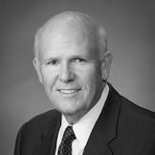



Thomas J. Falk Daniel F. Akerson David B. Burritt Ilene S. Gordon

Chairman

32

Executive Compensation


Proposal

3

Advisory Vote to Approve the Compensation of Our NEOs (Say-on-Pay)

- Independent oversight by Management Development and Compensation Committee with the assistance of an independent consultant.

- Executive compensation targets are set by reference to 50th percentile of peers with actual payouts dependent on performance.

- More than 93% of votes cast at the 2018 annual meeting approved Say-on-Pay.

The Board unanimously recommends that you vote FOR the advisory vote to approve the compensation of our named executive officers.

We ask our stockholders to vote annually to approve, on an advisory (non-binding) basis, the compensation of our named executive officers (NEOs) as described in detail in the Compensation Discussion and Analysis (CD&A) and the accompanying tables in the Executive Compensation section of this Proxy Statement beginning on page 34. This vote is commonly known as Say-on-Pay.

Stockholders should review the entire Proxy Statement and, in particular, the CD&A for information on our executive compensation programs and other important items.

We believe that the information provided in this Proxy Statement demonstrates that our executive compensation programs are designed to link pay to performance. Accordingly, the Board recommends that stockholders approve the compensation of our NEOs by approving the following Say-on-Pay resolution:

RESOLVED, that the stockholders of Lockheed Martin Corporation approve, on an advisory basis, the compensation of the named executive officers identified in the “Summary Compensation Table,” as disclosed in the Lockheed Martin Corporation 2019 Proxy Statement pursuant to Item 402 of Regulation S-K, including the Compensation Discussion and Analysis, the compensation tables and the accompanying footnotes and narratives. This vote is not intended to address any specific item of compensation, but rather our overall compensation policies and procedures related to the NEOs. Although the results of the Say-on-Pay vote do not bind the Corporation, the Board will, as it does each year, continue to review the results carefully and plans to continue to seek the views of our stockholders throughout the year.

Compensation Committee Report

The Management Development and Compensation Committee makes recommendations to the Board of Directors concerning the compensation of the Corporation’s NEOs. We have reviewed and discussed with management the Compensation Discussion and Analysis that will be included in the Corporation’s Schedule 14A Proxy Statement, filed pursuant to Section 14(a) of the Securities Exchange Act of 1934, as amended. Based on that review and discussion, we recommended to the Board of Directors that the Compensation Discussion and Analysis be included in the Proxy Statement. The Board approved our recommendation.



Daniel F. Akerson Nolan D. Archibald Thomas J. Falk Ilene S. Gordon Vicki A. Hollub

Chairman

www.lockheedmartin.com 2019 Proxy Statement 33

Executive Compensation

Compensation Discussion and Analysis (CD&A)

This CD&A discusses the compensation decisions for the NEOs listed in the Summary Compensation Table on page 52. Mr. Orlando P. Carvalho retired as Executive Vice President, Aeronautics, effective October 1, 2018. Effective January 8, 2018, Mr. Frank A. St. John was appointed Executive Vice President, Missiles and Fire Control and Mr. Richard H. Edwards became Executive Vice President, Lockheed Martin International and is no longer considered an executive officer of the Corporation given his change in responsibilities. Although neither Mr. Edwards nor Mr. Carvalho served as executive officers of the Corporation at the end of 2018, they are included among our 2018 NEOs, as shown below, as they were among our top five most highly compensated employees who served as an executive officer during some portion of 2018:

 |  | Years in Position | Years of Service
NEO | Title | At End of 2018 | At End of 2018
NEO | Title | (rounded) | (rounded)
Marillyn A. Hewson | Chairman of the Board, | 6 years | 36 years
 | President and Chief Executive Officer
Bruce L. Tanner | Executive Vice President and | 11 years | 37 years
 | Chief Financial Officer
Richard F. Ambrose | Executive Vice President, Space | 6 years | 18 years
Dale P. Bennett | Executive Vice President, Rotary and Mission Systems | 6 years | 38 years
Frank A. St. John | Executive Vice President, Missiles and Fire Control | 1 year | 32 years
Orlando P. Carvalho | Retired Executive Vice President, Aeronautics | 6 years | 39 years
Richard H. Edwards | Executive Vice President, Lockheed Martin International | 1 year | 35 years

To assist stockholders in finding important information, | Page
To assist stockholders in finding important information, | 35 | Executive Summary
this CD&A is organized as follows: | 35
 | 37 | Summary of Compensation Approach
 | 40 | 2018 | Named Executive Officers’ Compensation
 | 47 | 2019 | Compensation Decisions
 | 48 | Other Compensation Matters

2018 Say-on-Pay Votes

At our 2018 annual meeting, more than 93% of the votes cast by our stockholders approved our Say-on-Pay proposal. We meet with our key investors throughout the year to understand the topics that matter most to them as they relate to executive compensation. We consider the input of our stockholders, along with emerging best practices, to ensure alignment with our executive pay programs. Most investors with whom we engaged in 2018 reacted positively to our pay governance and executive compensation programs.

We welcome feedback regarding our executive compensation programs and will continue to engage with our stockholders in 2019.

34

Executive Summary

Our 2018 Performance

Record |  | Record Segment |  | Record
Sales of |  | Operating Profit of |  | Backlog level of
$53.8B |  | $5,877M |  | $130.5B

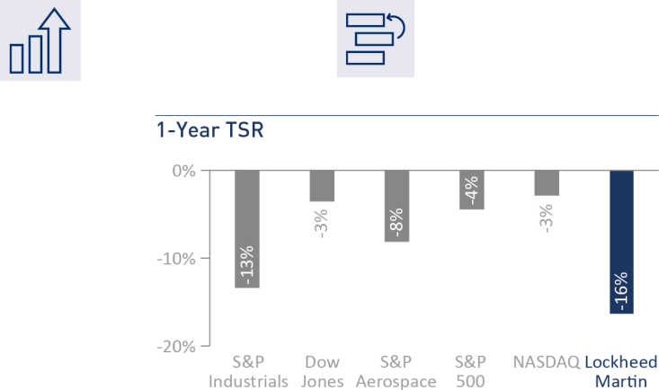

In 2018, the Corporation achieved records for sales, segment operating profit, orders, and backlog. Lockheed Martin’s net sales in 2018 were $53.8 billion versus $50.0 billion in 2017, an increase of eight percent and a record-setting amount for the Corporation. We also continued the expansion of our international business during 2018, which represented 28% of our sales for the year.

We generated cash from operations of $3.1 billion in 2018 after $5.0 billion of pension contributions. In addition, we ended 2018 with record orders of $79 billion, driving a record backlog of approximately $130.5 billion. Our net earnings in 2018 were approximately $5.0 billion, or $17.59 per share, which was also a record. Our business segment operating profit* for 2018 was $5.9 billion, up 15 percent versus 2017.

During 2018, we delivered 91 F-35s, meeting our target for the year, which was nearly a 40 percent increase over 2017. The F-35 program also celebrated several international milestones, as Australia, Japan, and the United Kingdom each marked the home basing of their first F-35s. In November, the U.S. Government awarded an aggregate $22.7 billion Undefinitized Contract Action Block Buy for the production of over 250 F-35 aircraft in order to provide greater production efficiency, stability and cost savings. Our F-35 aircraft backlog has grown to nearly 400 production aircraft, including orders from our international partners.
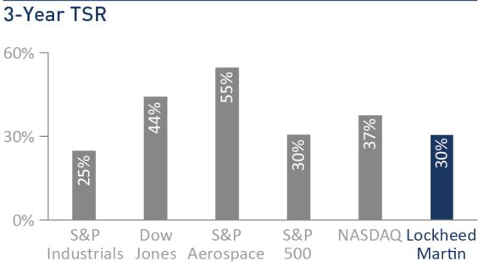

The Corporation also had strategic and operational accomplishments across our other business segments in 2018. The world watched with excitement as NASA’s InSight lander successfully touched down on the surface of Mars. We won a $1.8 billion contract to upgrade the missile-defense capabilities of U.S. and allied military forces. We also delivered the first 10 Long Range Anti-Ship Missiles to our U.S. Air Force customer, achieving Early Operational Capability status ahead of schedule. The U.S. Missile Defense Agency awarded us a contract to design, develop and deliver a new ballistic missile defense radar to be located in Hawaii.
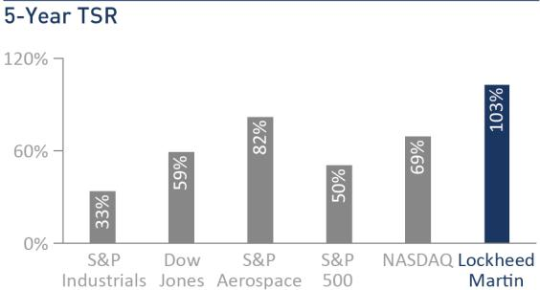

In addition to these financial, strategic, and operational accomplishments, we

continued our efforts to return cash to stockholders through dividends and
share repurchases. During 2018, we returned $3.8 billion of cash from
operations to our stockholders, with $1.5 billion in share repurchases and
$2.3 billion paid in cash dividends. Despite macro-economic and geo-political
events of late 2018 adversely impacting our stock price for the fiscal year
under review, the Corporation achieved another record-setting year as

manifested in its financial and operational accomplishments.

- See Appendix A for an explanation of Non-GAAP terms.

www.lockheedmartin.com

Executive Compensation

Record Earnings per Share of


$17.59

2019 Proxy Statement | 35

Executive Compensation

Compensation Overview

Our executive compensation programs covering our NEOs are designed to attract and retain critical executive talent, to motivate behaviors that align with stockholders’ interests and to pay for performance. The majority of our NEOs’ pay is variable and contingent on performance with approximately two-thirds, on average, in the form of long-term incentives (LTI). To ensure pay is competitive with market practices, we conduct a benchmarking analysis each year when establishing base salary, annual incentive target opportunities and LTI target opportunities. Each element of compensation is evaluated against the 50th percentile, which we refer to as “market rate,” of our comparator group of companies, as shown on page 39. Although target incentive opportunities are set by reference to the market rate, incentive plan terms provide for actual payouts to be based upon actual performance that can result in payouts above or below targeted levels. Based on actual results relative to our pre-established goals under our incentive programs, the 2018 annual incentive program paid out at 184% of target and the 2016-2018 LTIP paid out at 136.1% of target for all NEOs.

2018 CEO Compensation

2018 CEO Target Pay Mix. We believe that, to the maximum extent possible, the compensation opportunities of our CEO should be variable, and the variable elements of the compensation package should tie to the Corporation’s long-term success and the achievement of sustainable long-term total returns to our stockholders. As shown in the chart to the right, a significant portion of our CEO’s target compensation is variable and in the form of LTI with more than half of total target pay in the form of equity-based incentives.

Base Salary. In 2018, Ms. Hewson’s base salary was set at $1,745,000.

2018 Annual Incentive. Ms. Hewson’s target annual incentive amount for

2018 was 175% of salary or $3,053,750.

2018-2020 Long-Term Incentives. In 2018, Ms. Hewson was granted an LTI award of approximately $12.2 million, which was allocated 50% in Performance Stock Units (PSUs), 30% in Restricted Stock Units (RSUs), and 20% in the cash-based Long-Term Incentive Performance award (LTIP). RSUs will cliff-vest after three years, while the vesting of PSUs and LTIP will be based upon our results relative to the three-year performance goals that were established in the beginning of 2018.

Benefit and Retirement Plans. Ms. Hewson is eligible for benefit and retirement programs, similar to other employees. None of our NEOs received additional years of service credits or other forms of formula enhancements under our benefit or retirement plans. Our pension formula is based on years of service and pension eligible compensation, which is similar to the formula offered by other companies with defined benefit plans. Effective January 1, 2016, the compensation element of the pension calculation was frozen and, on January 1, 2020, the service element of the pension calculation will be frozen.

CEO Target Opportunity Mix *

- Fixed vs. variable and cash vs. equity components are designated in the Core Compensation Elements table on page 40. We consider base salary and annual incentives as short-term pay and PSUs, LTIP, and RSUs as long-term pay. Cash represents base salary, annual incentive target and LTIP target. We do not include retirement or other compensation components in the chart.

36

Executive Compensation

Summary of Compensation Approach

Guiding Pay Principles

- Attract, motivate and retain executive talent

- Market-based 50th percentile approach to target all compensation elements

- Link executive pay to Enterprise performance

- Provide an appropriate mix of short-term vs. long-term pay and fixed vs. variable pay

- Align to stockholder interests and long-term company value

Our Decision-Making Process

The Compensation Committee seeks input from our CEO and other members of our management team as well as input and advice from the independent compensation consultant to ensure the Corporation’s compensation philosophy and information relevant to individual compensation decisions are taken into account.

Independent Pay Governance





Independent

Board Members

Review and approve compensation of the CEO and review and ratify compensation of other NEOs. Review with management, at least annually, the succession plan for the CEO and other senior positions.

Independent

Compensation Consultant

Provides advice on executive pay programs, pay levels and best practices. Provides design advice for annual LTI vehicles and other compensation programs.

Independent

Compensation Committee

Reviews and approves incentive goals relevant to NEO compensation. Reviews and approves the compensation for each NEO. Recommends CEO compensation to the independent members of the Board.

Stockholders &

Other Key Stakeholders

Provide feedback on various executive pay practices and governance during periodic meetings with management which then is reviewed by and discussed with our independent Board members.

 | Chairman, |  | Management | Independent | Compensation | Independent
Role | Chairman, | Management | Compensation | Compensation | Compensation | Board
Role | President & CEO | Management | Consultant(1) | Consultant(2) | Committee(3) | Members
Peer Group / External Market Data and Best Practices for | Reviews | Reviews | Develops | Develops/ | Reviews | —
Compensation Design and Decisions |  |  |  | Reviews
Annual NEO Target Compensation | Recommends | — | — | Reviews | Approves | Ratify
Annual CEO Target Compensation | — | — | — | Advises | Recommends | Approve
Annual and Long-Term Incentive Measures, Performance | Reviews | Develops | — | Reviews | Approves | Ratify
Targets and Performance Results
Long-Term Incentive Grants, Dilution, Burn Rate | Reviews | Develops | — | Reviews | Approves | Ratify
Risk Assessment of Incentive Plans | Reviews | Reviews | — | Develops | Reviews | —
Succession Plans | Reviews | Develops | — | — | — | Review
- Aon Hewitt & Willis Towers Watson.

- Meridian Compensation Partners, LLC (Meridian).

- Daniel F. Akerson (Chairman), Nolan D. Archibald, Thomas J. Falk, Ilene S. Gordon and Vicki A. Hollub.

www.lockheedmartin.com 2019 Proxy Statement 37

Executive Compensation

How We Determine Market Rate Compensation

As a starting point, for each of the principal elements of executive compensation we define the “market rate” as the size-adjusted 50th percentile of our comparator group of companies. Size-adjusted market rates are calculated for us by Aon Hewitt using regression analysis. This statistical technique accounts for revenue size differences within the peer group and results in a market rate for all compensation elements consistent with our revenue relationship to our peers. We also may adjust the market rate to reflect differences in an executive’s job scope relative to the industry or the comparator group of companies, as appropriate.

The Compensation Committee considers the current market data in combination with other internal factors when setting annual target pay levels, such as changes to market data year-over-year, internal pay equity, individual performance, job scope and criticality to the Corporation. Our incentive plans are designed so that actual performance in excess of established performance targets results in payouts above target and actual performance below established performance targets results in payouts below target or no payout.

How We Select the Comparator Group for Market Rate Purposes

We regularly review our comparator group to maintain relevancy and to ensure the availability of data, while seeking to avoid significant annual changes in the group to ensure a level of consistency.

To establish the market rate for each of the principal elements of compensation, we select a group of publicly-traded companies (our comparator group) to identify market rates. Because the number of comparable companies with our revenue level is not extensive, we include companies in our comparator group based on a number of factors, including:

- similarity in size (a high correlative factor in determining pay), generally based on annual revenues;

- participation in the Aon Hewitt executive compensation survey (our primary source for data in making market comparisons), which enables us to obtain reliable data for market comparisons that otherwise may not be publicly available;

- industrial companies and, to the extent possible, companies that compete in the aerospace and defense industry, which enables comparison with companies that face similar overall labor costs, economic factors and market fluctuations;

- companies that are included in the executive talent pool we consider when recruiting outside talent, as competitive conditions and a limited number of comparably-sized aerospace and defense companies require us to recruit outside the core aerospace and defense companies for a broad range of disciplines (e.g., finance, human resources, legal, supply chain management) to obtain individuals with a broad range of skills that are transferable across industries; and

- companies with comparable executive officer positions or management structures, which enables more appropriate compensation comparisons.

We do not consider market capitalization in selecting our comparator group because market capitalization can change quickly as industries and companies go in and out of favor as investments and companies restructure.

The data presented to and considered by the Compensation Committee regarding the level of compensation at the Corporation’s comparator group of peer companies was developed from the proprietary results of the Aon Hewitt executive compensation survey, subject to review by Meridian. All of the 2018 comparator group companies participated in the Aon Hewitt survey.

As disclosed in last year's Proxy Statement, the Compensation Committee reviewed our comparator group during 2017, considering certain business combinations that occurred within our peer group, and approved a revised comparator group for 2018, which eliminated Johnson Controls International plc due to its business combination with Tyco International and International Paper Company because it is no longer similar in size to us in terms of its annual revenues. General Electric Company and International Business Machines Corporation were added as new comparator companies given their similarity to the Corporation in terms of size, industry and geographic presence. In addition, these newly added companies compete with us for key talent with comparable executive officer positions in terms of breadth, complexity and scope of responsibilities.

38

Executive Compensation

As such, we used the following companies as our comparator group for purposes of establishing market rate compensation for each of the principal elements of our compensation programs for 2018. Our 2018 revenues represented the 44th percentile of the comparator group.

2018 Comparator Group Companies

3M Company | FedEx Corporation | Northrop Grumman Corporation*
The Boeing Company* | General Dynamics Corporation* | Raytheon Company*
Caterpillar Inc. | General Electric Company | United Parcel Service, Inc.
Cisco Systems, Inc. | Honeywell International Inc.* | United Technologies Corporation*
Deere & Company | International Business Machines Corporation
DowDuPont Inc. | Intel Corporation
* Aerospace & Defense Industry

Consideration of Internal Pay Equity

Consistent with past practice, the Compensation Committee reviewed the pay relationship of the CEO to the other NEOs as part of its annual compensation review in 2018. This material was presented to the Compensation Committee by Meridian in its capacity as the Committee’s independent compensation consultant.

Compensation and Risk

The Corporation’s executive and broad-based compensation programs are intended to promote decision-making that supports a pay for performance philosophy while mitigating risk by utilizing the following design features:

• Mix of fixed and variable pay opportunities | • Moderate severance program and post-employment restrictive
• Multiple performance measures, multiple time periods and capped |  | covenants
payouts under incentive plans | • Institutional focus on ethical behavior
• Stock ownership requirements | • | Annual risk review
• Oversight by independent Board committees | • Compensation Committee oversight of equity burn rate and dilution
• Set incentive goals at the Enterprise or business segment level | • | Clawback policy

At the Compensation Committee’s request, Meridian reviewed all executive and broad-based incentive compensation programs in 2018 and concluded that risks arising from our incentive compensation programs are not reasonably likely to have a material adverse effect on the Corporation.

www.lockheedmartin.com 2019 Proxy Statement 39

Executive Compensation

2018 Named Executive Officers’ Compensation

2018 Target Compensation

Our NEOs’ target compensation for 2018 is shown below, which is closely aligned to the market rate. When determining pay for our NEOs, the Compensation Committee considers the current market data in combination with other internal factors when setting annual target pay levels, such as changes to market data year-over-year, internal pay equity, individual performance, job scope and criticality to the Corporation.

 |  | Annual Incentive
 | Base | Target | Target | 2018 | Total Target Direct
NEO | Salary | Target | Amount | LTI Grant | Compensation
NEO | ($) | % | ($) | ($) | ($)
Ms. Hewson | 1,745,000 | 175 | 3,053,750 | 12,235,097 | 17,033,847
Mr. Tanner | 1,030,000 | 115 | 1,184,500 | 4,500,260 | 6,714,760
Mr. Ambrose | 880,000 | 100 | 880,000 | 3,600,137 | 5,360,137
Mr. Bennett | 880,000 | 100 | 880,000 | 3,600,137 | 5,360,137
Mr. St. John | 880,000 | 100 | 880,000 | 3,600,137 | 5,360,137
Mr. Carvalho | 880,000 | 100 | 880,000 | 3,600,137 | 5,360,137
Mr. Edwards | 880,000 | 100 | 880,000 | 3,600,137 | 5,360,137

2018 Core Compensation Elements

Our compensation programs are designed to provide a mix of short- and long-term compensation, fixed and variable pay and cash and equity-based compensation, as well as to reflect our philosophy of providing pay for performance. Retirement programs or “all other compensation” are not included in our core compensation elements below (additional information about these programs can be found on page 50).

 | Fixed |  |  |  | Variable
 | Base Salary | + | Annual Incentive | + |  | Long-Term Incentives
 |  |  |  |  | 50% PSUs | 20% LTIP | 30% RSUs
WHAT? | Cash |  | Cash |  | Equity | Cash | Equity
WHEN? | Annual |  | Annual |  | 3-year | 3-year | 3-year
 |  |  |  |  | Performance Cycle | Performance Cycle | Cliff Vesting
HOW? | Market rate, as well as |  | 70% Financial |  | Relative TSR* | (50%) | Value delivered through
Measures, | internal pay equity, |  | 20% Sales, 40% Segment |  | ROIC** | (25%) | long-term stock price
Measures, | internal pay equity, |  | Operating Profit**, 40% Cash from |  | ROIC** | (25%) | long-term stock price
Weightings & | experience and critical |  | Operating Profit**, 40% Cash from |  | Performance Cash** (25%) |  | performance
Weightings & | experience and critical |  | Operations |  |  |  | performance
Payouts | skills |  | Operations
Payouts | skills |  | 30% Strategic & Operational Key |  | • Award 0-200% of target # | • Payout: 0-200% of target
 |  |  | Metrics: Focus Programs, Mission |  | of shares | • Relative TSR measure
 |  |  | Success®, Program Performance, |  | • Relative TSR measure | capped at 100% if TSR is
 |  |  | Portfolio Shaping Initiatives, |  | capped at 100% if TSR is | negative
 |  |  | Innovation, Talent Management |  | negative
Payout: 0-200% of target | • Value capped at 400% of
Payout: 0-200% of target | stock price on date of grant
 | times shares earned

WHY? | Provides competitive | Attracts and motivates
 | levels of fixed pay to | executives by linking annual
 | attract and retain | company performance to an
 | executives. | annual cash incentive.

Creates strong alignment with stockholder interests by linking long-term pay to key performance metrics and stock price. Provides a balance of internal and market based measures to assess long-term performance.

Promotes retention of key talent and aligns executive and stockholder interests.

* 2018-2020 Relative TSR performance is measured against our industry peers in the S&P 500 Aerospace & Defense Index (S&P Aerospace).

- Refer to Appendix A for an explanation of Non-GAAP terms as well as our disclosure regarding forward-looking statements concerning future performance or goals for future performance.

40

Executive Compensation

Base Salary

Base salaries are reviewed annually and may be increased to align more appropriately with the market rate (50th percentile), taking into account the executive’s individual performance and internal pay equity. In establishing the base salary for each NEO, we determined the market rate using comparator group company data and evaluated whether the market rate should be adjusted up or down based on differences in the scope of the NEO’s position as compared to the industry and the comparator group companies.

2018 Annual Incentive

As was the case for 2017, the 2018 annual incentive plan for our CEO, other NEOs and all other officers elected by the Board, was based 70% on financial goals and 30% on strategic and operational goals measured at the Enterprise level, as illustrated in the graphic below. Although the annual incentive plan uses a formulaic approach, the Compensation Committee retains discretion, which includes choosing and approving goals, assessing strategic and operational results and modifying payouts based on business segment and individual performance for any officer elected by the Board, including the NEOs.
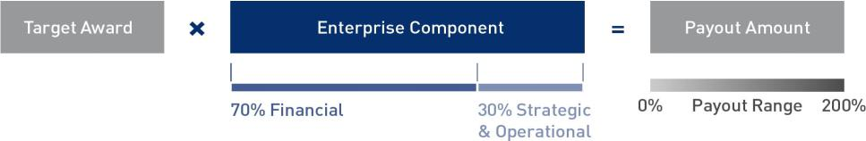

Under the terms of our annual incentive plan, the CEO’s bonus cannot exceed 0.3% of Performance Cash (see Appendix A for Non-GAAP definition) and the bonus for each of the other NEOs cannot exceed 0.2% of Performance Cash. Annual incentive payouts range from 0% to 200% of target.

2018 Annual Incentive Goals and Results

At its February 2018 meeting, the Compensation Committee approved Enterprise-wide objectives for 2018 reflecting financial and strategic and operational goals. These goals are used as the Enterprise Component for all executives in the Corporation and serve as the only goals for the CEO, other NEOs and all other officers elected by the Board.

Financial Assessment (70% Weight). The financial targets under the annual incentive plan align with the guidance we disclosed publicly at the beginning of 2018. We believe this approach to setting the financial metrics for annual incentive purposes appropriately links compensation to our effectiveness in meeting our public commitments to our stockholders.

Our financial commitments are established at the completion of our annual long-range planning process and are consistent with our long-range plan commitments. The long-range planning process includes reviews of the assumptions used by the business segments in generating their financial projections, such as industry trends and competitive assessments, current and future projected program performance levels and the risks and opportunities surrounding these baseline assumptions. The long-range plan on which our financial goals are based is tied to the business environment in which we operate and can vary year-over-year.

Our long-range plan values for sales, segment operating profit (see Appendix A for definition of Non-GAAP terms) and Cash from Operations are set forth in the 2018 guidance we provided publicly to investors in January 2018 and represent the target level (100% performance) for each of these metrics. We established maximum (200% performance) and threshold payout levels (50% performance) around these targets based on a review of historical performance against long-range plan commitments for each of the three annual incentive goal metrics, which ensures the appropriate level of rigor on each of the threshold, target and maximum goals. Notably, our Cash from Operations goal for 2018 was lower than our 2017 goal because the Corporation accelerated future pension contributions of $3.4 billion to 2018 in order to preserve the benefit of the associated tax deduction at the higher statutory rate in 2017. We used straight-line interpolation between target and both maximum and minimum historical performance levels. In all cases, payouts deteriorate more rapidly as we move from target level to the minimum payout level compared to the level of increase as we move from target level to maximum payout level. This asymmetry reflects the importance we place on meeting our financial goals. The Compensation Committee reviewed the methodology and the targets established as part of its annual process during 2018.

www.lockheedmartin.com 2019 Proxy Statement 41

Executive Compensation

 |  | 2018 Goals | Reported | Calculated | Weighted
2018 Financial Measures | Weight | 2018 Goals | Results | Calculated | Weighted
2018 Financial Measures | Weight | ($) | ($) | Payout | Payout
Sales | 20% | 50,000 – 51,500M | 53,762M | 200% | 40%
Segment Operating Profit* | 40% | 5,200– 5,350M | 5,877M | 200% | 80%
Cash from Operations | 40% | ≥ 3,000M | 3,138M | 146% | 58%
Financial Payout Factor |  |  |  |  | 178%

* See Appendix A for definition of Non-GAAP terms.

Strategic & Operational Assessment (30% Weight). Our strategic and operational performance assessments are inherently different than financial performance assessments. For the 2018 performance year, a broad set of goals were established for our strategic and operational commitments at the beginning of the year. The strategic and operational performance goals are not measured against quantitative performance criteria for each goal, because some are aspirational, cannot be forecasted reliably or are qualitative in nature. When determining the overall payout factor, the Compensation Committee considers both quantitative and qualitative results and applies discretion when evaluating performance in totality. The strategic and operational performance goals and results are set forth below.

2018 Strategic & Operational Goals Summary Assessment Summary Highlights

Focus Programs: Secure key Focus Program wins and achieve Keep Sold Program milestones


- 76% win rate on programs throughout the year

- Record orders of $79 billion with record backlog at year-end of approximately $130.5 billion

  - More than 25 franchise wins and extensions >$ 500M Total Program Value

Mission Success: Achieve Mission | • Continued operational excellence with 100% Mission Success in targeted events
Success milestones | • Key program milestones achieved throughout the Corporation, including on F-35
Program Performance: Execute programs to achieve customer | • Exceeded affordability goals and optimized subcontractor performance objectives
commitments and increase stockholder value | • Returned $3.8 billion of Cash from Operations to our stockholders through dividends and
 | share repurchases


Portfolio Shaping / Enterprise Initiatives:

Assess portfolio on an ongoing basis to maximize stockholder value, which includes M&A activity, streamlining operations and other enterprise initiatives


- Key strategic partnerships launched to drive business growth

- Positioned business to invest in and implement digital transformation

Innovation: Execute technology strategy, | • | Achieved leading positions in hypersonics, directed energy, and other critical capabilities
ensuring robust innovation, collaboration | • | Large strategic investments with prioritized focus on transformational technologies
and strategic partnering | •

Talent Management: Attract, develop and retain the workforce needed to deliver commitments to customers and stockholders

- Exceeded retention rate target for top performers

- Enhanced development and succession placements for key executive positions

- Successfully executed diversity and inclusion initiatives

- Achieved staffing targets in key growth areas

Strategic & Operational Payout Factor | 195%

The Compensation Committee reviewed these accomplishments and recommended this factor to recognize the Corporation’s strong operational performance in a highly competitive environment while undertaking major strategic initiatives.

42

Executive Compensation

Summary of Annual Incentive Payout Calculations

For 2018, Ms. Hewson's annual incentive target percentage did not change and remained at 175% of her base salary. The Compensation Committee approved changes to annual incentive target percentages for other NEOs, aligning with the 2018 market rates (50th percentile). Mr. Tanner's target was increased from 110% to 115% of his base salary and our business segment EVPs' targets were set to 100% of their base salaries. The final payout factor and payout amounts for each of our NEOs, as determined by the Board, are shown below:

Summary of 2018 Enterprise Performance & Overall Payout Factor

 |  |  |  | Weight |  | 2018 Factors |  |  | Weighted Payout
Financial |  |  |  | 70% |  | 178% |  |  | 125%
Strategic & Operational |  |  |  | 30% |  | 195% |  |  | 59%
Overall Payout Factor |  |  |  |  |  |  |  |  | 184%
 | Base Salary | Target % of Salary | Target Award |  |  | Overall Payout |  |  | Payout
NEO | ($) | (%) | ($) | X |  | Factor |  | = | ($)
Ms. Hewson | 1,745,000 | 175 | 3,053,750 |  |  |  |  |  | 5,618,900
Mr. Tanner | 1,030,000 | 115 | 1,184,500 |  |  |  |  |  | 2,179,500
Mr. Ambrose | 880,000 | 100 | 880,000 |  |  |  |  |  | 1,619,200
Mr. Bennett | 880,000 | 100 | 880,000 |  |  | 184% |  |  | 1,619,200
Mr. St. John | 880,000 | 100 | 880,000 |  |  |  |  |  | 1,619,200
Mr. Carvalho | 880,000 | 100 | 880,000 |  |  |  |  |  | 1,619,200
Mr. Edwards | 880,000 | 100 | 880,000 |  |  |  |  |  | 1,619,200

2018 Long-Term Incentive Compensation

The following summary shows the 2018 LTI compensation mix for the CEO, EVPs and Senior Vice Presidents (SVPs) and other principal terms of the awards.
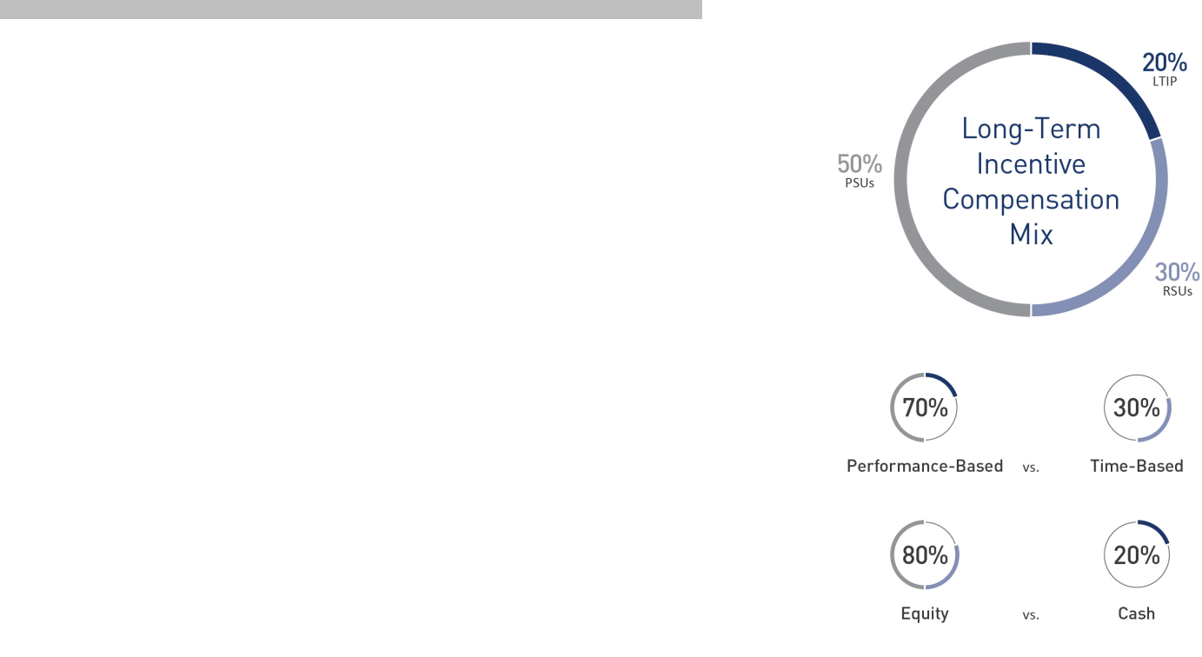

PSUs (distributed in common stock):

Performance Measures: Three-year Relative TSR (50%), ROIC (25%) & Performance Cash (25%)

Caps:

- 200% of target shares
- Relative TSR measure capped at 100% if the Corporation’s TSR is negative
- Value capped at 400% of stock price on date of grant times shares earned

RSUs (distributed in common stock):

Vesting Schedule: RSUs cliff vest 100% three years after the grant date

3-Year LTIP (paid in cash):

Performance Measures: Three-year Relative TSR (50%), ROIC (25%), & Performance Cash (25%)

Caps:

- 200% of target amount
- Relative TSR measure capped at 100% if the Corporation’s TSR is negative
- Individual payout capped at $10 million

www.lockheedmartin.com 2019 Proxy Statement 43

Executive Compensation

In determining the appropriate level of equity grants for 2018, the Compensation Committee took into consideration the long-term incentive market rate (50th percentile) along with a variety of other factors, including the number of awards outstanding and shares remaining available for issuance under the Corporation’s equity incentive plans, the number of shares that would be issued under contemplated awards over the range of potential performance achievement, the total number of the Corporation’s outstanding shares, the resulting implications for stockholder dilution and the number of shares granted to our executives year-over-year.

PSU Awards (50% of the LTI award)

PSU awards are calculated by multiplying the overall target LTI award value by the 50% weighting assigned to the PSU element. The total PSU value is then multiplied by the weighting assigned to each PSU component (50% to Relative TSR, 25% to ROIC, 25% to Performance Cash). For 2018, the number of PSUs granted is based on the grant date fair market value of each PSU element using the Monte Carlo simulation method for the Relative TSR component and the grant date fair market value discounted to reflect the deferral of dividends for ROIC and Performance Cash components.

Each NEO’s PSU target number of shares is determined at the beginning of the three-year performance period, and the actual number of shares earned at the end of the period is calculated based on our performance measured against the three financial metrics.

The number of shares granted at the end of the cycle can range from 0% to 200% of the applicable target number of shares. If TSR is negative at the end of the performance cycle, the rating for the Relative TSR measure is capped at 100%. In addition, the maximum value that can be earned under a PSU award is 400% of the stock price on the date of grant times the shares earned. The award calculation is formulaic pursuant to the provisions defined in the award agreement, and no adjustment can be made to the final number of shares granted, which is determined based on the performance outcomes relative to our pre-set goals. Participants also accrue dividend equivalents on the shares earned, which are paid in cash following vesting of the underlying shares.

RSU Awards (30% of LTI award)

RSU awards are calculated by multiplying the overall target LTI award value by the 30% weighting assigned to the RSU element. The number of RSUs granted is determined by the grant date fair market value discounted to reflect deferral of dividends. Deferred dividend equivalents are accrued during the vesting period and paid in cash following the vesting of the underlying shares.

LTIP Awards (20% of the LTI award)

LTIP awards are cash-based and are calculated by multiplying the overall target LTI award value by the 20% weighting assigned to the LTIP element.

Each NEO’s LTIP target is determined at the beginning of the three-year performance period, and the actual award earned at the end of the period is calculated based on the same performance measures as those used for the PSUs: 50% Relative TSR, 25% ROIC and 25% Performance Cash. Payouts can range from 0% to 200% of the applicable target. If TSR is negative at the end of the performance cycle, the rating for the Relative TSR measure is capped at 100%. The award calculation is formulaic pursuant to the provisions defined in the award agreement, and no adjustment can be made to the final payout factor, which is determined based on the performance outcomes relative to our pre-set goals.

For the 2018-2020 LTIP grants, any amount payable to a single participant in excess of $10 million will be forfeited.

Selection of LTI Performance Measures

The LTI performance metrics approved by the Compensation Committee are measures that we believe most effectively support our long-term business and strategic goals and directly tie the long-term goals of our executive leadership team to the interests of our stockholders. The measurements used for the financial component of our 2018 annual incentive plan (Sales, Segment Operating Profit and Cash from Operations) also serve as the foundation for achieving our long-term goals such that we must consistently achieve or exceed the Corporation’s annual goals in order to achieve our LTI goals.

The selected LTI performance metrics consist of Relative TSR (50% weight), ROIC (25% weight) and Performance Cash (25% weight). We chose these three metrics because we believe they represent the best measures of value creation for the Corporation over a long-term period. We also applied equal weighting to the market-based measure of value creation, TSR, to what we believe are the best internal measures of value creation, Performance Cash and ROIC.

We selected Relative TSR to measure our performance against our industry peers in the S&P Aerospace Index. Because every industry faces different challenges and opportunities, we believe that comparing our TSR against peers facing a similar business environment is preferred to comparisons outside our industry. Commensurate with this philosophy, we expanded this comparator group in 2019 as further described on page 48.

44

Executive Compensation

Because the Relative TSR index is not perfectly aligned with the businesses in which Lockheed Martin operates and because any number of macro-economic factors that could affect market performance are beyond the control of the Corporation, we use ROIC and Performance Cash as internal measures that can be directly affected by management’s decisions. ROIC measures how effectively we employ our capital over time, while our Performance Cash provides the means for investment or value creation. By including a cash measure in both our annual and long-term incentive plans, the plans also mitigate the risk of short-term cash strategies that do not create long-term value.

In tandem, we believe that these metrics drive the behaviors of our management team in ways that are intended to create the most value for our stockholders.

Setting Performance Goals for PSUs and LTIP

Our long-range planning process is used to establish the target (100% level of payment) for the Performance Cash and ROIC metrics in the PSU and LTIP grants. In setting minimum and maximum levels of payment, we reviewed historical levels of performance against long-range plan commitments, and conducted sensitivity analyses on alternative outcomes focused on identifying likely minimum and maximum boundary performance levels. Levels between 100% and the minimum and maximum levels were derived using linear interpolation between the performance hurdles. As with our annual incentive performance goals, PSU and LTIP payouts deteriorate more rapidly as we move from target level to the minimum payout level than they increase as we move from target level to maximum payout level. This asymmetry reflects the importance we place on meeting our financial commitments.

The specific Performance Cash and ROIC target values for the 2018-2020 PSU and LTIP plans are not publicly disclosed at the time of grant due to the proprietary nature and competitive sensitivity of the information. However, the method used to calculate the awards will be based on actual performance compared to the Corporation’s 2018-2020 targets, which use straight-line interpolation between points. The individual award agreements require specified adjustments to ensure that the ultimate payouts are not impacted to the benefit or detriment of management by specified events, such as unplanned pension contributions, changes in accounting (GAAP) standards or impact of an acquisition or divestiture valued at more than $1 billion. The Compensation Committee does not have discretion to adjust the results of the PSU and LTIP awards beyond the adjustments specified in the award agreements.

2018-2020 Performance Goals

Relative TSR (50%)* |  |  | Performance Cash (25%) |  |  | ROIC (25%)
Relative TSR | Payout Factor |  | Performance Cash Metric | Payout Factor |  | ROIC Performance Metric | Payout Factor
Percentile | Payout Factor |  | Performance Cash Metric | Payout Factor |  | ROIC Performance Metric | Payout Factor
75th – 100th | 200% |  | Plan + ≥ $2.0B | 200% |  | Plan + ≥ 160 bps | 200%
60th | 150% |  | Plan + $1.5B | 175% |  | Plan + 120 bps | 175%
50th | 100% (Target) |  | Plan + $1.0B | 150% |  | Plan + 80 bps | 150%
40th | 50% |  | Plan + $0.5B | 125% |  | Plan + 40 bps | 125%
35th | 25% |  | Plan | 100% |  | Plan | 100%
< 35th | 0% |  | Plan - $0.2B | 75% |  | Plan - 10 bps | 75%
* 2018-2020 Relative TSR performance is measured |  |  | Plan - $0.5B | 50% |  | Plan - 20 bps | 50%
against our industry peers in the S&P Aerospace |  |  | Plan - $0.5B | 50% |  | Plan - 20 bps | 50%
Index. |  |  | Plan - $0.7B | 25% |  | Plan - 30 bps | 25%
 |  |  | Below Plan - $0.7B | 0% |  | Below Plan - 30 bps | 0%

2016-2018 LTIP and PSU Awards

The cash-based LTIP and share-based PSU payouts for the three-year performance period ended December 31, 2018, were calculated by comparing actual corporate performance for each metric for the period January 1, 2016 through December 31, 2018, against a table of payment levels from 0% to 200% (with the 100% payout level being considered target) established at the beginning of the performance period in January 2016.

 | Measure | Performance | Performance | Weighting | Payout Factor
 | Measure | Target | Result | Weighting | Payout Factor
 | Relative TSR | 50th Percentile | 44th Percentile | 50% | 72.2%
 | Performance Cash* | $14.6B | $17.9B | 25% | 200.0%
 | ROIC* | 15.3% | 17.9% | 25% | 200.0%
 | * See Appendix A for definition of Non-GAAP terms.

www.lockheedmartin.com 2019 Proxy Statement 45

Executive Compensation

2016-2018 LTIP Payouts

Based on a weighted payout factor of 136.1%, the following table shows the payouts under the 2016-2018 LTIP made in January 2019.

2016–2018 LTIP

 | Target | Payout
NEO | ($) | ($)
Ms. Hewson | 2,307,000 | 3,139,827
Mr. Tanner | 803,000 | 1,092,883
Mr. Ambrose | 503,000 | 684,583
Mr. Bennett | 664,000 | 903,704
Mr. St. John | 340,000 | 462,740
Mr. Carvalho | 664,000 | 903,704
Mr. Edwards | 503,000 | 684,583

2016-2018 PSU Awards

The 2016-2018 target PSU award value was allocated to each performance measure based on the pre-defined weightings, namely 50% to Relative TSR, 25% to ROIC, and 25% to Performance Cash. PSU awards earned are calculated by multiplying the payout factor for each performance metric by the target number of units for each performance metric. The actual value realized by the NEOs at vesting also depends on our stock price, which may be higher or lower than the grant date fair market value.

 |  |  | 2016-2018 Target PSUs (#) |  |  | Total Shares
 | NEO | Relative TSR | Performance Cash* | ROIC* |  | Total Shares
 |  |  |  |  |  | Distributed/Earned
 | Ms. Hewson | 13,580 | 6,987 | 6,987 |  | 37,753
 | Mr. Tanner | 4,727 | 2,432 | 2,432 |  | 13,141
 | Mr. Ambrose | 2,962 | 1,523 | 1,523 |  | 8,231
 | Mr. Bennett | 3,909 | 2,011 | 2,011 |  | 10,867
 | Mr. St. John | 201 | 103 | 103 |  | 558
 | Mr. Carvalho | 3,909 | 2,011 | 2,011 |  | 10,587
 | Mr. Edwards | 2,962 | 1,523 | 1,523 |  | 8,231
 | * See Appendix A for definition of Non-GAAP terms.
46

Executive Compensation

2019 Compensation Decisions

The Compensation Committee approved 2019 target compensation for the NEOs based on the market rate, along with other factors such as the executive’s performance, internal equity, job scope and criticality to the Corporation.

2019 Base Salary

 |  | 2019 Base Salary
 | NEO | ($)
 | Ms. Hewson | 1,798,000
 | Mr. Tanner* | 1,030,000
 | Mr. Ambrose | 905,000
 | Mr. Bennett | 905,000
 | Mr. St. John | 905,000
 | Mr. Edwards | 905,000
 | * Mr. Bruce L. Tanner is retiring in 2019 and is no longer serving as Chief Financial Officer effective February 11, 2019.

2019 Annual Incentive Goals

There were no changes to our annual incentive plan design for the 2019 performance year.

The Compensation Committee approved the key corporate commitments set forth below for purposes of assessing performance in 2019. Although the annual incentive plan uses a formulaic approach to determine payout, the Compensation Committee retains discretion to modify the payouts for the CEO, other NEOs and all other officers elected by the Board.

2019 Financial Goals (Weight 70%)

The financial commitments are consistent with our long-range plan commitments, and are the same ranges we provided as public guidance in January 2019 in our year-end earnings release. These commitments for 2019 are set forth below.

 |  | 2019 Goal
2019 Commitments | Weighting | ($)
Sales | 20% | 55,750 - 57,250M
Segment Operating Profit | 40% | 6,000 - 6,150M
Cash from Operations | 40% | ≥ 7,400M

For the purposes of assessing performance under our annual incentive program, results may be adjusted from reported amounts for the incremental benefits or impacts associated with non-recurring items, such as acquisitions or divestitures. Cash from Operations results have been adjusted in prior years for unplanned pension contributions so that the impact on incentive compensation is not a factor in the decision to make the additional pension contribution.

2019 Strategic and Operational Goals (Weight 30%)

- Focus Programs: Shape and secure Key Focus Program wins and achieve Keep Sold Program milestones

- Mission Success: Achieve Mission Success milestones

- Program Performance: Execute programs to achieve customer commitments and increase stockholder value

- Portfolio Shaping / Enterprise Initiatives: Assess the company portfolio on an ongoing basis to maximize stockholder value, including M&A activity, streamlining operations and other Enterprise-wide initiatives

- Innovation: Execute technology and digital transformation strategy, ensuring robust innovation, collaboration and strategic partnering

- Talent Management: Attract, develop and retain the workforce needed to deliver commitments to customers and stockholders

www.lockheedmartin.com 2019 Proxy Statement 47

Executive Compensation

2019 Long-Term Incentive Award Opportunities

For 2019, the LTI award mix is the same as last year and is allocated 50% toward PSUs, 20% toward LTIP and 30% toward RSUs. The number of PSUs and RSUs granted to participants for 2019 will be determined using the closing stock price of Lockheed Martin common stock on the NYSE on the date of grant.

For the 2019-2021 LTIP grants, any amount payable to a single participant in excess of $10 million will be forfeited. The terms and performance measures of the 2019-2021 PSUs and LTIP awards are similar to the 2018-2020 awards (see pages 43-45), with the exception of the enhanced clawback provision (as described in the next section) and the peer comparators to be used to measure the Corporation's Relative TSR performance.

The Compensation Committee approved an expanded performance peer group comprised of 15 industry peers beginning with the 2019-2021 performance cycle, including the S&P Aerospace Index companies and several other large publicly traded U.S. Government Contractors. While the S&P Aerospace Index has been, in our judgment, the best index against which to compare our Relative TSR, it has been impacted by multiple business transactions and exhibited significant volatility in the number of its constituents over the past several years. For example, the number of companies in the S&P Aerospace Index varied between 9 to 12 companies between 2016 and 2018, the impact from which resulted in abrupt performance ranking and payout implications. As such, the Compensation Committee approved an expanded custom peer group starting with the 2019-2021 LTI awards, as shown below.

2019-2021 Relative TSR Comparators

Arconic Inc. | Honeywell International Inc. | Science Applications International Corp.
Booz Allen Hamilton Holding Corporation | Huntington Ingalls Industries, Inc. | Textron Inc.
CACI International Inc | Leidos Holdings, Inc. | The Boeing Company
General Dynamics Corporation | Northrop Grumman Corporation | TransDigm Group Incorporated
Harris Corporation | Raytheon Company | United Technologies Corporation

Other Compensation Matters

Our Use of Independent Compensation Consultants

The independent compensation consultant provides important information about market practices, the types and amounts of compensation offered to executives generally and the role of corporate governance considerations in making compensation decisions. The Compensation Committee’s charter authorizes it to retain outside advisors that it believes are appropriate to assist in evaluating executive compensation.

For 2018, the Compensation Committee continued to retain Meridian as an independent compensation consultant. In connection with its retention of

Meridian, the Compensation Committee considered the following factors in assessing Meridian’s independence:

- Meridian’s services for the Corporation are limited to executive and director compensation.

- The compensation paid to Meridian is less than 1% of Meridian’s revenues.

- Meridian has business ethics and insider trading and stock ownership policies, which are designed to avoid conflicts of interest.

- Meridian employees supporting the engagement do not own Lockheed Martin securities.

- Meridian employees supporting the engagement have no business or personal relationships with members of the Compensation Committee or with any Lockheed Martin executive officer.

At its February 2019 meeting, the Compensation Committee renewed the engagement of Meridian. At that time, Meridian confirmed the continuing accuracy of each of the factors described above.

The nature and scope of Meridian’s engagement was determined by the Compensation Committee and not limited in any way by management. During 2018, Meridian also provided consultative services to the Governance Committee regarding the compensation of the Corporation’s independent directors. A description of the services provided by Meridian can be found on pages 37 and 70.

48

Executive Compensation

Policy Regarding Timing of Equity Grants

We have a corporate policy statement concerning the grant of equity awards. Under that policy:

- The Compensation Committee is responsible for determining the grant date of all equity awards to executive officers.

- No equity award may be backdated. A future date may be used if, among other reasons, the Compensation Committee’s action occurs in proximity to the release of earnings or during a trading blackout period.

- Proposed equity awards are presented to the Compensation Committee in February of each year. Off-cycle awards may be considered in special circumstances, which may include hiring, retention or acquisition transactions.

In addition, our existing incentive performance award plan prohibits repricing of stock options or paying cash for underwater stock options.


Clawback and Other Protective Provisions

The Governance Guidelines include a clawback policy, which prior to the 2019 enhancements described below, provided that if the Board of Directors determines that an officer’s intentional misconduct, gross negligence or failure to report such acts by another person was a contributing factor in requiring us to restate any of our financial statements or constituted fraud, bribery or another illegal act (or contributed to another person’s fraud, bribery or other illegal act) which adversely impacted our financial position or reputation, then the Board shall take such action as it deems in the best interest of the Corporation and necessary to remedy the misconduct and prevent its recurrence. Among other actions, the Board may seek to recover or require reimbursement of any amount awarded to the officer after January 1, 2008, in the form of an annual incentive bonus or LTI award.

In February 2019, the Compensation Committee enhanced the clawback to ensure that it has the most appropriate level of discretionary authority and powers to protect the Corporation and its stockholders' interests, in consideration of recent external events involving high level executives of other companies. Following the Compensation Committee’s proactive analysis of the policy, the Compensation Committee added two situations that will allow the Board to clawback incentive compensation paid to an officer: (1) an officer’s intentional misconduct or gross negligence causes severe reputational or financial harm to the Corporation and (2) an officer’s misappropriation of Lockheed Martin Proprietary Information that causes, or is intended to cause, severe reputational or financial harm to the Corporation. These additional situations will apply to incentive compensation awarded beginning in 2019.

The clawback policy is incorporated into our annual incentive plan and in the award agreements for the long-term incentive awards, covering all variable incentive compensation. There were no events requiring Board consideration of a clawback action during 2018.

In the event the Board recoups incentive compensation under the policy, management intends to disclose the aggregate amount of incentive compensation recovered, so long as the underlying event has already been publicly disclosed in our filings with the SEC. This disclosure would appear in the proxy statement following any such Board action and would provide the aggregate amount of recovery for each event if there is more than one applicable event.

The award agreements for the NEOs also contain post-employment restrictive covenants. The post-employment restrictions were incorporated into all executive level award agreements beginning in 2011, and compensation awarded under those agreements may be subject to clawback in the event an executive breaches any of the post-employment restrictive covenants.

Anti-Hedging and Pledging Policy

Our policies prohibit hedging and pledging of Lockheed Martin stock by all directors, officers and employees. Under our policies, Lockheed Martin directors, officers and employees may not purchase or sell derivative securities based on Lockheed Martin common stock or other Lockheed Martin securities. This policy also prohibits hedging or monetization transactions such as forward-sale contracts, equity swaps, collars and exchange funds, that are designed to hedge or offset any decrease in the market value of equity securities, lock in then-current market gains without the sale of the underlying security, or transactions in which the director or employee may divest aspects of the risks and rewards of ownership. This policy applies to shares of Lockheed Martin common stock (1) that are granted to the employee or director by Lockheed Martin as part of their compensation and (2) held, directly, or indirectly, by the employee or director.

www.lockheedmartin.com 2019 Proxy Statement 49

Executive Compensation

Stock Ownership Requirements for Key Employees

To better align their interests with the long-term interests of our stockholders, we expect our officers (including the NEOs) and other members of management to maintain an ownership interest in the Corporation based on the following guidelines:

Title | Annual Base
Title | Salary Multiple
Chairman, President and CEO | 6 times
Chief Financial Officer | 4 times
Executive Vice Presidents | 3 times
Senior Vice Presidents | 2 times

NEOs are required to achieve ownership levels within five years of assuming their role and must hold net shares from vested RSUs and PSUs and net shares from options exercised until the value of the shares equals the specified multiple of base salary. The securities counted toward their respective target threshold include common stock, unvested RSUs, and stock units under our 401(k) plans and other deferral plans. Unvested PSUs at target are not counted towards ownership levels. Each of our NEOs has met or exceeded their respective ownership requirements.

Benefit, Retirement and Perquisite Programs

We offer other compensatory arrangements to our NEOs. The purpose for these benefits is to ensure security of executives, provide assistance with business-related expenses, and be competitive with the other companies in our industry. Below is a summary of programs available to our NEOs. Further details are described in footnotes to the Summary Compensation Table on page 52.

Health, Welfare and Retirement Benefits. Our NEOs are eligible for savings, pension, medical, disability, and life insurance benefits under the plans available to salaried, non-union employees. We offer supplemental pension and savings plans to make up for benefits that otherwise would be unavailable due to Internal Revenue Service (IRS) limits on qualified plans. These plans are restorative and do not provide an enhanced benefit. We also offer a plan for the deferral of short-term and long-term cash performance incentive compensation.

Perquisites and Security. Perquisites provided to the NEOs include executive physicals and personal travel on the corporate aircraft, as well as home and personal security as needed to address security concerns arising out of our business. We believe security is necessary and generally provided to executives within our industry given the nature of our business. In the event of a threat to an executive officer, the CBS Committee reviews and approves the security recommended by our Chief Security Officer. Furthermore, our Board has directed our CEO to use corporate aircraft for security reasons while on personal travel. Other NEOs may use the corporate aircraft for personal travel dependent upon circumstances and availability.

During 2018, the increase in Ms. Hewson's security-related expenses was attributable to non-recurring events, which included explicit threats to her and her personal residence and the costs associated with installation and maintenance of security systems at her residence.

Tax Assistance. We do not have agreements or severance arrangements that provide tax gross-ups for excise taxes imposed as a result of a change in control. In 2018, we provided tax assistance for taxable security expenses, business association expenses and travel expenses for a family member accompanying a NEO for a business reason. We pay an amount estimated to cover the income tax imposed on employees who became subject to income tax in a state other than their state of residence due to business travel.

Tax assistance was provided for these items because the associated tax liability imposed on the executive would not have been incurred unless business reasons required the items to be provided or the executive to travel to the non-resident state. For Ms. Hewson, the total tax assistance amount reported for 2018 included a $99,936 payment attributable to non-resident state income taxes, including payment associated with her long-term incentive awards, which were incurred as a result of her business travels during the vesting period of 2015-2018.

50

Executive Compensation

Post-Employment, Change in Control, Divestiture and Severance Benefits

Our NEOs do not have employment agreements but participate in the Lockheed Martin Corporation Executive Severance Plan. Benefits are payable under this plan in the event of a company-initiated termination of employment other than for cause. All of the NEOs are covered under the plan.

The benefit payable in a lump sum under the plan is two weeks of basic severance plus a supplemental payment of one times the NEO’s base salary and the equivalent of one year’s target annual incentive bonus. For the CEO, the multiplier is 2.99 instead of one.

NEOs participating in the plan also receive a lump sum payment to cover the cost of medical benefits for one year in addition to outplacement and relocation services. To receive the supplemental severance benefit, the NEO must execute a release of claims and an agreement containing post-employment, non-compete and non-solicitation covenants identical to those included in our NEOs’ LTI award agreements.

With respect to LTI, upon certain terminations of employment, including death, disability, retirement, layoff, divestiture or a change in control, the NEOs may be eligible for continued vesting on the normal schedule, immediate payment of benefits previously earned or accelerated vesting of LTI in full or on a pro rata basis.

The type of event and the nature of the benefit determine which of these approaches will apply. The purpose of these provisions is to protect previously earned or granted benefits by making them available following the specified event. We view the vesting (or continued vesting) to be an important retention feature for senior-level employees. Because benefits paid at termination consist of previously granted or earned benefits, we do not consider termination benefits as a separate item in compensation decisions. Our LTI awards do not provide for tax assistance.

In the event of a change in control, our plans provide for the acceleration of the payment of the nonqualified portion of earned pension benefits and nonqualified deferred compensation. All LTI awards require a “double trigger” for vesting to accelerate (both a change in control and a qualifying termination of employment), unless the successor does not assume or continue the awards or provide substitute awards.

Tax Deductibility of Executive Compensation

We originally designed our annual incentive and LTI programs for NEOs to qualify as performance-based compensation exempt from the $1 million cap on deductibility under Section 162(m) of the Internal Revenue Code. The exemption from Section 162(m)’s deduction limit for performance-based compensation has been repealed, effective for taxable years beginning after December 31, 2017. As a result, compensation paid to our NEOs after December 31, 2017 in excess of $1 million will not be deductible unless it qualifies for transition relief applicable to certain written binding contracts in place as of November 2, 2017 and which were not materially modified after that date. It appears that the transition relief was not intended to apply to programs with a discretionary component such as our annual incentive plan which would mean that annual incentive payments made to our NEOs in 2018 for service in 2017 would not be deductible. We do not view our long-term incentive plans as having a discretionary component and will seek to qualify the 2016 and 2017 grants as covered by the transition relief. Until there is further guidance, there is no assurance we will be successful. The Compensation Committee reserves the right to modify compensation that was initially intended to be exempt from Section 162(m) or to grant executive compensation that is not performance-based if the Committee determines that such modifications or grants are permissible and consistent with our executive compensation philosophy.

www.lockheedmartin.com 2019 Proxy Statement 51

Executive Compensation

Summary Compensation Table

The following table shows annual and long-term compensation awarded, earned or paid for services in all capacities to the NEOs for the fiscal year ended December 31, 2018 and, where applicable, the prior fiscal years. Numbers have been rounded to the nearest dollar.

 |  |  |  |  | Change in
 |  |  |  |  | Pension
 |  |  |  |  | Value and
 |  |  |  | Non-Equity | Nonqualified
 |  |  | Stock | Non-Equity | Deferred | All Other
 |  | Salary | Stock | Incentive Plan | Compensation | All Other | Total
 |  | Salary | Awards | Compensation | Earnings | Compensation | Total
Name and Principal Position | Year | ($) | ($) | ($) | ($) | ($) | ($)
(a) | (b) | (c) | (e) | (g) | (h) | (i) | (j)
Marillyn A. Hewson | 2018 1,769,262 |  | 9,788,097 | 8,758,727 | 68 | 1,200,459 | 21,516,613
Chairman, President and
Chairman, President and | 2017 | 1,688,269 | 9,504,252 | 8,318,060 | 2,687,391 | 668,871 | 22,866,843
Chief Executive Officer
Chief Executive Officer | 2016 | 1,634,231 | 9,228,211 | 8,159,848 | 1,151,615 | 399,828 | 20,573,733
Bruce L. Tanner | 2018 1,024,808 |  | 3,600,260 | 3,272,383 | 6 | 128,335 | 8,025,792
Executive Vice President and
Executive Vice President and | 2017 | 995,962 | 3,360,121 | 3,044,547 | 2,293,379 | 115,791 | 9,809,800
Chief Financial Officer
Chief Financial Officer | 2016 | 963,942 | 3,212,032 | 3,005,020 | 1,528,251 | 91,363 | 8,800,608
Richard F. Ambrose | 2018 | 857,500 | 2,880,137 | 2,303,783 | 138,976 | 113,105 | 6,293,501
Executive Vice President Space
Dale P. Bennett | 2018 | 892,276 | 2,880,137 | 2,522,904 | 1 | 391,137 | 6,686,455
Executive Vice President
Executive Vice President | 2017 | 851,635 | 2,680,257 | 2,113,400 | 800,854 | 223,124 | 6,669,270
Rotary and Mission Systems
Rotary and Mission Systems | 2016 | 824,615 | 2,656,116 | 2,074,286 | 1,131,770 | 108,949 | 6,795,736
Orlando P. Carvalho | 2018 | 875,673 | 2,880,137 | 2,522,904 | 0 | 147,412 | 6,426,126
Retired Executive Vice President
Retired Executive Vice President | 2017 | 851,635 | 2,680,257 | 2,258,300 | 1,907,070 | 178,538 | 7,875,800
Aeronautics
Aeronautics | 2016 | 824,615 | 2,656,116 | 2,224,358 | 1,258,922 | 112,641 | 7,076,652
Richard H. Edwards | 2018 | 871,635 | 2,880,137 | 2,303,783 | 0 | 344,592 | 6,400,147
Executive Vice President
Lockheed Martin International
Frank A. St. John | 2018 | 848,462 | 2,880,137 | 2,081,940 | 0 | 255,109 | 6,065,648
Executive Vice President
Missiles and Fire Control

Name and Principal Position (Column (a))

Information is provided for Messrs. Ambrose, Edwards and St. John for 2018 only because they were not NEOs in 2017 or 2016. Mr. Carvalho retired as Executive Vice President, Aeronautics, effective October 1, 2018. Mr. Edwards stepped down as Executive Vice President, Missiles and Fire Control, effective January 8, 2018 and is now Executive Vice President, Lockheed Martin International.

Salary (Column (c))

Salary is paid weekly in arrears. The amount of salary reported may vary from the approved annual rate of pay because the salary reported in the table is based on the actual number of weekly pay periods in a year. Amounts for 2018 include payment of cash in lieu of accrued vacation for Ms. Hewson $32,916 and Mr. Bennett $16,602.

52

Executive Compensation

Stock Awards (Column (e))

Represents the aggregate grant date fair value computed in accordance with Financial Accounting Standards Board (FASB) Accounting Standards Codification (ASC) Topic 718 (ASC 718), for RSUs granted in 2018, 2017, and 2016, and PSUs granted in 2018, 2017, and 2016, disregarding potential forfeitures based on service requirements.

 | 2018 Aggregate | 2018 Aggregate
 | Grant Date | Grant Date
 | Fair Value RSUs | Fair Value PSUs
 | ($) | ($)
Ms. Hewson | 3,670,465 | 6,117,632
Mr. Tanner | 1,349,962 | 2,250,297
Mr. Ambrose | 1,079,757 | 1,800,380
Mr. Bennett | 1,079,757 | 1,800,380
Mr. Carvalho | 1,079,757 | 1,800,380
Mr. Edwards | 1,079,757 | 1,800,380
Mr. St. John | 1,079,757 | 1,800,380

The ASC 718 grant date fair value of one 2018 RSU ($354.60), 2017 RSU ($254.51), and 2016 RSU ($206.37), is the closing price of one share of our stock on the date of grant, discounted to take into account the deferred dividend equivalents that are accrued until vesting.

Values for the PSUs, which are subject to performance conditions, are based on the probable outcome on the grant date of three separate performance conditions (approximately 50% of the target shares are earned based upon Relative TSR, approximately 25% of the target shares are earned based upon Performance Cash, and approximately 25% of the target shares are earned based upon ROIC).

The grant date fair value of $420.75 for 2018, $266.41 for 2017, and $212.37 for 2016 for the Relative TSR portion of the PSU award was determined using a Monte Carlo simulation model. The value was determined using the historical stock price volatilities of the companies in our comparator group over the most recent 2.86-year period for 2018 and 2.93-year period for 2017 and 2016, assuming dividends for each company are reinvested on a continuous basis and a risk-free rate of interest of 2.38% for 2018, 1.47% for 2017, and 1.03% for 2016, and that deferred dividend equivalents accrued on shares earned will be paid in cash upon vesting. The grant date fair value of $354.60 for 2018, $254.51 for 2017, and $206.37 for 2016 for the Performance Cash and ROIC portions of the awards is based on the closing price of our stock on the date of grant, discounted to take into account the deferred dividend equivalents that are accrued until vesting. In addition to the level of performance achieved, the value of the PSUs earned will be determined by the price of our stock on the date any shares are issued at the end of the performance period, which may be more or less than the grant date fair value.

The maximum grant date fair values of the 2018 PSU awards, assuming a 200% maximum payout on all three metrics are as follows: Ms. Hewson:

$12,235,264; Mr. Tanner: $4,500,594; Mr. Ambrose: $3,600,760; Mr. Bennett: $3,600,760; Mr. Carvalho: $3,600,760; Mr. Edwards: $3,600,760; and Mr.

St. John: $3,600,760.

The maximum grant date fair values of the 2017 PSU awards, assuming a 200% maximum payout on all three metrics are as follows: Ms. Hewson:

$11,880,697; Mr. Tanner: $4,200,593; Mr. Bennett: $3,350,904; and Mr. Carvalho: $3,350,904.

The maximum grant date fair values of the 2016 PSU awards, assuming a 200% maximum payout on all three metrics are as follows: Ms. Hewson:

$11,535,598; Mr. Tanner: $4,015,313; Mr. Bennett: $3,320,349; and Mr. Carvalho: $3,320,349.

www.lockheedmartin.com 2019 Proxy Statement 53

Executive Compensation

Non-Equity Incentive Plan Compensation (Column (g))

Includes the amount paid for annual incentive bonuses. The Compensation Committee will continue to use discretion to assess performance against objectives established at the beginning of the year. We also report amounts earned under our LTIP cash awards in the three-year period ending on December 31 of the year reported in Column (g) of the table.

The table below shows the respective 2018 annual incentive bonus and amount earned under the 2016-2018 LTIP cash and reported for each NEO:

 | 2018 Annual | 2016-2018
 | Incentive Payout | LTIP Payout
 | ($) | ($)
Ms. Hewson | 5,618,900 | 3,139,827
Mr. Tanner | 2,179,500 | 1,092,883
Mr. Ambrose | 1,619,200 | 684,583
Mr. Bennett | 1,619,200 | 903,704
Mr. Carvalho | 1,619,200 | 903,704
Mr. Edwards | 1,619,200 | 684,583
Mr. St. John | 1,619,200 | 462,740

Change in Pension Value and Nonqualified Deferred Compensation Earnings (Column (h))

Reports the change in the present value of the pension benefit for the NEO for the year reported (for example, from December 31, 2017 to December 31, 2018) and is not the amount that will be paid to the NEO. The table excludes the negative aggregate change in the present value in 2018 of the NEO's accumulated benefits as follows: Ms. Hewson (-$2,988,049); Mr. Tanner (-$119,223); Mr. Bennett (-$901,125); Mr. Carvalho (-$164,763); Mr. Edwards (-$820,466); and Mr. St. John (-$228,172). This column also reports above-market earnings on compensation that was deferred before 2009 by the NEOs under our nonqualified deferred compensation plans as follows: Ms. Hewson $68; Mr. Tanner $6; Mr. Ambrose $22; and Mr. Bennett $1. Above-market earnings represent the difference between the interest rate used to calculate earnings under the applicable plan and 120% of the applicable federal long-term rate prescribed by the Internal Revenue Code. None of the NEOs had above-market earnings in 2017 or 2016. The Interest Investment Option was closed to new deferrals and transfers from other investment options effective July 1, 2009. See the 2018 Nonqualified Deferred Compensation table for additional information.

The disclosure of the change in present value of the pension benefit is based on the Corporation’s final average compensation formula in its defined benefit plan which multiplies a percentage (1.25% of compensation below the social security wage base and 1.5% above that level) times years of service times the average of the employee’s highest three years of compensation in the last ten years ending with 2015. This is the same formula used for all participants accruing a pension benefit in 2018; none of the NEOs (including Ms. Hewson) has been credited with any extra years of service or provided a benefit from a special or enhanced formula. Under a three-year final average compensation formula, increasing service, age and compensation (prior to January 1, 2016) will result in an increase in the earned benefit. Effective January 1, 2016, the pay element of the pension calculation was frozen. With pay no longer a factor, any increase in a NEO’s pension benefit is based on service alone. The year-over-year value is also affected by the changes in interest rate and life expectancy (longevity) assumptions. The pension benefit for each of the NEOs increased during 2018. However, for each of the NEOs with the exception of Mr. Ambrose (whose pension value increased more than the other NEOs from the additional year of service given his lower comparative total years of service), there is no change in pension value because the increases were offset by the lower present value factor resulting from the increase in the discount rate from 3.625% to 4.25% and shortened longevity.

The Summary Compensation Table uses the same interest rate and longevity assumptions that we use to report pension liabilities for all pension plan participants in our financial statements. These assumptions are updated annually for the year-end measurements of our pension plans. The amounts reported for 2018, 2017, and 2016 used a discount rate of 4.250%, 3.625%, and 4.125%, respectively, as the interest rate. In 2014, the Society of Actuaries issued revised longevity assumptions, and began refining those assumptions annually. We used the revised assumptions in our calculations, indicating a shortened longevity compared with each prior year.

54

Executive Compensation

All Other Compensation (Column (i))

Perquisites and other personal benefits provided to the NEOs in 2018 included: security; annual executive physicals; business association expenses; use of corporate aircraft for personal travel and other related expenses; and travel and other expenses for a family member accompanying the NEO while on business travel. Not all of the listed perquisites or personal benefits were provided to each NEO. In addition, the Corporation made available event tickets and a company-provided car and driver for personal commuting to some of the NEOs, but required the NEOs to reimburse the Corporation for the incremental cost to the Corporation in 2018 of such items. The cost of any category of the listed perquisites and personal benefits did not exceed the greater of $25,000 or 10% of total perquisites and personal benefits for any NEO, except for: (i) security for Ms. Hewson $369,796;

- personal use of the corporate aircraft for Ms. Hewson $464,467; Mr. Tanner $34,159; Mr. Bennett $268,363; Mr. Carvalho $49,312; Mr. Edwards $203,426; and Mr. St. John $39,689; and (iii) relocation expenses for Mr. St. John $76,428. The incremental cost for use of corporate aircraft for personal travel was calculated based on the total personal travel flight hours multiplied by the estimated hourly aircraft operating costs for 2018 (including fuel, maintenance, staff travel expenses, catering and other variable costs, but excluding fixed capital costs for the aircraft, hangar facilities, and staff salaries).

The incremental cost for personal security is calculated based on billings for services and equipment from third parties and for overtime and related expenses where the services are provided by the Corporation’s personnel. Given the nature of our business, additional security may be provided for travel in high-risk areas or to address particular situations. We believe that providing personal security in response to concerns arising out of employment by the Corporation is business-related.

In addition to perquisites, column (i) also contains items of compensation listed in the following table. All items are paid under broad-based programs for U.S. salaried employees except for the tax assistance and the Lockheed Martin Corporation Supplemental Savings Plan (NQSSP) and the Lockheed Martin Corporation Non-qualified Capital Accumulation Plan (NCAP) (together, the Nonqualified Defined Contribution Plans) match or Corporation contributions. Items include matching contributions made to eligible universities, colleges and other non-profit organizations under the Corporation’s matching gift programs available to all employees. Listed amounts may include contributions made in 2019 to match 2018 executive contributions.

Other Items of Compensation Included in “All Other Compensation” Column (i)

 | Tax Assistance | Corporation | Corporation
 | Tax Assistance | Contributions to | Contributions to | Group Life | Matching Gift
 | for Business- | Qualified Defined | Nonqualified Defined | Group Life | Matching Gift
 | Related Items | Contribution Plans | Contribution Plans | Insurance | Programs
Name | ($) | ($) | ($) | ($) | ($)
Ms. Hewson | 217,503 | 9,200 | 94,981 | 25,070 | 12,000
Mr. Tanner | 12,126 | 9,024 | 52,465 | 4,902 | 11,000
Mr. Ambrose | 23,350 | 12,900 | 38,550 | 5,544 | 0
Mr. Bennett | 50,400 | 9,024 | 43,516 | 6,376 | 11,000
Mr. Carvalho | 23,788 | 11,667 | 40,854 | 6,376 | 0
Mr. Edwards | 63,966 | 12,900 | 39,398 | 5,544 | 1,000
Mr. St. John | 70,532 | 9,024 | 41,884 | 0 | 6,000

In 2018, the Corporation provided tax assistance on business-related items associated with taxable business association expenses, security expenses, non-resident state income taxes on business travel and travel expenses for a family member accompanying the NEO while on business travel. For Ms. Hewson, the total tax assistance amount reported for 2018 included a $99,936 payment attributable to non-resident state income taxes, including payment associated with her long-term incentive award, which were incurred as a result of her business travels during the vesting period of 2015-2018. Tax assistance was provided for these items because the associated tax liability imposed on the executive would not have been incurred unless business reasons required the items to be provided or the executive to travel to the non-resident state. Mr. St. John elected to opt out of the Corporation's employee term life insurance and received a credit of $1,112 which is included in All Other Compensation.

www.lockheedmartin.com 2019 Proxy Statement 55

Executive Compensation

2018 Grants of Plan-Based Awards

 |  |  |  |  |  |  |  |  |  |  |  |  | All Other
 |  |  |  |  | Estimated Future Payouts Under |  |  |  |  | Estimated Future Payouts Under |  |  | Stock
 |  |  |  |  |  |  |  |  |  |  |  |  | Awards:
 |  |  |  |  | Non-Equity Incentive Plan Awards |  |  |  |  | Equity Incentive Plan Awards |  |  | Awards:
 |  |  |  |  |  |  |  |  |  |  |  |  | Number of
 |  |  |  |  |  |  |  |  |  |  |  |  | Shares of |  | Grant Date
 |  |  |  |  | Threshold |  | Target | Maximum |  | Threshold | Target | Maximum | Stock or |  | Fair Value of
 | Grant |  | Award |  |  |  |  |  |  |  |  |  | Units |  | Stock Awards
Name | Grant |  | Award |  | ($) |  | ($) | ($) |  | (#) | (#) | (#) | (#) |  | ($)
Name | Date |  | Type |  | ($) |  | ($) | ($) |  |  |  |  |  |  | ($)
(a) | (b) |  |  |  | (c) |  | (d) | (e) |  | (f) | (g) | (h) | (i) |  | (l)
Marillyn A. Hewson | — |  | MICP | 213,763 |  |  | 3,053,750 | 6,107,500 |  | — | — | — | 0 |  | 0
 | 2/22/2018 |  | RSU |  | — |  | — | — |  | — | — | — | 10,351 |  | 3,670,465
 | — |  | LTIP | 152,938 |  |  | 2,447,000 | 4,894,000 |  | — | — | — | 0 |  | 0
 | 2/22/2018 |  | PSU |  | — |  | — | — |  | 1,079 | 15,896 | 31,792 | 0 |  | 6,117,632
Bruce L. Tanner | — |  | MICP | 82,915 |  |  | 1,184,500 | 2,369,000 |  | — | — | — | 0 |  | 0
 | 2/22/2018 |  | RSU |  | — |  | — | — |  | — | — | — | 3,807 |  | 1,349,962
 | — |  | LTIP | 56,250 |  |  | 900,000 | 1,800,000 |  | — | — | — | 0 |  | 0
 | 2/22/2018 |  | PSU |  | — |  | — | — |  | 397 | 5,847 | 11,694 | 0 |  | 2,250,297
Richard F. Ambrose | — |  | MICP | 61,600 |  |  | 880,000 | 1,760,000 |  | — | — | — | 0 |  | 0
 | 2/22/2018 |  | RSU |  | — |  | — | — |  | — | — | — | 3,045 |  | 1,079,757
 | — |  | LTIP | 45,000 |  |  | 720,000 | 1,440,000 |  | — | — | — | 0 |  | 0
 | 2/22/2018 |  | PSU |  | — |  | — | — |  | 318 | 4,678 | 9,356 | 0 |  | 1,800,380
Dale P. Bennett | — |  | MICP | 61,600 |  |  | 880,000 | 1,760,000 |  | — | — | — | 0 |  | 0
 | 2/22/2018 |  | RSU |  | — |  | — | — |  | — | — | — | 3,045 |  | 1,079,757
 | — |  | LTIP | 45,000 |  |  | 720,000 | 1,440,000 |  | — | — | — | 0 |  | 0
 | 2/22/2018 |  | PSU |  | — |  | — | — |  | 318 | 4,678 | 9,356 | 0 |  | 1,800,380
Orlando P. Carvalho | — |  | MICP | 61,600 |  |  | 880,000 | 1,760,000 |  | — | — | — | 0 |  | 0
 | 2/22/2018 |  | RSU |  | — |  | — | — |  | — | — | — | 3,045 |  | 1,079,757
 | — |  | LTIP | 45,000 |  |  | 720,000 | 1,440,000 |  | — | — | — | 0 |  | 0
 | 2/22/2018 |  | PSU |  | — |  | — | — |  | 318 | 4,678 | 9,356 | 0 |  | 1,800,380
Richard H. Edwards | — |  | MICP | 61,600 |  |  | 880,000 | 1,760,000 |  | — | — | — | 0 |  | 0
 | 2/22/2018 |  | RSU |  | — |  | — | — |  | — | — | — | 3,045 |  | 1,079,757
 | — |  | LTIP | 45,000 |  |  | 720,000 | 1,440,000 |  | — | — | — | 0 |  | 0
 | 2/22/2018 |  | PSU |  | — |  | — | — |  | 318 | 4,678 | 9,356 | 0 |  | 1,800,380
Frank A. St. John | — |  | MICP | 61,600 |  |  | 880,000 | 1,760,000 |  | — | — | — | 0 |  | 0
 | 2/22/2018 |  | RSU |  | — |  | — | — |  | — | — | — | 3,045 |  | 1,079,757
 | — |  | LTIP | 45,000 |  |  | 720,000 | 1,440,000 |  | — | — | — | 0 |  | 0
 | 2/22/2018 |  | PSU |  | — |  | — | — |  | 318 | 4,678 | 9,356 | 0 |  | 1,800,380

Estimated Future Payouts Under Non-Equity Incentive Plan Awards (Columns (c), (d) and (e))

Includes annual incentive grants (MICP) for 2018 and LTIP grants for the 2018-2020 period ending December 31, 2020.

The MICP measures performance over a one-year period and is described under “2018 Annual Incentive” on page 41. The threshold, or minimum amount payable (assuming an award is earned), is 7% of target while the maximum is 200% of target.

The LTIP award measures performance against three separate metrics described under “2018 Long-Term Incentive Compensation” on page 43. The threshold is the minimum amount payable for a specified level of performance stated in the LTIP award agreement. For the 2018-2020 award, the threshold amount payable is 6.25% of the target award. The maximum award payable under the LTIP award is 200% of target value. Awards are subject to forfeiture upon termination of employment prior to the end of the performance cycle, except in the event of retirement, death, disability, divestiture or layoff. If death, disability, or divestiture occurs prior to the end of the performance period, LTIP awards are prorated. If the employee retires or is laid off after August 22, 2018, but prior to the end of the performance period, the LTIP awards are prorated. Following a change in control, the 2018-2020 LTIP awards vest at the target amount

56

Executive Compensation

upon involuntary termination without cause or voluntary termination with good reason or if the successor does not assume the LTIP awards.

Estimated Future Payouts Under Equity Incentive Plan Awards (Columns (f), (g) and (h))

The table includes PSU awards for the 2018-2020 period ending December 31, 2020. At the end of the three-year vesting period, which ends on the third anniversary of the date of grant, the amount earned is payable in shares of stock and cash representing deferred dividend equivalents accrued on the earned shares during the three-year performance period. Awards are subject to forfeiture upon termination of employment prior to the end of the vesting period, except in the event of termination following retirement, or layoff occurring after August 22, 2018, death, disability or divestiture. In any of these events, PSU awards are paid out at the end of the vesting period on a prorated basis. Following a change in control, the PSUs vest at the target amount upon involuntary termination without cause or voluntary termination with good reason or if the successor does not assume the PSUs.

Shares are earned under the PSU awards based upon performance against three separate metrics described under “PSU Awards” on page 44. If performance falls below the threshold level of performance for a metric, no shares would be earned with respect to that metric. Assuming any payment is earned, the minimum amount payable under the PSU award is 25% of the target shares attributable to ROIC or Performance Cash, the lowest level payable under these metrics. The maximum number of shares payable under the PSU is 200% of the number of target shares.

All Other Stock Awards: Number of Shares of Stock (Column (i))

Shows the number of RSUs granted on February 22, 2018. The RSUs vest on the third anniversary of the date of grant or upon death or disability. The 2018 RSUs are prorated upon divestiture if not assumed by the successor. Following a change in control, the RSUs vest upon involuntary termination without cause or voluntary termination for good reason or if the successor does not assume the RSUs. If the employee retires or is laid off after August 22, 2018, but prior to the third anniversary of the date of grant, the RSUs become nonforfeitable and are paid at the end of the vesting period. During the vesting period, deferred dividend equivalents are accrued and subject to the same vesting schedule as the underlying RSUs. At the end of the vesting period, the RSUs are paid in shares of stock and the accrued dividend equivalents are paid in cash. If any tax withholding is required on the 2018 RSUs or accrued dividend equivalents during the vesting period (for example, on account of retirement eligibility), the RSUs provide for accelerated vesting of the number of shares or accrued dividend equivalents required to satisfy the tax withholding. The award is then reduced either by the number of shares or by the amount of accrued dividend equivalents subject to acceleration of vesting for tax withholding.

Grant Date Fair Value of Stock Awards (Column (l))

Represents the aggregate grant date fair value computed in accordance with FASB ASC 718 for RSUs and PSUs granted in 2018, disregarding potential forfeitures based on service requirements.

The grant date fair value of the 2018 RSU grant is $354.60 per RSU, which is based on the closing price of one share of our stock on the date of grant, discounted to take into account the deferred dividend equivalents accrued until vesting.

The grant date fair value for the PSUs, which are subject to performance conditions, is based on the probable outcome of each of the three performance conditions. The grant date fair value of $420.75 for the Relative TSR portion of the award is determined using a Monte Carlo simulation model. The grant date fair value of $354.60 for the Performance Cash and ROIC portions of the awards is based on the closing price of one share of our stock on the date of grant, discounted to take into account the deferred dividend equivalents accrued until vesting.

www.lockheedmartin.com 2019 Proxy Statement 57

Executive Compensation

Outstanding Equity Awards at 2018 Fiscal Year-End

 |  |  | Option Awards |  |  |  |  |  |  |  | Stock Awards
 | Number of |  |  |  |  |  |  |  |  |  |  | Equity Incentive |  | Equity Incentive
 | Number of |  |  |  |  |  |  |  |  |  | Market Value | Plan Awards: |  | Plan Awards:
 | Securities |  |  |  |  |  |  | Number of |  |  | Market Value | Number of |  | Market or Payout
 | Underlying |  |  | Option |  |  |  |  |  |  | of Shares or | Unearned Shares, |  | Value of Unearned
 | Unexercised |  |  | Option |  |  |  | Shares or Units |  |  | Units of Stock | Units or Other |  | Shares, Units or
 | Options |  |  | Exercise | Option |  |  | of Stock That |  |  | That Have | Rights That Have |  | Other Rights That
 | Exercisable |  |  | Price | Option |  |  | Have Not Vested(1) |  |  | Not Vested(2) | Not Vested(3) |  | Have Not Vested(4)
Name | (#) |  |  | ($) | Expiration |  |  |  | (#) |  | ($) |  | (#) | ($)
Name | (#) |  |  | ($) | Date |  |  |  | (#) |  | ($) |  | (#) | ($)
(a) | (b) |  |  | (e) | (f) |  |  |  | (g) |  | (h) |  | (i) | (j)
Marillyn A. Hewson | 82,935 |  | 82.01 |  | 1/28/2022 |  | 9,926 |  | 5 |  | 2,599,024 | 19,132 | 6 | 5,009,523
 | 59,434 |  | 79.60 |  | 1/29/2021 |  | 13,396 |  | 7 |  | 3,507,609 | 30,113 | 8 | 7,884,788
 | — |  |  | — | — |  | 16,005 |  | 9 |  | 4,190,749 | — |  | —
 | — |  |  | — | — |  | 37,753 |  | 10 |  | 9,885,246 | — |  | —
Bruce L. Tanner | 97,213 |  | 82.01 |  | 1/28/2022 |  | 3,642 |  | 5 |  | 953,621 | 7,037 | 6 | 1,842,568
 | 64,531 |  | 79.60 |  | 1/29/2021 |  | 4,735 |  | 7 |  | 1,239,812 | 10,647 | 8 | 2,787,810
 | 55,000 |  | 74.89 |  | 1/31/2020 |  | 5,570 |  | 9 |  | 1,458,449 | — |  | —
 | — |  |  | — | — |  | 13,141 |  | 10 |  | 3,440,839 | — |  | —
Richard F. Ambrose | — |  |  | — | — |  | 2,922 |  | 5 |  | 765,096 | 5,631 | 6 | 1,474,421
 | — |  |  | — | — |  | 3,110 |  | 7 |  | 814,322 | 6,972 | 8 | 1,825,548
 | — |  |  | — | — |  | 3,501 |  | 9 |  | 916,702 | — |  | —
 | — |  |  | — | — |  | 8,231 |  | 10 |  | 2,155,205 | — |  | —
Dale P. Bennett | — |  |  | — | — |  | 2,931 |  | 5 |  | 767,453 | 5,631 | 6 | 1,474,421
 | — |  |  | — | — |  | 3,800 |  | 7 |  | 994,992 | 8,494 | 8 | 2,224,069
 | — |  |  | — | — |  | 4,638 |  | 9 |  | 1,214,414 | — |  | —
 | — |  |  | — | — |  | 10,867 |  | 10 |  | 2,845,415 | — |  | —
Orlando P. Carvalho | 29,705 |  | 82.01 |  | 1/28/2022 |  | 2,931 |  | 5 |  | 767,453 | 5,631 | 6 | 1,474,421
 | 20,466 |  | 79.60 |  | 1/29/2021 |  | 3,800 |  | 7 |  | 994,992 | 8,494 | 8 | 2,224,069
 | 15,300 |  | 74.89 |  | 1/31/2020 |  | 4,638 |  | 9 |  | 1,214,414 | — |  | —
 | — |  |  | — | — |  | 10,587 |  | 10 |  | 2,772,100 | — |  | —
Richard H. Edwards | — |  |  | — | — |  | 2,931 |  | 5 |  | 767,453 | 5,631 | 6 | 1,474,421
 | — |  |  | — | — |  | 3,120 |  | 7 |  | 816,941 | 6,972 | 8 | 1,825,548
 | — |  |  | — | — |  | 3,513 |  | 9 |  | 919,844 | — |  | —
 | — |  |  | — | — |  | 8,231 |  | 10 |  | 2,155,205 | — |  | —
Frank A. St. John | — |  |  | — | — |  | 3,045 |  | 5 |  | 797,303 | 5,631 | 6 | 1,474,421
 | — |  |  | — | — |  | 1,723 |  | 7 |  | 451,150 | 446 | 8 | 116,781
 | — |  |  | — | — |  | 2,059 |  | 9 |  | 539,129 | — |  | —
 | — |  |  | — | — |  | 558 |  | 10 |  | 146,107 | — |  | —

- Includes RSUs granted on February 22, 2018. This column also includes PSUs granted on January 28, 2016 for the 2016-2018 performance period. The vesting period for the PSUs ended on January 28, 2019 and the performance period ended on December 31, 2018. The number of shares shown in column (g) for the 2016-2018 PSUs is the number of shares earned under the PSU metrics and paid upon vesting. NEOs also receive a cash payment for deferred dividend equivalents accrued through vesting.

- The market value shown in column (h) is calculated by multiplying the number of shares shown in column (g) by the December 31, 2018 per share closing price of our stock ($261.84). NEOs also receive a cash payment for deferred dividend equivalents accrued through vesting.

- Represents PSUs granted on February 22, 2018 for the 2018-2020 performance period and on January 26, 2017 for the 2017-2019 performance period; the PSUs are earned and paid out in shares of our stock at the end of the three-year vesting period based upon performance on three separate metrics (Relative TSR, Performance Cash, and ROIC). The number of shares of stock shown in column (i) is based upon the threshold level of performance for each of the three metrics or, if performance to date on the metric has exceeded the threshold level (as is the case for performance through December 31, 2018), the estimated level of performance as of December 31, 2018. Performance under each metric is determined separately, with the three results added together to obtain the number of shares shown in column (i). NEOs also receive a cash payment for deferred dividend equivalents accrued through vesting.

- The market value shown in column (j) is calculated by multiplying the number of PSUs reported in column (i) by the December 31, 2018 per share closing price of our stock ($261.84).

58

Executive Compensation

- Represents RSUs granted on February 22, 2018, which vest February 22, 2021, except that vesting may occur earlier as described in the “2018 Grants of Plan-Based Awards” table.

- Represents PSUs granted on February 22, 2018 and which are earned over a three-year period but provide for pro rata payments for certain terminations as described in the “2018 Grants of Plan-Based Awards” table.

- Represents RSUs granted on January 26, 2017, which vest on January 26, 2020, except that vesting may occur earlier as described in the “2018 Grants of Plan-Based Awards” table.

- Represents PSUs granted on January 26, 2017 and which are earned over a three-year period but provide for pro rata payments for certain terminations as described in the “2018 Grants of Plan-Based Awards” table.
- Represents RSUs granted on January 28, 2016, which vested on January 28, 2019.

- Represents PSUs granted on January 28, 2016, which vested on January 28, 2019. For Mr. Carvalho, the PSUs vested in a pro-rated amount following his retirement.

Option Exercises and Stock Vested During 2018

 | Option Awards |  |  | Stock Awards
 | Number of Shares | Value Realized |  | Number of Shares | Value Realized
 | Acquired on Exercise | on Exercise |  | Acquired on Vesting(1) | on Vesting(2)
Name | (#) | ($) |  | (#) | ($)
(a) | (b) | (c) |  | (d) | (e)
Marillyn A. Hewson | — | — |  | 60,456 | 21,219,811
Bruce L. Tanner | — | — |  | 21,683 | 7,609,804
Richard F. Ambrose | — | — |  | 13,530 | 4,747,115
Dale P. Bennett | — | — |  | 13,551 | 4,755,157
Orlando P. Carvalho | — | — |  | 16,210 | 5,689,582
Richard H. Edwards | — | — |  | 13,524 | 4,745,561
Frank A. St. John | — | — |  | 2,778 | 976,245

- Vesting on January 29, 2018 of RSUs and PSUs granted on January 29, 2015 following the three-year vesting period, accelerated vesting on February 22, 2018 of a portion of RSUs granted on January 26, 2017 and on December 7, 2018 of a portion of RSUs granted on February 22, 2018 equal to the value of the tax withholding obligation due upon retirement-eligibility of the NEO. Represents aggregate number of shares vested prior to disposition of shares to the Corporation to satisfy tax withholding obligation.

- Value realized was calculated based on the number of shares acquired on vesting multiplied by the per share closing price of our common stock on the date of vesting (January 29, 2018, $351.42, February 22, 2018, $355.41 and December 7, 2018, $285.40).
2018 Pension Benefits

During 2018, the NEOs participated in the Lockheed Martin Corporation Salaried Employee Retirement Program (LMRP), which is a combination of several prior plans (collectively, the “Prior Plan”) for salaried employees with some protected benefits.

The calculation of retirement benefits under the LMRP is determined by a formula that takes into account the participant’s years of credited service and average compensation for the highest three years of the last ten years of employment ending with 2015. Average compensation includes the NEO’s base salary and annual incentive bonuses. NEOs must have either five years of service or be actively employed by the Corporation at age 65 to vest in the LMRP. Normal retirement age is 65; however, benefits are payable as early as age 55 at a reduced amount or without reduction at age 60. Benefits are payable as a monthly annuity for the lifetime of the employee, as a joint and survivor annuity, as a life annuity with a five- or ten-year guarantee, or as a level income annuity.

The calculation of retirement benefits under the Prior Plan is based on a number of formulas, some of which take into account the participant’s years of credited service and pay over the career of the NEO. Certain other formulas in the Prior Plan are based upon the final average compensation and credited service of the employee. Pay under certain formulas in the Prior Plan currently includes salary, commissions, overtime, shift differential, lump sum pay in lieu of a salary increase, annual incentive bonuses awarded that year, and pre-tax employee contributions. A portion of the pension benefits for Mr. Tanner was earned under the Prior Plan.

All of the NEOs were vested and (with the exception of Mr. St. John) are eligible for early retirement as of December 31, 2018 under the LMRP.

During 2018, the NEOs also participated in the Lockheed Martin Corporation Supplemental Retirement Plan (Supplemental Pension), which is a restorative plan and provides benefits in excess of the benefit payable under IRS rules through the LMRP, our tax-qualified plan (see the footnote to column (d) to the “2018 Pension Benefits” table on page 60).

www.lockheedmartin.com 2019 Proxy Statement 59

Executive Compensation

In July 2014, the Corporation announced that the LMRP will be frozen in two steps. Increases in compensation are no longer taken into account effective January 1, 2016. Increases in service will no longer be taken into account effective January 1, 2020. This change in plan structure also carries over to the Supplemental Pension benefit accruals available to the NEOs. Retirement benefits earned thereafter will be paid through defined contribution plans. As part of the transition to paying retirement benefits from defined contribution plans, beginning in 2016 eligible salaried employees (including the NEOs) receive a 2% Corporation contribution to the Lockheed Martin Corporation Salaried Savings Plan. The NEOs continue to receive the 2% Corporation contribution in the NCAP after reaching the Internal Revenue Code limitation for this contribution in the qualified plan. This contribution will increase to 6% beginning in 2020. Employees (none of which are NEOs) hired on or after January 1, 2006 do not participate in the LMRP and already receive the 6% contribution.

2018 Pension Benefits Table

 |  | Number of Years | Present Value of | Payments
 |  | Number of Years | Accumulated | During Last
 |  | Credited Service | Benefit | Fiscal Year
Name | Plan Name | (#) | ($) | ($)
(a) | (b) | (c) | (d) | (e)
Marillyn A. Hewson | Lockheed Martin Corporation Salaried Employee Retirement Program | 36.1 | 1,886,420 | 0
 | Lockheed Martin Corporation Supplemental Retirement Plan | — | 45,937,913 | 0
Bruce L. Tanner | Lockheed Martin Corporation Salaried Employee Retirement Program | 36.1 | 1,896,207 | 0
 | Lockheed Martin Corporation Supplemental Retirement Plan | — | 17,530,853 | 0
Richard F. Ambrose | Lockheed Martin Corporation Salaried Employee Retirement Program | 18.5 | 996,575 | 0
 | Lockheed Martin Corporation Supplemental Retirement Plan | — | 6,380,665 | 0
Dale P. Bennett | Lockheed Martin Corporation Salaried Employee Retirement Program | 37.6 | 1,947,746 | 0
 | Lockheed Martin Corporation Supplemental Retirement Plan | — | 11,917,347 | 0
Orlando P. Carvalho | Lockheed Martin Corporation Salaried Employee Retirement Program | 38.5 | 2,080,760 | 0
 | Lockheed Martin Corporation Supplemental Retirement Plan | — | 14,491,199 | 0
Richard H. Edwards | Lockheed Martin Corporation Salaried Employee Retirement Program | 35.3 | 1,824,443 | 0
 | Lockheed Martin Corporation Supplemental Retirement Plan | — | 11,140,055 | 0
Frank A. St. John | Lockheed Martin Corporation Salaried Employee Retirement Program | 31.6 | 1,225,884 | 0
 | Lockheed Martin Corporation Supplemental Retirement Plan | — | 2,903,320 | 0

Plan Name (Column (b))

The Lockheed Martin Corporation Supplemental Retirement Plan (Supplemental Pension) uses the same formula for benefits as the tax-qualified plan uses for calculating the NEO’s benefit. Although all service recognized under the tax-qualified plan is recognized under the Supplemental Pension, a benefit would be earned under the Supplemental Pension only in years when the NEO’s total accrued benefit would exceed the benefit accrued under the tax-qualified plan. The Supplemental Pension benefits are payable in the same form as benefits are paid under the LMRP, except lump sum payments are available under the Supplemental Pension.

Present Value of Accumulated Benefit (Column (d))

The amounts in column (d) were computed using the same assumptions we used to account for pension liabilities in our financial statements and as described in Note 11 to our financial statements contained in our 2018 Annual Report, except that the amounts were calculated based on benefits commencing at age 60 (or current age if greater). We used these ages rather than the plan’s normal retirement age of 65 because an employee may commence receiving pension benefits at age 60 without any reduction for early commencement. A portion of Mr. Tanner’s benefit was earned under the Prior Plan that applies a reduction for early commencement at age 60. The amounts shown for Mr. Tanner reflect the reduction for early commencement of the benefit. Amounts paid under our plans use assumptions contained in the plans and may be different than those used for financial statement reporting purposes. Only the benefit payable under the Supplemental Pension is payable in the form of a lump sum. If a NEO elected a lump sum payment, the amount of the lump sum would be based on plan assumptions and not the assumptions used for financial statement reporting purposes. As a result, the actual lump sum payment would be an amount different than what is reported in this table. The age of the NEO at retirement would also impact the size of the lump sum payment. The amount using plan assumptions is shown on the “Potential Payments Upon Termination or Change in Control” table.

60

Executive Compensation

2018 Nonqualified Deferred Compensation

Participants in our tax-qualified 401(k) plan may defer up to 40% of base salary on a pre-tax, Roth or after-tax basis. In addition, we make a matching contribution equal to 50% of up to the first 8% of base salary contributed by the participant. Employee and Corporation matching contributions in excess of the Internal Revenue Code limitations may be contributed to the NQSSP on a pre-tax basis at the election of the NEO. We also make Corporation contributions in excess of the Internal Revenue Code limitations to the NCAP equal to 2% of the NEO’s base salary. Employee contributions, matching and Corporation contributions to the plans are nonforfeitable at all times. NQSSP and NCAP contributions are credited with earnings or losses, as appropriate, based on the investment option or options in which the account has been invested, as elected by the participant. Each of the NQSSP and NCAP investment options is available under our tax-qualified 401(k) plan for salaried employees. The NQSSP and NCAP provide for payment following termination of employment in a lump sum or up to 25 annual installments at the participant’s election. All amounts accumulated and unpaid under the NQSSP and NCAP must be paid in a lump sum within 15 calendar days following a change in control.

The Deferred Management Incentive Compensation Plan (DMICP) provides the opportunity to defer, until termination of employment or beyond, the receipt of all or a portion of annual incentive bonuses and LTIP awards. NEOs may elect any of the investment funds available in the NQSSP (with the exception of the Company Stock Fund) or two investment alternatives available only under the DMICP for crediting earnings (losses). Under the DMICP Stock Investment Option, earnings (losses) on deferred amounts will accrue at a rate that tracks the performance of our common stock, including reinvestment of dividends. Under the DMICP Interest Investment Option, earnings accrue at a rate equivalent to the then published rate for computing the present value of future benefits under Cost Accounting Standards 415, Deferred Compensation (CAS 415 rate). The Interest Investment Option was closed to new deferrals and transfers from other investment options effective July 1, 2009, however, as was the case in 2018, minimal above-market amounts may be reported for prior year deferrals. Amounts credited to the Stock Investment Option may not be reallocated to other options. In addition, Stock Investment Option deferrals will be paid in shares of our common stock upon distribution. The DMICP provides for payment in January or July following termination of employment in a lump sum or up to 25 annual installments at the NEO’s election. All amounts accumulated under the DMICP must be paid in a lump sum within 15 days following a change in control.

www.lockheedmartin.com 2019 Proxy Statement 61

Executive Compensation

This table reports compensation earned by the NEOs and deferred under NQSSP, NCAP and DMICP. The NQSSP is a nonqualified 401(k) plan with a match on a portion of the salary deferral. The NCAP is a nonqualified defined contribution excess plan with Corporation contributions. The DMICP is a nonqualified deferred compensation plan through which participants may defer two types of compensation:

- Annual incentive bonus (DMICP (Bonus)).

- Amounts payable under our LTIP program (DMICP (LTIP)).

2018 Nonqualified Deferred Compensation Table

 |  | Executive | Registrant | Aggregate | Aggregate
 |  | Contributions | Contributions | Earnings in | Balance at
 |  | in Last FY | in Last FY | Last FY | Last FYE
Name |  | ($) | ($) | ($) | ($)
(a) |  | (b) | (c) | (d) | (f)
Marillyn A. Hewson | NQSSP | 328,769 | 65,754 | (568,021) | 5,173,122
 | NCAP | — | 29,227 | (3,462) | 86,603
 | DMICP (Bonus) | — | — | (1,757,079) | 24,744,734
 | DMICP (LTIP) | — | — | (1,056,051) | 14,351,423
 | TOTAL | 328,769 | 94,981 | (3,384,613) | 44,355,882
Bruce L. Tanner | NQSSP | 243,545 | 37,469 | (432,172) | 5,506,472
 | NCAP | — | 14,996 | (2,146) | 44,145
 | DMICP (Bonus) | 842,696 | — | (394,338) | 3,714,767
 | DMICP (LTIP) | 1,112,958 | — | (137,896) | 2,137,582
 | TOTAL | 2,199,199 | 52,465 | (966,552) | 11,402,966
Richard F. Ambrose | NQSSP | 134,500 | 26,900 | (196,714) | 1,702,479
 | NCAP | — | 11,650 | (1,495) | 30,834
 | DMICP (Bonus) | — | — | (423,755) | 2,462,819
 | DMICP (LTIP) | — | — | (153,959) | 2,440,863
 | TOTAL | 134,500 | 38,550 | (775,923) | 6,636,995
Dale P. Bennett | NQSSP | 196,895 | 31,503 | (180,780) | 2,478,856
 | NCAP | — | 12,013 | (1,419) | 35,322
 | DMICP (Bonus) | 935,935 | — | (754,773) | 6,623,391
 | DMICP (LTIP) | — | — | (277,800) | 2,491,444
 | TOTAL | 1,132,830 | 43,516 | (1,214,772) | 11,629,013
Orlando P. Carvalho | NQSSP | 86,581 | 28,841 | (17,622) | 216,997
 | NCAP | — | 12,013 | (1,715) | 35,308
 | DMICP (Bonus) | — | — | (51,389) | 273,942
 | DMICP (LTIP) | — | — | — | —
 | TOTAL | 86,581 | 40,854 | (70,726) | 526,247
Richard H. Edwards | NQSSP | 68,664 | 27,465 | (80,470) | 811,749
 | NCAP | — | 11,933 | (1,238) | 30,887
 | DMICP (Bonus) | — | — | — | —
 | DMICP (LTIP) | — | — | — | —
 | TOTAL | 68,664 | 39,398 | (81,708) | 842,636
Frank A. St. John | NQSSP | 159,677 | 30,415 | (32,792) | 539,550
 | NCAP | — | 11,469 | (1,130) | 19,068
 | DMICP (Bonus) | 387,197 | — | (108,812) | 1,777,270
 | DMICP (LTIP) | 460,333 | — | (114,234) | 1,664,558
 | TOTAL | 1,007,207 | 41,884 | (256,968) | 4,000,446

62

Executive Compensation

Executive Contributions in Last Fiscal Year (Column (b))

Includes salary deferrals to NQSSP in 2018, annual incentive bonus paid in 2018 for 2017 performance deferred to DMICP, and LTIP paid in 2018 for the 2015-2017 performance period deferred to the DMICP.

Registrant Contributions in Last Fiscal Year (Column (c))

Includes Corporation matching contributions to NQSSP made in 2018 and Corporation contributions made to NCAP in 2018. The NQSSP match and NCAP Corporation contributions are also included in column (i) of the “Summary Compensation Table.”

Aggregate Balance at Last Fiscal Year End (Column (f))

The following table lists the amounts reported as executive or registrant contributions in columns (b) and (c) of the “2018 Nonqualified Deferred Compensation” table that are also reported as compensation in the “Summary Compensation Table” for 2018. These contributions consist of NEO and Corporation matching contributions made to the NQSSP and Corporation contributions made to the NCAP for service in 2018. Contributions with respect to 2018 performance deferred in 2019 (annual incentive bonus and LTIP) are not included as these amounts are not credited until 2019, and are not included in column (f). The following table also lists the amounts reported in column (f) as part of the Aggregate Balance at Last FYE (2018) that is reported as compensation for prior years in the “Summary Compensation Table” for years beginning with 2006. Column (f) includes earnings in excess of 120% of the applicable federal rate (above-market earnings) on deferrals made prior to July 1, 2009 reported for 2018 in column (h) of the Summary Compensation Table as follows: Ms. Hewson $68; Mr. Tanner: $6; Mr. Ambrose $22; and Mr. Bennett $1.

 |  |  | Of Amount Reported in Column (f)
 | Aggregate Balance |  | NEO and Corporation Contributions to | Amount Reported in “Summary
 | Aggregate Balance |  | NQSSP and Corporation Contributions to | Amount Reported in “Summary
 | at December 31, |  | NCAP Reported in “Summary | Compensation Table” for Prior
 | 2018 in Column (f) |  | Compensation Table” for 2018 | Years (Beginning with 2006)
Name | ($) |  | ($) | ($)
Ms. Hewson | 44,355,882 |  | 423,750 | 22,149,734
Mr. Tanner | 11,402,966 |  | 296,010 | 7,716,652
Mr. Ambrose | 6,636,995 |  | 173,050 | 0
Mr. Bennett | 11,629,013 |  | 240,411 | 4,038,385
Mr. Carvalho | 526,247 |  | 127,435 | 135,087
Mr. Edwards | 842,636 |  | 108,061 | 0
Mr. St. John | 4,000,446 |  | 201,561 | 0

www.lockheedmartin.com 2019 Proxy Statement 63

Executive Compensation

Potential Payments Upon Termination or Change in Control

The table below summarizes the benefits that become payable to a NEO at, following, or in connection with retirement, change in control, death, disability, layoff, divestitures, termination or resignation under the terms of our benefit plans.

Summary of Payment Triggers

Pension-Qualified(1)

Retirement – Annuity payable on a reduced basis at age 55; annuity payable on a non-reduced basis at age 60; steeper reduction for early commencement at age 55 for terminations prior to age 55 than for terminations after age 55.

Change in Control – No acceleration.

Death/Disability/Layoff – Spousal annuity benefit as required by law in event of death unless waived by spouse. For either (i) disability between age 53 and 55 with eight years of service or (ii) layoff between age 53 and 55 with eight years of service or before age 55 with 25 years of service, participant is eligible for the more favorable actuarial reductions for participants terminating after age 55.

Divestiture – No provisions; absent a negotiated transfer of liability to buyer, treated as retirement or termination.

Termination/Resignation – Annuity payable on a reduced basis at age 55; annuity payable on a non-reduced basis at age 60; steeper reduction for early commencement at age 55 for terminations prior to age 55 than for terminations after age 55.

Supplemental Pension(1)

Retirement – Annuity or lump sum at later of age 55 or termination, same early reductions applied as for Pension-Qualified.

Change in Control – Lump sum.

Death/Disability/Layoff – Annuity or lump sum at later of age 55 or termination, same provisions as Pension-Qualified for spousal waiver, disability, and layoff.

Divestiture – No provisions; absent a negotiated transfer of liability to buyer, treated as retirement or termination.

Termination/Resignation – Annuity or lump sum, same early reductions applied as for Pension-Qualified.

LTIP (2017-2019 and 2018-2020)

Retirement/Death/Disability/Layoff – Prorated payment at the end of the three-year performance period for retirement, death, disability or layoff during that period, subject to six-month minimum service from date of grant for retirement and layoff.

Change in Control – Immediate payment at target for change in control event occurring during performance cycle if not assumed by successor; immediate payment at target following involuntary termination without cause or voluntary termination with good reason within 24 months of change in control during performance cycle if award is assumed by successor.

Divestiture(2) – Prorated payment at the end of the three-year performance period for divestiture during that period.

Termination/Resignation – Forfeited if termination occurs prior to becoming retirement-eligible or anytime if termination is due to misconduct; termination on or after the six-month anniversary of the grant date and either (i) age 55 and ten years of service or (ii) age 65 is treated as retirement-eligible.

64

Executive Compensation

RSUs

Retirement – Continued vesting of RSUs and dividend equivalents subject to six-month minimum service from date of grant.

Change in Control – Immediate vesting of RSUs and dividend equivalents if not assumed by successor. Immediate vesting following involuntary termination without cause or voluntary termination with good reason within 24 months of change in control if assumed by successor.

Death/Disability/Layoff – Continued vesting of RSUs and dividend equivalents after layoff, subject to six-month minimum service from date of grant.

Immediate vesting following death or disability.

Divestiture(2) – Unless assumed by the successor, RSUs and dividend equivalents will vest on a pro-rata basis based on the days into the vesting period at closing unless the employee is retirement-eligible in which case the RSU grant will continue to vest until the vesting date.

Termination/Resignation – Forfeit unvested RSUs and dividend equivalents if termination occurs prior to becoming retirement-eligible or anytime if termination is due to misconduct. Termination on or after the six-month anniversary of the grant date and either (i) age 55 and ten years of service or (ii) age 65 is treated as retirement-eligible.

PSUs (2017-2019 and 2018-2020)

Retirement/Death/Disability/Layoff – Prorated payment of PSUs and dividend equivalents at the end of the three-year performance period for retirement, death, disability or layoff during that period subject to six-month minimum service from date of grant for retirement and layoff.

Change in Control – Immediate vesting of PSUs and dividend equivalents at target if award is not assumed by successor. Immediate payment at target following involuntary termination without cause or voluntary termination with good reason within 24 months of change in control if assumed by successor.

Divestiture(2) – Prorated payment of PSUs and dividend equivalents at the end of the three-year performance period for divestiture during that period.

Termination/Resignation – Forfeit PSUs and dividend equivalents if termination occurs prior to becoming retirement-eligible or anytime of termination is due to misconduct; termination on or after the six-month anniversary of the grant date and either (i) age 55 and ten years of service, or (ii) age 65 is treated as retirement-eligible.

Executive Severance Plan

Retirement – No payment.

Change in Control – No payment unless terminated.

Death/Disability – No payment.

Layoff – Payment of a lump sum amount equal to a multiple of salary, annual bonus equivalent, and health care continuation coverage cost plus outplacement services and relocation assistance. The multiple of salary and annual bonus equivalent for the CEO is 2.99; for all other NEOs it is 1.0.

Divestiture – No payment.

Termination/Resignation – No payment.

www.lockheedmartin.com 2019 Proxy Statement 65

Executive Compensation

Annual Incentive Bonus(3)

Retirement – Payment may be prorated based on year-end performance results for retirement during the year with six months of participation in the year.

Change in Control – No provision.

Death/Disability – Payment may be prorated at target for death, disability or layoff during the year with three months of participation in the year.

Layoff – No payment if layoff occurs at any time during the year, including on the last day of the year, and payment is made under the Executive Severance Plan. Otherwise, payment may be prorated with six months of participation in the year.

Divestiture – No provision.

Termination/Resignation – No payment will be made for termination/resignation during the year.

DMICP(4)

Retirement – Lump sum or installment payment in accordance with NEO elections.

Change in Control – Immediate lump sum payment.

Death/Disability/Layoff – Lump sum or installment payments in accordance with NEO elections, except lump sum only for layoff prior to age 55.

Divestiture – Follows termination provisions.

Termination/Resignation – Lump sum if termination is prior to age 55; after age 55, lump sum or installment payment in accordance with NEO elections.

NQSSP/NCAP(4)

Retirement – Lump sum or installment payments in accordance with NEO elections.

Change in Control – Immediate lump sum payment.

Death/Disability/Layoff – Lump sum for death; for disability or layoff, lump sum or installment payments in accordance with NEO elections.

Divestiture – Follows termination provisions.

Termination/Resignation – Lump sum or installment payments in accordance with NEO elections.

- See “2018 Pension Benefits” table for present value of accumulated benefit.

- Divestiture is defined as a transaction which results in the transfer of control of a business operation to any person, corporation, association, partnership, joint venture, or other business entity of which less than 50 percent of the voting stock or other equity interests (in the case of entities other than corporations) is owned or controlled directly or indirectly by us, one or more of our subsidiaries, or by a combination thereof following the transaction.

- See “Compensation Discussion and Analysis” for discussion of annual incentive bonus payment calculation.

- See “Aggregate Balance at Last FYE” column in “2018 Nonqualified Deferred Compensation” table for amounts payable.

The following table quantifies the payments under our executive compensation programs in RSU, LTIP and PSU awards and the lump sum payable under the Supplemental Pension that would be made assuming a termination event had occurred on December 31, 2018. Payments under other plans do not change as a result of the termination event, and quantification of those payments is found elsewhere in this Proxy Statement; benefits under plans available generally to salaried employees also are not included. The table shows amounts that would actually be paid on or shortly after December 31, 2018 on account of the trigger event. Amounts that are contingent upon future performance, continued vesting or already earned as of December 31, 2018 are described and quantified in the footnotes following the table. Award agreements for the NEOs contain clawback provisions and post-employment restrictive covenants and to receive a supplemental severance benefit, an executive must execute a release of claims and an agreement containing two-year post-employment non-compete and non-solicitation covenants.

66

Executive Compensation

Potential Payments Upon Termination or Change in Control Table

 |  | Retirement | Change | Death/ | Layoff | Divestiture | Termination/
 |  | Retirement | In Control | Disability | Layoff | Divestiture | Resignation
Name |  | ($) | ($) | ($) | ($) | ($) | ($)
Marillyn A. Hewson | Supplemental Pension | 47,076,384 | 47,076,384 | 47,076,384 | 47,076,384 | 47,076,384 | 47,076,384
 | LTIP | 0 | 4,823,000 | 0 | 0 | 0 | 0
 | RSUs | 0 | 10,947,548 | 10,947,548 | 0 | 0 | 0
 | PSUs | 0 | 18,457,603 | 0 | 0 | 0 | 0
 | Executive Severance | 0 | 0 | 0 | 16,109,015 | 0 | 0
 | TOTAL | 47,076,384 | 81,304,535 | 58,023,932 | 63,185,399 | 47,076,384 | 47,076,384
Bruce L. Tanner | Supplemental Pension | 18,625,633 | 18,625,633 | 18,625,633 | 18,625,633 | 18,625,633 | 18,625,633
 | LTIP | 0 | 1,740,000 | 0 | 0 | 0 | 0
 | RSUs | 0 | 3,880,832 | 3,880,832 | 0 | 0 | 0
 | PSUs | 0 | 6,544,229 | 0 | 0 | 0 | 0
 | Executive Severance | 0 | 0 | 0 | 3,260,252 | 0 | 0
 | TOTAL | 18,625,633 | 30,790,694 | 22,506,465 | 21,885,886 | 18,625,633 | 18,625,633
Richard F. Ambrose | Supplemental Pension | 6,762,369 | 6,762,369 | 6,762,369 | 6,762,369 | 6,762,369 | 6,762,369
 | LTIP | 0 | 1,270,000 | 0 | 0 | 0 | 0
 | RSUs | 0 | 2,647,311 | 2,647,311 | 0 | 0 | 0
 | PSUs | 0 | 4,437,175 | 0 | 0 | 0 | 0
 | Executive Severance | 0 | 0 | 0 | 2,658,509 | 0 | 0
 | TOTAL | 6,762,369 | 15,116,855 | 9,409,680 | 9,420,878 | 6,762,369 | 6,762,369
Dale P. Bennett | Supplemental Pension | 12,698,025 | 12,698,025 | 12,698,025 | 12,698,025 | 12,698,025 | 12,698,025
 | LTIP | 0 | 1,390,000 | 0 | 0 | 0 | 0
 | RSUs | 0 | 3,164,432 | 3,164,432 | 0 | 0 | 0
 | PSUs | 0 | 5,303,785 | 0 | 0 | 0 | 0
 | Executive Severance | 0 | 0 | 0 | 2,655,394 | 0 | 0
 | TOTAL | 12,698,025 | 22,556,242 | 15,862,457 | 15,353,420 | 12,698,025 | 12,698,025
Orlando P. Carvalho | Supplemental Pension | 15,323,509 | 15,323,509 | 15,323,509 | 15,323,509 | 15,323,509 | 15,323,509
 | LTIP | 0 | 1,390,000 | 0 | 0 | 0 | 0
 | RSUs | 0 | 3,164,431 | 3,164,431 | 0 | 0 | 0
 | PSUs | 0 | 5,303,785 | 0 | 0 | 0 | 0
 | Executive Severance | 0 | 0 | 0 | 2,667,752 | 0 | 0
 | TOTAL | 15,323,509 | 25,181,725 | 18,487,940 | 17,991,261 | 15,323,509 | 15,323,509
Richard H. Edwards | Supplemental Pension | 11,752,759 | 11,752,759 | 11,752,759 | 11,752,759 | 11,752,759 | 11,752,759
 | LTIP | 0 | 1,270,000 | 0 | 0 | 0 | 0
 | RSUs | 0 | 2,655,928 | 2,655,928 | 0 | 0 | 0
 | PSUs | 0 | 4,437,175 | 0 | 0 | 0 | 0
 | Executive Severance | 0 | 0 | 0 | 2,668,326 | 0 | 0
 | TOTAL | 11,752,759 | 20,115,862 | 14,408,687 | 14,421,085 | 11,752,759 | 11,752,759
Frank A. St. John | Supplemental Pension | 0 | 3,092,488 | 0 | 0 | 0 | 0
 | LTIP | 0 | 1,070,900 | 0 | 0 | 0 | 0
 | RSUs | 0 | 1,885,717 | 1,885,717 | 0 | 1,139,996 | 0
 | PSUs | 0 | 1,472,741 | 0 | 0 | 0 | 0
 | Executive Severance | 0 | 0 | 0 | 2,662,391 | 0 | 0
 | TOTAL | 0 | 7,521,846 | 1,885,717 | 2,662,391 | 1,139,996 | 0

www.lockheedmartin.com 2019 Proxy Statement 67

Executive Compensation

Termination/Resignation

Resignation by executives who are eligible for retirement, for purposes of this table, is treated as retirement. All NEOs, except Mr. St. John, were eligible for retirement as of December 31, 2018.

Supplemental Pension

The Supplemental Pension lump sum value was calculated using plan assumptions and age of the executive as of December 31, 2018. Payments under the Supplemental Pension do not commence prior to age 55, except in the case of a change in control. The Supplemental Pension assumptions in effect for December 31, 2018, are a 4.00 percent discount rate (2.5 percent for benefits earned prior to 2005) and the mortality tables applicable to lump sum distributions for qualified plans under section 417(e) of the Internal Revenue Code (1983 Group Annuity Mortality with sex distinction for benefits earned prior to 2005; and after 2004 if the resulting benefit is larger). The Supplemental Pension assumptions are set forth in the plan document and may be different than the assumptions used to calculate the accrued benefit reported in the “2018 Pension Benefits” or “Summary Compensation” tables or for financial reporting.

Long-Term Incentive Performance Awards

The table shows an amount payable in the event of a change in control trigger event for the 2017-2019 and 2018-2020 LTIP performance periods. For a trigger event based upon death, disability, retirement (or resignation after satisfying the requirements for retirement), layoff or divestitures on December 31, 2018, amounts (if any) for the 2017-2019 and 2018-2020 LTIP performance periods would not be payable until after the end of the performance period. The estimated prorated amounts payable for the 2017-2019 performance cycle based on performance through December 31, 2018 are: Ms. Hewson: $1,287,792; Mr. Tanner: $455,280; Mr. Ambrose: $298,100;

Mr. Bennett: $363,140; Mr. Carvalho: $363,140; Mr. Edwards: $298,100; and Mr. St. John: $190,188. The estimated prorated amounts payable for the

2018-2020 performance cycle based on performance through December 31, 2018 are: Ms. Hewson: $560,666;

Mr. Tanner: $206,211; Mr. Ambrose: $164,969; Mr. Bennett: $164,969; Mr. Carvalho: $164,969; Mr. Edwards: $164,969; and Mr. St. John: $164,969. The table does not include amounts for the 2016-2018 performance cycle as these amounts are reported in the "Summary Compensation Table" (see notes to column (g)).

Restricted Stock Units

All 2016, 2017 and 2018 RSUs would continue to vest for retirement or layoff occurring on December 31, 2018, and would not become payable until

January 2019, January 2020 and January 2021, respectively, and are not included in the table. For a change in control (assuming satisfaction of the

double trigger), death, disability or divestiture, the reported value of the RSUs was based upon the closing price of our stock on December 31, 2018

($261.84) plus deferred dividend equivalents that accrued. The amounts for retirement or layoff on December 31, 2018 are not payable until the end of

the respective vesting periods (January 2019, January 2020 and January 2021 for the 2016, 2017 and 2018 RSUs, respectively) but would have the

same value on December 31, 2018 as the amounts shown for immediate payment on account of death, disability and divestiture. If an NEO is

retirement-eligible, then in the case of a divestiture occurring on December 31, 2018, the RSUs will continue to vest and are treated as a retirement.

Performance Stock Units

The table shows an amount payable in the event of a change in control trigger event for the 2016-2018, 2017-2019 and 2018-2020 performance

periods. The amount shown for the PSUs upon a change in control is the target level of the shares valued using the closing price of our stock on

December 31, 2018 ($261.84) plus deferred dividend equivalents that accrued. The table assumes the double trigger occurred. For a trigger event

based upon death, disability, retirement (or resignation after satisfying the requirements for retirement), layoff or divestitures on December 31, 2018,

amounts (if any) for the 2016-2018, 2017-2019 and 2018-2020 PSU performance periods would be paid on a prorated basis following the end of the

applicable performance period. The payments estimated to be paid on a non-prorated basis following the end of the performance cycle using the

December 31, 2018 stock price are reported for the 2016-2018 PSU performance cycle in column (h) of the "Outstanding Equity Awards at 2018 Fiscal

Year-End Table" at 2018 and for 2017-2019 and 2018-2020 in column (j) of that table. The prorated amounts for a trigger event occurring on December

31, 2018 plus deferred dividend equivalents that accrued are for each cycle: (i) 2016-2018 cycle: Ms. Hewson: $10,457,440; Mr. Tanner: $3,639,225;

Mr. Ambrose: $2,279,845; Mr. Bennett: $3,009,566; Mr. Carvalho: $3,009,566; Mr. Edwards: $2,279,845; and Mr. St. John: $153,790; (ii) 2017-2019

cycle: Ms. Hewson: $3,381,338; Mr. Tanner: $1,195,193; Mr. Ambrose: $782,550; Mr. Bennett: $953,490; Mr. Carvalho: $953,490; Mr. Edwards:

$782,550; and Mr. St. John: $49,673; and (iii) 2018-2020 cycle: Ms. Hewson: $913,545; Mr. Tanner: $335,660; Mr. Ambrose: $268,960; Mr. Bennett:

$268,960; Mr. Carvalho: $268,960; Mr. Edwards: $268,960; and Mr. St. John: $268,960. The prorated amounts are based on the estimated

performance and stock price as of December 31, 2018.

68

Executive Compensation

Executive Severance

The total amounts projected for severance payments due to layoff are based on the plan (as amended) approved by the Board in 2008. It includes payment for one year of salary (2.99 years for Ms. Hewson) and one year of target annual incentive (2.99 for Ms. Hewson), estimated costs for benefits continuation for one year, outplacement services and relocation assistance (if required under the plan terms).

CEO Pay Ratio

As required by Section 953(b) of the Dodd-Frank Wall Street Reform and Consumer Protection Act, and Item 402(u) of Regulation S-K, the Corporation must annually disclose in its proxy statement the median of the annual total compensation of all employees (excluding the CEO), the annual total compensation of its CEO, and the ratio of the CEO compensation to the employee median compensation. The ratio of CEO pay to the pay of the Corporation’s median employee for fiscal year 2018 is 191 to one.

Lockheed Martin employs approximately 105,000 employees that are, in large part, highly-skilled professionals located primarily in the United States, but also represented in numerous other countries. Because there has been a change in employee compensation arrangements that could result in a significant impact in our pay ratio disclosure, as well as a change in the fiscal 2017 median employee's circumstances during the fiscal year under review, the Corporation has re-identified the median employee for fiscal 2018. Our calculation included all employees as of December 31, 2018, similar to the date used for the fiscal 2017 calculation.

The median employee was determined by:

- calculating the total annual cash compensation (base salary plus annual incentive) of all employees except the CEO, and then sorting those employees from highest to lowest; and

- determining the median employee from that list.

The total annual compensation for our CEO for fiscal year 2018 was $21,516,613. The total annual compensation for the median employee was

$112,527, encompassing base salary, incentives/recognition awards, overtime, change in pension value, company contributions to defined contribution plans, and company-paid life insurance premiums. The annual total compensation of the median employee was determined in the same manner as the total compensation shown for our CEO in column (j) in the “Summary Compensation Table” on page 52.

www.lockheedmartin.com 2019 Proxy Statement 69

Director Compensation

Annual Directors’ Compensation (Non-Employee Directors)

Annual Cash Retainer | $155,000
Annual Equity Retainer | $155,000
Audit Committee Chairman Cash Retainer | $30,000
Compensation Committee Chairman Cash Retainer | $30,000
Other Committee Chairman Cash Retainers | $20,000
Lead Director Cash Retainer | $35,000
Director Education – reimbursed for costs and expenses

Director compensation is an important tool used to attract and retain qualified directors. The Governance Committee annually reviews publicly available data for the companies in the comparator group we use for benchmarking executive compensation (listed on page 39). Although the Committee reviews director compensation annually, it has been the practice of the Committee to recommend changes no more frequently than every two years.

As director compensation for other comparator companies continues to increase during the two-year cycle, the Corporation’s position relative to the median for director compensation changes. For this reason, the Committee sets director compensation above the median with the expectation that compensation will decline relative to the median over the two-year cycle and may be below the median by the end of the two-year period. In 2018, Meridian, acting as independent compensation consultant to the Governance Committee, assisted in its review of director compensation and best practices in director compensation design. Based upon that review at its September 2018 meeting, the Board did not make any changes to directors’ compensation for 2019.

The annual equity retainer is paid in stock units under the Lockheed Martin Corporation Amended and Restated Directors Equity Plan (Directors Equity Plan). Except in certain circumstances, stock units vest 50 percent on June 30 and 50 percent on December 31 following the grant date. Upon a change in control or a director’s retirement, death, or disability, the director’s stock units and outstanding options become fully vested, and the director has the right to exercise the options. Upon a director’s termination of service from our Board, we distribute the vested stock units, at the director’s election, in whole shares of stock or in cash, in a lump sum or in annual installments over a period of up to 20 years. Prior to distribution, a director has no voting, dividend or other rights with respect to the stock units held under the Directors Equity Plan, but is credited with additional stock units representing dividend equivalents (converted to stock units based on the closing price of our stock on the dividend payment dates). Outstanding options have a term of ten years. The Directors Equity Plan provides that a director eligible for retirement at the next annual meeting receives a prorated grant (one-third) for the four months of service prior to the annual meeting.

Consistent with the terms of the Directors Equity Plan, from and after January 1, 2018, a director who has satisfied the Board’s stock ownership guidelines may elect to have vested stock units awarded after that date to be paid in a lump sum on the March 31 following the one-year anniversary of the grant rather than following termination of Board service. Any director who has not satisfied the stock ownership guidelines will continue to be paid along with any accumulated dividend equivalents upon termination or retirement from the Board.

Although the Directors Equity Plan authorizes the grant of stock units or stock options, in June 2014, the Board approved a resolution to the effect that each non-employee director would elect to receive the equity portion of the retainer in the form of stock units for each year beginning with 2015 and would not elect options to purchase shares unless the Board resolution is further amended or revoked.

The Lockheed Martin Corporation Directors Deferred Compensation Plan (Directors Deferred Compensation Plan) provides non-employee directors the opportunity to defer up to 100 percent of the cash portion of their fees. Deferred amounts earn interest at a rate that tracks the performance of: (i) the investment options available under the employee deferred compensation plans; or (ii) our company stock (with dividends reinvested), at the director’s election. Deferred fees are distributed in a lump sum or in up to 15 annual installments commencing at a time designated by the director following termination.

Stock Ownership Guidelines

To align their interests with the long-term interests of our stockholders, we expect our directors to maintain an ownership interest in the Corporation. Under our stock ownership guidelines for directors, non-employee directors have five years from the time they join the Board to achieve stock ownership levels (common stock or stock units) equivalent to five times the annual cash retainer. Each non-employee director has exceeded the stock ownership guidelines, except for Ms. Gordon (who has until June 2021 to meet the guidelines), Mr. Johnson and Mr. Taiclet (who each have until January 2023 to meet the guidelines) and Ms. Hollub (who has until July 2023 to meet the guidelines). Ms. Hewson is subject to the Stock Ownership Requirements for Key Employees as described on page 50.

70

Director Compensation

2018 Director Compensation

The following table provides information on the compensation of our directors for the fiscal year ended December 31, 2018. Ms. Hewson does not receive separate compensation for service as a director of the Corporation.

 | Fees Earned or | Stock Awards | All Other | Total
 | Paid in Cash | Stock Awards | Compensation | Total
Name | ($) | ($) | ($) | ($)
(a) | (b) | (c) | (g) | (h)
Daniel F. Akerson | 185,000 | 155,000 | 145 | 340,145
Nolan D. Archibald | 210,000 | 155,000 | 10,000 | 375,000
David B. Burritt | 155,000 | 155,000 | 10,196 | 320,196
Bruce A. Carlson | 155,000 | 155,000 | 1,838 | 311,838
James O. Ellis, Jr. | 175,000 | 155,000 | 1,872 | 331,872
Thomas J. Falk | 185,000 | 155,000 | 10,447 | 350,447
Ilene S. Gordon | 155,000 | 155,000 | 12,529 | 322,529
Vicki A. Hollub* | 77,500 | 77,500 | 0 | 155,000
Jeh C. Johnson | 155,000 | 155,000 | 0 | 310,000
James M. Loy* | 57,212 | 51,667 | 24 | 108,903
Joseph W. Ralston | 175,000 | 155,000 | 636 | 330,636
James D. Taiclet, Jr. | 155,000 | 155,000 | 0 | 310,000
* Ms. Hollub joined the Board in July 2018. Mr. Loy retired from the Board in April 2018.

Fees Earned or Paid in Cash (Column (b))

Represents the aggregate dollar amount of 2018 fees earned or paid in cash for services as a director, including annual retainer, committee chairman retainer and Lead Director retainer.

Stock Awards (Column (c))

Represents the aggregate grant date fair value computed in accordance with ASC 718 for awards of stock units in 2018 under the Directors Equity Plan. For 2018, each of Messrs. Akerson, Archibald, Burritt, Carlson, Ellis, Falk, Johnson, Ralston and Taiclet and Ms. Gordon was credited with 436.8043 stock units with an aggregate grant date fair value of $155,000. The grant date fair value is the closing price of our stock ($354.85) on the

date of the grant (January 31, 2018), and Mr. Loy was credited with a pro-rated award of 145.6014 stock units with an aggregate grant date fair value

of $51,667. Ms. Hollub was credited with 238.5129 stock units with an aggregate grant date fair value of $77,500. The grant date fair value was

$324.93 per share on the date of grant (August 1, 2018). The outstanding number of stock units credited to each director under the Directors Equity

Plan (and the comparable predecessor plans), as of December 31, 2018, were: Mr. Akerson 3,326; Mr. Archibald 25,375; Mr. Burritt 8,618; Mr. Carlson

2,146; Mr. Ellis 19,932; Mr. Falk 9,814; Ms. Gordon 1,363; Ms. Hollub 242; Mr. Johnson 449; Mr. Loy 16,413; Mr. Ralston 23,572 and Mr. Taiclet 449.

All Other Compensation (Column (g))

Perquisites and other personal benefits provided to directors did not exceed $10,000. All other compensation includes matching contributions made to eligible universities, colleges, and other non-profit organizations under the Corporation’s matching gift programs. The Corporation’s matching contribution includes the following charitable contributions made in 2018 or to be made by the Corporation in 2019 to match a contribution in the prior year: Mr. Archibald $10,000; Mr. Burritt $10,000; Mr. Ellis $1,000; Mr. Falk $10,000; and Ms. Gordon $12,000. The matching gift programs are the same as the programs generally available to employees. Other amounts include tax assistance on travel expenses for a spouse accompanying a director while on business travel.

www.lockheedmartin.com 2019 Proxy Statement 71

Security Ownership of Management and Certain Beneficial Owners

Directors and Executive Officers

The following table shows Lockheed Martin common stock beneficially owned by and stock units credited to each NEO, director, nominee and all NEOs, directors, nominees and other executive officers as a group as of January 31, 2019. Except as otherwise noted, the named individuals had sole voting and investment power with respect to such securities. No director, nominee or NEO, individually or as a group, beneficially owned more than one percent of our outstanding common stock. All amounts are rounded to the nearest whole share. No shares have been pledged. The address of each director, nominee and executive officer is c/o Lockheed Martin Corporation, 6801 Rockledge Drive, Bethesda, MD 20817.

Name | Common Stock | (1) | Stock |  | Total
Name | Common Stock | (2) | Units* |  | Total
Daniel F. Akerson | 7,500 |  | 3,861 | 4 | 11,361
Richard F. Ambrose | 6,943 |  | 20,239 | 6,7,8 | 27,182
Nolan D. Archibald | 25,375 |  | 178 | 4 | 25,553
Dale P. Bennett | 53,697 |  | 24,472 | 6,7,8 | 78,168
David B. Burritt | 8,613 |  | 15,377 | 4,5 | 23,990
Bruce A. Carlson | 749 |  | 2,304 | 4,5 | 3,053
Orlando P. Carvalho | 115,453 |  | 8,068 | 6,7,8 | 123,521
Richard H. Edwards | 12,075 |  | 7,101 | 7,8 | 19,176
James O. Ellis, Jr. | 19,007 |  | 1,660 | 4 | 20,667
Thomas J. Falk | 5,250 | 3 | 10,349 | 4 | 15,599
Ilene S. Gordon | 0 |  | 1,898 | 4 | 1,898
Marillyn A. Hewson | 192,946 |  | 35,540 | 6,7,8 | 228,486
Vicki A. Hollub | 242 |  | 796 | 4,5 | 1,038
Jeh C. Johnson | 449 |  | 535 | 4 | 984
Joseph W. Ralston | 23,572 |  | 178 | 4 | 23,751
Frank A. St. John | 2,471 |  | 4,920 | 6,7,8 | 7,391
James D. Taiclet, Jr. | 449 |  | 535 | 4 | 984
Bruce L. Tanner | 297,722 |  | 19,070 | 6,7,8 | 316,792
All directors, nominees and executive officers as a group
(22 individuals including those named above) | 806,096 |  | 188,544 |  | 994,640

* Does not include unvested PSUs.

- Includes common stock not currently owned but which could be acquired within 60 days following January 31, 2019 through the exercise of stock options for Ms. Hewson 142,369; Mr. Carvalho 65,471; and Mr. Tanner 216,744. Includes shares payable at termination with respect to vested stock units credited under the Directors Equity Plan for which a director has elected payment in stock for Mr. Archibald 25,375; Mr. Burritt 483; Mr. Carlson 749; Mr. Ellis 18,807; Ms. Hollub 242; Mr. Johnson 449; Mr. Ralston 23,572; and Mr. Taiclet 449. Units for which a director has elected payment in cash are reported in the “Stock Units” column. There are no voting rights associated with stock units.

- Includes shares attributable to the participant’s account in the Lockheed Martin Salaried Savings Plan for Mr. Ambrose 296; Mr. Bennett 9,034; Mr. Carvalho 11,365; Mr. Edwards 4,877; Ms. Hewson 481; Mr. St. John 20; and Mr. Tanner 2,560. Participants have voting power and investment power over the shares.

- Represents shares beneficially owned by Mr. Falk and his spouse through a family limited partnership.

- Represents stock units under the Directors Equity Plan for which directors have elected to receive distributions of units in the form of cash and unvested stock units credited on January 31, 2019 (annual equity award) for Mr. Akerson 3,861; Mr. Archibald 178; Mr. Burritt 8,670; Mr. Carlson 1,932; Mr. Ellis 1,660; Mr. Falk 10,349; Ms. Gordon 1,898; Ms. Hollub 535; Mr. Johnson 535; Mr. Ralston 178; and Mr. Taiclet 535. There are no voting rights associated with stock units.

- Represents stock units under the Directors Deferred Compensation Plan representing deferred cash compensation for Mr. Burritt 6,707; Mr. Carlson 372 and Ms. Hollub 261. The stock units (including dividend equivalents credited as stock units) are distributed in the form of cash. There are no voting rights associated with stock units.

- Includes stock units attributable to the participant’s account under the DMICP (including any units credited under the LTIP awards) for Mr. Ambrose 11,461; Mr. Bennett 13,895; Mr. Carvalho 1,017; Ms. Hewson 8,768; Mr. St. John 133; and Mr. Tanner 6,330. Although most of the units will be distributed following

72

Security Ownership of Management and Certain Beneficial Owners

termination or retirement in shares of stock, none of the units are convertible into shares of stock within 60 days of January 31, 2019. There are no voting rights associated with stock units.

- Includes stock units attributable to the participant’s account under the NQSSP for Mr. Ambrose 2,746; Mr. Bennett 3,846; Mr. Carvalho 319; Mr. Edwards 1,050; Ms. Hewson 3,450; Mr. St. John 19; and Mr. Tanner 4,363. Amounts credited to a participant’s account in the NQSSP are distributed in cash following termination of employment. There are no voting rights associated with stock units.

- Includes unvested RSUs for Mr. Ambrose 6,032; Mr. Bennett 6,731; Mr. Carvalho 6,731; Mr. Edwards 6,051; Ms. Hewson 23,322; Mr. St. John 4,768; and Mr. Tanner 8,377. Each RSU represents a contingent right to receive one share of common stock. There are no voting rights associated with RSUs.

Security Ownership of Certain Beneficial Owners

The following table shows information regarding each person known to be a “beneficial owner” of more than 5% of our common stock. For purposes of this table, beneficial ownership of securities generally means the power to vote or dispose of securities, or the right to acquire securities that may be voted or disposed of, regardless of any economic interest in the securities. All information shown is based on information reported by the filer on a Schedule 13G filed with the SEC on the dates indicated in the footnotes to this table.

Name and Address | Amount of | Percent of
Name and Address | Common Stock | Outstanding Shares
State Street Corporation and State Street | 44,672,698 | 15.7
Bank and Trust Company⁽¹⁾
State Street Financial Center
One Lincoln Street
Boston, MA 02111
The Vanguard Group⁽²⁾ | 21,665,266 | 7.6
100 Vanguard Boulevard
Malvern, PA 19355
BlackRock, Inc.⁽³⁾ | 18,811,944 | 6.6
55 East 52nd Street
New York, NY 10055
Capital World Investors⁽⁴⁾ | 17,727,367 | 6.2
333 South Hope Street
Los Angeles, CA 90071

- As reported on a Schedule 13G filed on February 13, 2019 by State Street Corporation on behalf of itself and specified direct and indirect subsidiaries (State Street) in their various fiduciary and other capacities. State Street had shared voting power with respect to 43,921,063 shares and shared dispositive power with respect to 44,670,166 shares. State Street Bank and Trust Company (SSBTC) is the trustee and State Street Global Advisors (SSGA) is the independent fiduciary and/or investment manager for Lockheed Martin common stock held in a master trust for Lockheed Martin benefit plans which trust owns 12.23 percent of the common stock of the Corporation. SSBTC beneficially owns 36,286,137 of the 44,672,698 shares held by State Street of which 34,795,277 shares are held in its capacity as trustee for Lockheed Martin employee benefit plans and had shared voting power over 34,795,277 shares and shared dispositive power over 1,490,860 shares. SSGA beneficially owns 39,525,406 shares of the 44,672,698 shares held by State Street of which 34,795,277 were held by SSGA as independent fiduciary and/or investment manager for Lockheed Martin employee benefit plans and had shared voting power over 4,232,283 shares and shared dispositive power over 39,524,742 shares.

- As reported on a Schedule 13G/A filed on February 11, 2019 by The Vanguard Group. The Vanguard Group had sole dispositive power with respect to 21,313,151 shares and sole voting power over 300,692 shares.

- As reported on a Schedule 13G/A filed on February 6, 2019 by BlackRock, Inc. BlackRock, Inc. and its subsidiaries had sole dispositive power with respect to 18,811,944 shares and sole voting power over 17,119,809 shares.

- As reported on a Schedule 13G/A filed on February 12, 2019 by Capital World Investors (Capital World), a division of Capital Research and Management Company. Capital World had sole voting and dispositive power with respect to such shares.

Section 16(a) Beneficial Ownership Reporting Compliance

Section 16(a) of the Securities Exchange Act of 1934, as amended, requires that our executive officers and directors (and persons who own more than 10% of our equity securities) file reports of ownership and changes in ownership with the SEC, the NYSE and with us. Based solely on our review of copies of forms and written representations from reporting persons, the Corporation has determined that no reporting person known to it was delinquent with respect to their reporting obligations during 2018.

www.lockheedmartin.com 2019 Proxy Statement 73

Proposal | Stockholder Proposal to Amend the Proxy Access
4 | Bylaw
 | • Existing proxy access bylaw adopted following extensive stockholder engagement. | The Board unanimously
 | • Proxy access bylaw provides stockholders with meaningful proxy access. | recommends that
 | • Proxy access bylaw reflects current best practices. | you vote AGAINST
 | • Proxy access bylaw reflects current best practices. | Proposal 4.
 | • Stockholder aggregation limit is consistent with market practice and appropriate.


Mr. John Chevedden, 2215 Nelson Avenue, No. 205, Redondo Beach, California 90278, the beneficial owner of no less than 100 shares of common stock of the Corporation having a market value greater than $2,000, has notified the Corporation that he intends to present the following proposal at this year’s Annual Meeting:

Proposal 4 - Shareholder Proxy Access Enhancement

RESOLVED: Stockholders ask the board of directors to amend its proxy access bylaw provisions and any associated documents, to include the following change for the purpose of decreasing the average amount of Company common stock the average member of a nominating group would be required to hold for 3-years to satisfy the aggregate ownership requirements to form a nominating group:

No limitation shall be placed on the number of stockholders that can aggregate their shares to achieve the 3% of common stock required to nominate directors under our Company’s proxy access provisions.

Proxy access for shareholders enables shareholders to put competing director candidates on the company ballot to see if they can get more votes than some of management’s director candidates. A competitive election is good for everyone. This proposal can help ensue that our management will nominate directors with outstanding qualifications in order to avoid giving shareholders a reason to exercise their right to use proxy access.

Even if the 20 largest public pension funds were able to aggregate their shares, they would not meet the current 3% criteria for a continuous 3-years at most companies according to the Council of Institutional Investors. This proposal addresses the situation that our company now has with proxy access potentially for only the largest shareholders who are the least unlikely shareholders to make use of it.

Since no group of shareholders at any U.S. company has yet to make use of proxy access, it is important to make sure that the current limitation of 20 shareholders is not a deterrent to shareholders using proxy access.

A more practical proxy access right would give shareholders a position of strength to ask why we have one person in the dual role of Chairman and CEO. And this is exacerbated by having a seemingly weak Lead Director. Long-tenured Nolan Archibald (16-years) is Lead Director. Independence is all-important in a Lead Director and long-tenure is the opposite of independence in a director. Mr. Archibald is also a long-tenured Lead Director at Huntsman Corporation which has had flat stock performance during the last 5 years. Mr. Archibald also received the highest negative votes at Lockheed Martin in 2018.

Please vote yes:

Shareholder Proxy Access Enhancement - Proposal 4

74

Proposal 4: Stockholder Proposal to Amend the Proxy Access Bylaw


Board of Directors Statement in Opposition to Proposal 4

The Board has considered this stockholder proposal and recommends that stockholders vote AGAINST this proposal for the following reasons:

- Our existing proxy access bylaw is aligned with current best practices and provides stockholders with meaningful proxy access without imposing undue burdens and costs on the Corporation. Our proxy access bylaw provision permits an eligible stockholder, or a group of up to 20 stockholders who together have owned at least 3% of the Corporation's outstanding common stock continuously for at least three years, to nominate for election by the stockholders up to the greater of two directors or 20% of the number of directors in office at the time of the proxy access deadline. The feature of our proxy access provision that enables a group of up to 20 stockholders to aggregate their shares to reach the 3% ownership requirement is designed to make proxy access available to stockholders who do not individually meet the 3% threshold by allowing them to form groups. The 20-stockholder limit on groups is intended to ensure that the proxy access provision is available to groups of stockholders who have a reasonably sufficient economic stake in Lockheed Martin, and to protect the proxy access process from becoming unduly burdensome and expensive to administer.

- Our proxy access bylaw was the result of considerable discussion and consideration by our Board following engagement with many of our largest stockholders. Before proactively adopting proxy access in 2016, we reached out to more than 20 of our largest stockholders to solicit their opinions and recommendations. The Board considered this feedback, including our stockholders' views relating to the aggregation limit and the need to strike an appropriate balance, when approving our existing formulation of proxy access. The Board regularly reviews its corporate governance policies, including the Corporation's proxy access framework, and continues to believe that the Corporation's form of proxy access bylaw strikes an appropriate balance and is aligned with best practices.

- Our proxy access bylaw and aggregation limit are consistent with current proxy access provisions of the overwhelming majority of companies that have adopted proxy access bylaws. According to a recent survey of public companies that have adopted or modified proxy access since January 1, 2015, more than 90% have adopted a 20-stockholder aggregation limit.

- The 20-stockholder aggregation limit is not a meaningful impediment to Lockheed Martin stockholders who wish to satisfy the 3% requirement by combining their shares. The largest 20 institutional stockholders of the Corporation as a group held approximately 40% of our outstanding shares according to their filings with the Securities and Exchange Commission, including several who individually owned more than 3% and more than 50 who owned more than 0.15% (which is the average ownership needed for 20 stockholders to aggregate to 3%). Accordingly, numerous combinations of our top stockholders could aggregate their holdings to reach 3% ownership. In addition, our proxy access bylaw counts individual funds within the same fund family (under common management and investment control) as a single stockholder for purposes of the aggregation limit, making it easier to satisfy the 3% requirement.

- We have a long-standing commitment to sound corporate governance practices and an active investor engagement program. At the direction of the Board, the Corporation engages directly with its stockholders throughout the year to seek their views on an array of issues, including corporate governance matters. In addition to adopting proxy access, following engagement with many of our largest stockholders, in December 2017 the Board proactively amended the Corporation's Bylaws to provide that the stockholders have the power to amend the Corporation's Bylaws. Stockholders also have the right to call a special meeting. Our Board has also demonstrated its commitment to Board refreshment and to the election of highly qualified independent directors who bring diverse perspectives to our Board with skills that are aligned with our long-term business strategy. All directors are elected annually by our stockholders and we provide for majority voting for directors with a resignation policy. Over the past five years six new independent directors have been added to the Board and the average tenure of the Board has decreased to six years. In 2019, the Board also elected a new independent Lead Director to replace Nolan Archibald when he retires from the Board at the Annual Meeting.

The Board will continue to review best corporate governance practices and adopt those practices and procedures that it believes, in light of the circumstances, serve the best interests of the Corporation and our stockholders.

www.lockheedmartin.com 2019 Proxy Statement 75

Questions and Answers About the Annual Meeting

Do I need an admission ticket to attend the Annual Meeting?

Yes. You (and one family member guest) must present both an admission ticket and valid, government-issued photographic identification to attend the Annual Meeting. Please follow the advance registration instructions on page 82. Anyone not presenting an admission ticket and valid, government-issued photographic identification, will not be admitted into the Annual Meeting.

Who is entitled to vote at the Annual Meeting?

Holders of our common stock at the close of business on February 22, 2019 (the “Record Date”) are entitled to attend and vote their shares at the Annual Meeting. As of the Record Date, there were 282,807,688 shares outstanding. Each share outstanding on the Record Date is entitled to one vote on each proposal presented at the Annual Meeting. This includes shares held through Lockheed Martin Direct Invest, our dividend reinvestment and stock purchase plan, and through our employee benefit plans. Your proxy card shows the number of shares held in your account(s) as of the Record Date.

What is the difference between holding shares as a registered stockholder and as a beneficial owner?

If your shares are registered directly in your name with our transfer agent, Computershare Trust Company, N.A. (Computershare), you are considered the “registered stockholder” of those shares. We mail the Proxy Materials and our Annual Report to you directly.

If your shares are held in a stock brokerage account or by a bank or other nominee (street name), you are considered the “beneficial owner” of the shares that are registered in street name. In this case, the Proxy Materials and our Annual Report were forwarded to you by your broker, bank or other nominee. As the beneficial owner, you have the right to direct your broker, bank or other nominee how to vote your shares by following the voting instructions included in the mailing.

Employees with shares allocated to an employee benefit plan account will vote shares allocated to their benefit plan account electronically and will not receive a paper mailing for those shares. Employees should review the information on procedures for voting by plan participants on page 78.

What am I voting on and what are the Board voting recommendations?

Our stockholders will be voting on the following proposals if properly presented:

Proposal | Description | Board Voting | Page
Proposal | Description | Recommendations | Page
1 | Election of Directors | FOR ALL DIRECTOR- | 9
 |  | NOMINEES
2 | Ratification of Appointment of Ernst & Young LLP as Independent Auditors for 2019 | FOR | 30
3 | Advisory Vote to Approve the Compensation of our Named Executive Officers (Say-on-Pay) | FOR | 33
4 | Stockholder Proposal to Amend the Proxy Access Bylaw | AGAINST | 74

76

Questions and Answers About the Annual Meeting

Can other matters be decided at the Annual Meeting?

At the time this Proxy Statement went to press, we were not aware of any other matters to be presented at the Annual Meeting. If other matters are properly presented for consideration at the Annual Meeting, the proxy holders appointed by our Board (who are named on your proxy card if you are a registered stockholder) will have the discretion to vote on those matters in accordance with their best judgment on behalf of stockholders who provide a valid proxy by Internet, by telephone or by mail if you received it by mail.

What is the procedure for voting?

If your shares are registered in your name, you can vote using any of the methods described below.

- If your shares are held in the name of a broker, bank, or other nominee, your nominee will provide you with instructions on the procedure for voting your shares. Employees with shares allocated to an employee benefit plan account should review the information on procedures for voting by employees on page 78.

- If you hold shares in multiple accounts, you may receive multiple Proxy Material packages (electronically and/or by mail). Please be sure to vote all of your Lockheed Martin shares in each of your accounts in accordance with the voting instructions you receive.

By Internet or Telephone

You can vote your shares via the Internet at www.investorvote.com. Please have your proxy card in hand when you go online. You will have an opportunity to confirm your voting selections before your vote is recorded.

You can vote your shares by telephone by calling toll free 1-800-652-8683 within the U.S., Canada, and Puerto Rico, or 1-781-575-2300 from other locations. Please have your proxy card in hand when you call. You will have an opportunity to confirm your voting selections before your vote is recorded.

Internet and telephone voting facilities for registered stockholders will be available 24 hours a day until 1:00 a.m., EDT, on April 25, 2019. If you vote your shares on the Internet or by telephone, you do not have to return your proxy card.

The availability of Internet and telephone voting for beneficial owners will depend on the voting processes of your broker, bank or other nominee. You should follow the voting instructions in the materials that you received from your nominee.

By Mail

If you received your Proxy Materials by mail, mark, date and sign the proxy card and return it in the postage prepaid envelope provided. If voting instructions are provided, shares represented by the proxy card will be voted in accordance with the voting instructions.

If you want to vote in accordance with the Board’s recommendations, sign, date and return the proxy card without marking it. The named proxy holders will vote signed but unmarked proxy cards in accordance with the Board’s recommendations.

If you are a registered stockholder, and the postage prepaid envelope is missing, please mail your completed proxy card to Lockheed Martin Corporation, c/o Computershare Investor Services, P.O. Box 43116, Providence, RI 02940.

In Person at the Annual Meeting

All registered stockholders can vote in person at the Annual Meeting. Voting your proxy electronically via the Internet, by telephone or by mail does not limit your right to vote at the Annual Meeting.

- Designating a proxy. You also can choose to be represented by another person at the Annual Meeting by executing a legally valid proxy designating that person to vote on your behalf. You must properly pre-register your designee by following the instructions on page 82.

- Beneficial owners. If you are a beneficial owner of shares, you must obtain a legally valid proxy from your broker, bank or other nominee and present it to the inspectors of election with your ballot to be able to vote at the Annual Meeting.

A legal proxy is an authorization from you (if you are a registered stockholder), or your broker, bank or other nominee (if you are a beneficial owner) to vote the shares held in your name or in the nominee’s name that satisfies Maryland law and the SEC requirements for proxies.

www.lockheedmartin.com 2019 Proxy Statement 77

Questions and Answers About the Annual Meeting

Can I change my proxy vote?

Yes. If you are a registered stockholder, you can change your proxy vote or revoke your proxy at any time before the Annual Meeting by:

- Returning a signed proxy card with a later date;

- Authorizing a new vote electronically through the Internet or by telephone;

- Delivering a written revocation of your proxy to Lockheed Martin Corporation, Attention: Senior Vice President, General Counsel and Corporate Secretary, 6801 Rockledge Drive, Bethesda, MD 20817, before your original proxy is voted at the Annual Meeting; or

- Submitting a written ballot at the Annual Meeting.

If you are a beneficial owner of shares, you can submit new voting instructions by contacting your broker, bank or other nominee. You also can vote in person at the Annual Meeting if you obtain a legal proxy from your bank, broker or other nominee (the registered stockholder) as described in the answer to the previous question.

Your personal attendance at the Annual Meeting does not revoke your proxy. Unless you vote at the Annual Meeting, your last valid proxy prior to or at the Annual Meeting will be used to cast your vote.

What if I return my proxy card but do not provide voting instructions?

Proxies that are signed and returned but do not contain voting instructions will be voted:

- FOR the election of the 10 director-nominees listed in this proxy statement (Proposal 1);

- FOR the ratification of the appointment of Ernst & Young LLP, an independent registered public accounting firm, as independent auditors for the 2019 fiscal year (Proposal 2);

- FOR the advisory vote to approve the compensation of our named executive officers (Say-on-Pay) (Proposal 3);

- AGAINST the stockholder proposal to amend the proxy access bylaw (Proposal 4); and

- In the best judgment of the named proxy holders if any other matters are properly brought before the Annual Meeting.

How do I vote if I participate in one of the Corporation’s 401(k) or defined contribution plans?

As a participant in one of our employee 401(k) or defined contribution plans, you can direct the plan trustees how to vote shares allocated to your account(s) on a proxy voting direction or instruction card, electronically through the Internet or by telephone. Most active employees who participate in these benefit plans will receive an email notification announcing Internet availability of the Proxy Materials and how to submit voting directions.

If you do not provide timely directions to the plan trustee, shares allocated to your account(s) will be voted by the plan trustee depending on the terms of your plan or other legal requirements.

Plan participants may attend the Annual Meeting, but may not vote plan shares at the Annual Meeting. If you wish to vote, whether you plan to attend the Annual Meeting or not, you should direct the trustee of your plan(s) how you wish to vote your plan shares no later than 11:59 p.m., EDT, on April 22, 2019.

How many shares must be present to hold the Annual Meeting?

In order for us to lawfully conduct business at our Annual Meeting, a majority of the shares outstanding and entitled to vote as of the Record Date, must be present in person or by proxy. This is referred to as a quorum. Your shares are counted as present at the Annual Meeting if you attend the Annual Meeting and vote in person or abstain from voting, or if you properly return a proxy by Internet, by telephone or by mail in advance of the Annual Meeting and do not revoke the proxy.

78

Questions and Answers About the Annual Meeting

Will my shares be voted if I don’t provide my proxy or instruction card?

Registered Stockholders

If your shares are registered in your name, your shares will not be voted unless you provide a proxy by Internet, by telephone, by mail, or vote in person at the Annual Meeting.

Plan Participants

If you are a participant in one of our employee 401(k) or defined contribution plans and you do not provide timely directions to the plan trustee, shares allocated to your account(s) will be voted by the plan trustee depending on the terms of your plan and other legal requirements.

Beneficial Owners

If you hold shares through an account with a broker and you do not provide voting instructions, under NYSE rules, your broker may vote your shares on routine matters only. The ratification of the appointment of Ernst & Young LLP (Proposal 2) is considered a routine matter, and your nominee can therefore vote your shares on that Proposal even if you do not provide voting instructions. Proposals 1, 3 and 4 are not considered routine matters, and your nominee cannot vote your shares on those Proposals unless you provide voting instructions. Votes withheld by brokers in the absence of voting instructions from a beneficial owner are referred to as “broker non-votes.”

Multiple Forms of Ownership

The Corporation cannot provide a single proxy or instruction card for stockholders who own shares in multiple forms as registered stockholders, plan participants or beneficial owners. As a result, if your shares are held in multiple types of accounts, you must submit your votes for each type of account in accordance with the instructions you receive for that account.

What is the vote required for each proposal?

For Proposal 1, the votes that stockholders cast “FOR” a director-nominee must exceed the votes that stockholders cast “AGAINST” a director-nominee to approve the election of each director-nominee. For each of Proposals 2, 3 and 4 the affirmative vote of a majority of the votes cast is required to approve the proposal.

“Votes cast” excludes broker non-votes and generally excludes abstentions. Proposals 2, 3 and 4 are advisory and non-binding. However, the Board will review the voting results on these proposals and take the results into account when making future decisions regarding these matters.

What is the effect of an abstention?

A stockholder who abstains on some or all matters is considered present for purposes of determining if a quorum is present at the Annual Meeting, but an abstention is not counted as a vote cast under Maryland law. Accordingly, an abstention has no effect on the vote on any proposal.

What is the effect of a broker non-vote?

If a broker casts a vote on Proposal 2 (Ratification of Auditors), the vote will be included in determining whether a quorum exists for holding the meeting. The broker does not have authority to vote on the other proposals absent directions from the beneficial owner.

As a result, if the beneficial owner does not vote on Proposals 1, 3 or 4 so that there is a “broker non-vote” on those items, the broker non-votes do not count as votes cast for that proposal and have no effect on the proposal. Thus, a broker non-vote on these proposals will not impact our ability to obtain a quorum, will not affect the outcome with respect to the election of directors and will not otherwise affect the outcome of the vote on a proposal that requires the affirmative vote of a majority of the votes cast on the proposal.

Who will count the votes?

Representatives of Computershare will tabulate the votes and act as inspectors of election for the Annual Meeting.

www.lockheedmartin.com 2019 Proxy Statement 79

Questions and Answers About the Annual Meeting

Where can I find the voting results of the Annual Meeting?

The preliminary voting results will be announced at the Annual Meeting. The final voting results will be tallied by the inspectors of election and disclosed by the Corporation in a Current Report on Form 8-K filed with the SEC within four business days following the Annual Meeting.

What is “householding” and how does it affect me?

We have adopted a procedure approved by the SEC called “householding.” Under this procedure, we send only one Annual Report and Proxy Statement to eligible stockholders who share a single address, unless we have received instructions to the contrary from any stockholder at that address. This practice is designed to reduce our printing and postage costs. Stockholders who participate in householding will continue to receive separate proxy cards. We do not use householding for any other stockholder mailings, such as dividend checks, Forms 1099 or account statements.

If you are eligible for householding, but received multiple copies of the Annual Report and Proxy Statement and prefer to receive only a single copy of each of these documents for your household, please contact Computershare, Shareholder Relations, P.O. Box 505000, Louisville, KY 40233, or call 1-877-498-8861. If you are a registered stockholder residing at an address with other registered stockholders and wish to receive a separate Annual Report or Proxy Statement at this time or in the future, we will provide you with a separate copy. To obtain this copy, please contact Computershare as indicated above. If you own shares through a broker, bank, or other nominee, you should contact the nominee concerning householding procedures.

Can I receive a copy of the Annual Report?

Yes. We will provide a copy of our Annual Report without charge, upon written request, to any registered or beneficial owner of common stock entitled to vote at the Annual Meeting. Requests should be made in writing addressed to Investor Relations, Lockheed Martin Corporation, 6801 Rockledge Drive, Bethesda, MD 20817, by calling Lockheed Martin Stockholder Direct at 1-800-568-9758, or by accessing the Corporation’s website at

www.lockheedmartin.com/investor.

Can I view the Proxy Statement and Annual Report on the Internet?

Yes. The Proxy Statement and Annual Report are available on the Internet at www.edocumentview.com/LMT. Subject to the “householding” procedures above, all stockholders will receive paper copies of the Proxy Statement, proxy card and Annual Report by mail unless the stockholder has consented to electronic delivery or is an employee with shares allocated in an employee benefit plan. The SEC also maintains a website at www.sec.gov that contains reports, proxy statements, and other information regarding Lockheed Martin.

Can I choose to receive the Proxy Statement and Annual Report on the Internet instead of receiving them by mail?

Yes. If you are a registered stockholder or beneficial owner, you can elect to receive future Annual Reports and Proxy Statements on the Internet only and not receive copies in the mail by visiting Shareholder Services at www.lockheedmartin.com/investor and completing the online consent form. Your request for electronic transmission will remain in effect for all future Annual Reports and Proxy Statements, unless withdrawn. Withdrawal procedures also are available on this website.

Most active employees who participate in the Corporation’s 401(k) and defined contribution plans will receive an email notification announcing Internet availability of the Proxy Materials. A paper copy will not be provided unless requested by the employee following the instruction in the email notification.

Who pays the cost of this proxy solicitation?

The Corporation pays the cost of soliciting proxies on behalf of the Board for the Annual Meeting. We may solicit proxies by Internet, by telephone, by mail or in person. We may make arrangements with brokerage houses and other custodians, nominees and fiduciaries to send Proxy Materials to beneficial owners on our behalf. We reimburse them for their reasonable expenses. We have retained Morrow Sodali LLC, 470 West Avenue, Stamford, CT 06902 to aid in the solicitation of proxies and to verify related records for a fee of $45,000, plus expenses. To the extent necessary to ensure sufficient representation at the Annual Meeting, we may request the return of proxies by mail, express delivery, courier, telephone, Internet or other means. Stockholders are requested to return their proxies without delay.

80

Questions and Answers About the Annual Meeting

How do I submit a proposal or nomination for the Annual Meeting of Stockholders in 2020?

Address to Submit a Stockholder Proposal: Any stockholder who wishes to submit a proposal or nominate a director for consideration at the 2020 Annual Meeting must send their proposal to Lockheed Martin Corporation, Attention: Senior Vice President, General Counsel and Corporate Secretary, 6801 Rockledge Drive, Bethesda, MD 20817.

Deadline and Submission Requirements for Stockholder Proposals: There are separate requirements for stockholder proposals under SEC Rule 14a-8 and proposals under our proxy access provision as stated below. A copy of our Bylaws can be found at www.lockheedmartin.com/corporate-governance.

Type of Proposal |  | Deadline
Stockholder Proposal to be included in our |  | November 16, 2019
proxy statement and proxy card

Submission Requirements

- Must comply with applicable SEC Rules (including SEC Rule 14a-8); see also Staff Legal Bulletin 14, which may be found at www.sec.gov

- Must provide the information required under our Bylaws, including Section 1.10

Proxy Access Nominee - stockholder nomination of director to be included in our proxy statement and proxy card

Must be received between October 17, 2019 and November 16, 2019

Must provide the information required under our Bylaws, including Section 1.11

Stockholder Proposal or Director Nominee not intended to be included in our proxy statement and proxy card

Must be received between October 17, 2019 and November 16, 2019

Must provide the information required under our Bylaws, including Section 1.10

How can I contact the Corporation’s non-management directors?

Stockholders and all interested parties may communicate with the Lead Director or with the non-management directors as a group. If you wish to raise a question or concern to the Lead Director or the non-management directors as a group, you may do so by writing to the Lead Director by email at Lead.Director@lmco.com. You also may write to the Lead Director or Non-Management Directors, c/o Senior Vice President, General Counsel and Corporate Secretary, Lockheed Martin Corporation, 6801 Rockledge Drive, Bethesda, MD 20817.

Our Senior Vice President, General Counsel and Corporate Secretary or her delegate reviews all correspondence sent to the Board. The Board has authorized our Senior Vice President, General Counsel and Corporate Secretary or her delegate to respond to correspondence regarding routine stockholder matters and services (e.g., stock transfers, dividends, etc.). Correspondence from stockholders relating to accounting, internal controls or auditing matters are brought to the attention of the Audit Committee. All other correspondence is forwarded to the Lead Director who determines whether distribution to a Board committee or to the full Board for review is appropriate. Any director may, at any time, review a log of all correspondence addressed to the Board and request copies of such correspondence.

Can I find additional information on the Corporation’s website?

Yes. Although the information contained on our website is not part of this Proxy Statement, you will find information about the Corporation and our corporate governance practices at www.lockheedmartin.com/corporate-governance. Our website contains information about our Board, Board committees, Charter, Bylaws, Code of Conduct, Governance Guidelines and information about insider transactions. Stockholders may obtain, without charge, hard copies of the above documents by writing to Investor Relations, Lockheed Martin Corporation, 6801 Rockledge Drive, Bethesda, MD 20817.

www.lockheedmartin.com 2019 Proxy Statement 81

Attending the Annual Meeting

Location

The meeting location, parking details and directions are provided on the back cover of this Proxy Statement. No parking is available at the Center for Leadership Excellence. If you plan to drive, proceed to the parking lot and a shuttle will take you to the Auditorium. Please plan additional time in your schedule for the shuttle. Shuttle service will begin at 7:15 a.m. The Annual Meeting will begin promptly at 8:00 a.m.

Admission to the Annual Meeting

Attendance at the Annual Meeting is limited to Lockheed Martin stockholders as of the Record Date (or a named and properly authorized representative), and one family member guest. We reserve the right to limit the number of non-stockholder, family member guests who may attend the Annual Meeting. All attendees must pre-register. An admission ticket will be mailed to you.

Security Check

For security reasons, an admission ticket and valid, government-issued photographic identification (such as a driver’s license or passport) are required to enter the Annual Meeting. You also will be required to enter through a security check point before being granted access into the Annual Meeting. All hand-carried items will be subject to inspection and will be screened at the door. Cameras, cell phones, electronic devices, bags, briefcases and packages will not be permitted in the meeting. The Corporation may implement additional security procedures to ensure the safety of the meeting attendees.

Registration Deadline

If you would like to attend the Annual Meeting, please follow the instructions below to pre-register. You are permitted one guest who must be a family member. You must also pre-register your guest and provide his or her name and address. Your request to pre-register must be received by Friday, April 19, 2019. An admission ticket will be mailed to you.

Advance Registration Instructions

- Registered Stockholders. If you are a registered stockholder (your shares are held in your name), you must pre-register and obtain an admission ticket by (i) checking the appropriate box on the Internet voting site, (ii) following the prompts on the telephone voting site or (iii) marking the appropriate box on your proxy card.

- 401(k) Participants. If you are a participant in the Lockheed Martin 401(k) or defined contribution plans, and you received a notice of Internet availability of Proxy Materials or you received your Proxy Materials by email, you must pre-register to attend the Annual Meeting (but may not vote plan shares at the meeting). You must pre-register and obtain an admission ticket by (i) checking the appropriate box on the Internet voting site, (ii) following the prompts on the telephone voting site, or (iii) marking the appropriate box on your proxy voting direction card.

- Beneficial Owners. If you are a beneficial owner (your shares are held through a broker, bank or other nominee), you must pre-register and obtain an admission ticket by contacting the Corporation at: Lockheed Martin Corporation, Office of the Corporate Secretary, Mail Point 700, 6801 Rockledge Drive, Bethesda, MD 20817, or faxing a request to (301) 897-6960. Provide your name, mailing address and evidence of your stock ownership as of the Record Date. A copy of your brokerage or bank statement will suffice as evidence of ownership, or you can obtain a letter from your broker or bank.

- Stockholder Proponent. If you are a stockholder proponent and have submitted a proposal that will be presented at the Annual Meeting, you must pre-register and obtain an admission ticket by contacting the Corporation at: Lockheed Martin Corporation, Office of the Corporate Secretary,
Mail Point 700, 6801 Rockledge Drive, Bethesda, MD 20817, or faxing a request to (301) 897-6960.

82

Additional Information and Other Matters

Appendix A: Definition of Non-GAAP (Generally Accepted Accounting Principles) Measures

This Proxy Statement contains Non-GAAP financial measures (as defined by SEC Regulation G). While we believe that these Non-GAAP financial measures may be useful in evaluating Lockheed Martin, this information should be considered supplemental and is not a substitute for financial information prepared in accordance with GAAP. In addition, our definitions for Non-GAAP measures may differ from similarly titled measures used by other companies or analysts.

Segment Operating Profit

Segment Operating Profit represents the total earnings from our business segments before unallocated income and expense, interest expense, other non-operating income and expense, and income tax expense. This measure is used by our senior management in evaluating the performance of our business segments. The caption “Total Unallocated Items” reconciles Segment Operating Profit to Consolidated Operating Profit. We use Segment Operating Profit as a performance goal in the annual incentive plan.

 | 2018
 | Profit
($M) | ($)
Segment Operating Profit (Non-GAAP) | 5,877
Total Unallocated Items | 1,457
Consolidated Operating Profit (GAAP) | 7,334

Return on Invested Capital (ROIC)

ROIC is defined as net earnings plus after-tax interest expense divided by average invested capital (total equity plus debt) after adjusting total equity by adding back adjustments related to the Corporation’s post-retirement benefit plans. We use ROIC as a performance measure for LTIP and PSUs.

ROIC Calculation ($M) |  | Three-Year
ROIC Calculation ($M) |  | 2016–2018
Net Earnings^{(a)} | $ | 4,117
Adjustments for DTA Charge and ASU 2016-09^{(g)} |  | 500
Adjusted Net Earnings | $ | 4,617
Interest Expense (multiplied by 65% in 2016 and 2017 and by 79% in 2018)^{(a)(b)} |  | 460
Return | $ | 5,077
Average Debt^{(c)(d)} | $ | 14,489
Average Equity^{(d)(e)} |  | 2,271

Average Benefit Plan Adjustments^{(d)(f)}
Average Invested Capital

ROIC
- Three-year 2016-2018 values for Net Earnings and Interest Expense reflect average values over the period.

11,642

- 28,402

17.9%

- Represents after-tax interest expense utilizing the federal statutory rate of 35 percent in 2016 and 2017, and 21 percent in 2018. Interest expense is added back to net earnings as it represents the return to debt holders. Debt is included as a component of average invested capital.
- Debt consists of long-term debt, including current maturities, and short-term borrowings (if any).

- The three-year averages are calculated using thirteen quarter point balances at the start of the plan performance period and at the end of each quarter for each of the three-years in the performance period.

- Equity includes non-cash adjustments, primarily to recognize the funded/unfunded status of the Corporation’s benefit plans; and also to normalize for the one time impact of the deferred tax asset (DTA) noted in footnote (g) below.
- Average Benefit Plan Adjustments reflect the cumulative value of entries identified in the Corporation’s Consolidated Statements of Equity.

- Net earnings was adjusted to normalize the ROIC calculation for the $312 million tax benefit associated with the adoption of Accounting Standards Update No. 2016-09 and for the $1.8 billion DTA charge as reported in December 2017 as a result of the Federal Government’s enactment of the Tax Cuts and Jobs Act.

www.lockheedmartin.com 2019 Proxy Statement 83

Additional Information and Other Matters

Performance Cash

Performance Cash represents the Corporation’s Cash from Operations adjusted to exclude: (1) the difference between actual and planned pension funding under the Corporation’s long-range plan and (2) unplanned tax payments or benefits on divestitures of business units. This definition is used in our annual incentive plan for performance limitation testing and in our award agreements for RSUs, LTIP and PSUs. The performance limitation is described on page 41.

 | 2018 | 2016-2018
Cash Flow ($M) | ($) | ($)
Cash from Operations (GAAP) | 3,138 | 14,803
Pension Funding Adjustment
Actual Pension Funding | 5,000 | 5,255
Planned Pension Funding | 5,000 | 2,060
Delta | 0 | 3,195
Adjustment for Unplanned Tax Payments / (Benefits) on Divestitures | 0 | (65)
Net Adjusting Items | 0 | 3,130
Performance Cash (Non-GAAP) | 3,138 | 17,933

84

Additional Information and Other Matters

Disclosure Regarding Forward-Looking Statements

This Proxy Statement contains statements that, to the extent they are not recitations of historical fact, constitute forward-looking statements within the meaning of the federal securities laws, and are based on Lockheed Martin’s current expectations and assumptions. The words “believe,” “estimate,” “anticipate,” “project,” “intend,” “expect,” “plan,” “outlook,” “scheduled,” “forecast” and similar expressions are intended to identify forward-looking statements. These statements are not guarantees of future performance and are subject to risks and uncertainties. Actual results may differ materially due to factors such as:

- the Corporation’s reliance on contracts with the U.S. Government, which are conditioned upon the availability of funding and can be terminated by the U.S. Government for convenience, and the corporation’s ability to negotiate favorable contract terms;
- budget uncertainty; affordability initiatives; the risk of future sequestration under the Budget Control Act of 2011 or other budget cuts; and the impact of government shutdowns, including the possibility that Department of Defense (DoD) funds are diverted or the risk of nonpayment if we work on unfunded contracts to seek to maintain their projected cost and schedule profiles during any shutdown, and the existing delay in obtaining export licenses as a result of the recently-ended shutdown;

- risks related to the development, production, sustainment, performance, schedule, cost and requirements of complex and technologically advanced programs including the corporation’s largest, the F-35 program;
- economic, industry, business and political conditions including their effects on governmental policy (including Congressional actions to prevent the sale or delivery of our products, such as F-35 aircraft to Turkey), or other trade policies or sanctions (including potential sanctions on the Kingdom of Saudi Arabia);

- the Corporation's success expanding into and doing business in adjacent markets and internationally; the differing risks posed by international sales, including those involving commercial relationships with unfamiliar customers and different cultures; its ability to recover investments, which is frequently dependent upon the successful operation of ventures that it does not control; and changes in foreign national priorities, and foreign government budgets;

- the competitive environment for the Corporation’s products and services, including increased pricing pressures, aggressive pricing in the absence of cost realism evaluation criteria, competition from outside the aerospace and defense industry, and increased bid protests;

- planned production rates for significant programs; compliance with stringent performance and reliability standards; materials availability;
- the performance and financial viability of key suppliers, teammates, ventures, venture partners, subcontractors and customers;
- the timing and customer acceptance of product deliveries;

- the Corporation’s ability to continue to innovate and develop new products and to attract and retain key personnel and transfer knowledge to new personnel; the impact of work stoppages or other labor disruptions;

- the impact of cyber or other security threats or other disruptions to the Corporation’s businesses;
- the Corporation’s ability to implement and continue and the timing and impact of capitalization changes such as share repurchases, dividend payments, and pension funding;
- the Corporation’s ability to recover certain costs under U.S. Government contracts and changes in contract mix;
- the accuracy of the Corporation’s estimates and projections;

- movements in interest rates and other changes that may affect pension plan assumptions, equity, the level of the FAS/CAS adjustment and actual returns on pension plan assets;
- realizing the anticipated benefits of acquisitions or divestitures, ventures, teaming arrangements or internal reorganizations, and the Corporation’s efforts to increase the efficiency of its operations and improve the affordability of its products and services;

- risk of an impairment of goodwill and intangible assets, investments or other long-term assets, including the potential impairment of goodwill, intangible assets and inventory recorded as a result of the acquisition of the Sikorsky business and the potential further impairment of its equity investment in Advanced Military Maintenance, Repair and Overhaul Center LLC (AMMROC);

- the adequacy of the Corporation’s insurance and indemnities;

- the effect of changes in (or in the interpretation of) procurement and other regulations and policies affecting the Corporation's industry, including export of our products from the U.S. and other countries, cost allowability or recovery, aggressive government positions with respect to the use and ownership of intellectual property and potential changes to the DoD’s acquisition regulations relating to progress payments and performance-based payments;

- the effect of changes in accounting, taxation, or export regulations; and

- the outcome of legal proceedings, bid protests, environmental remediation efforts, government investigations or government allegations that the Corporation has failed to comply with law, other contingencies and U.S. Government identification of deficiencies in the Corporation’s business systems.

These are only some of the factors that may affect the forward-looking statements contained in this Proxy Statement. For a discussion identifying additional important factors that could cause actual results to vary materially from those anticipated in the forward-looking statements, see the Corporation’s filings with the SEC including, but not limited to, “Management’s Discussion and Analysis of Financial Condition and Results of Operations” and “Risk Factors” in the Corporation’s Annual Report on Form 10-K for the year ended Dec. 31, 2018 and subsequent quarterly reports on Form 10-Q. The Corporation’s filings may be accessed through the Investor Relations page of its website, www.lockheedmartin.com/investor, or through the website maintained by the SEC at www.sec.gov.

The Corporation’s actual financial results likely will be different from those projected due to the inherent nature of projections. Given these uncertainties, forward-looking statements should not be relied on in making investment decisions. The forward-looking statements contained in this Proxy Statement speak only as of the date of its filing. Except where required by applicable law, the Corporation expressly disclaims a duty to provide updates to forward-looking statements after the date of this Proxy Statement to reflect subsequent events, changed circumstances, changes in expectations, or the estimates and assumptions associated with them. The forward-looking statements in this Proxy Statement are intended to be subject to the safe harbor protection provided by the federal securities laws.

www.lockheedmartin.com 2019 Proxy Statement 85



JOIN US AT THE ANNUAL MEETING



Lockheed Martin Center for Parking Lot

Leadership Excellence Auditorium 6905 Rockledge Drive
6777 Rockledge Drive Bethesda, Maryland 20817
Bethesda, Maryland 20817 (Parking will be validated and shuttles will transport
stockholders to the Auditorium.)

No parking is available at the Center for Leadership Excellence. If you plan to drive, proceed to the parking lot and a shuttle will take you to the Auditorium. Please plan additional time in your schedule for the shuttle. Shuttle service will begin at 7:15 a.m. The Annual Meeting will begin promptly at 8:00 a.m.

DIRECTIONS FROM LOCAL AIRPORTS

From Dulles International Airport


- Dulles Airport Access Road to VA-267 E

- Merge onto I-495 N toward Baltimore/Bethesda

- Take exit 38 for I-270 Spur N toward Rockville/Frederick

- Take exit 1 for Democracy Blvd E

- Turn left at Fernwood Road

- Turn right at Rockledge Drive

- Turn left to Parking Lot at 6905 Rockledge Drive


From Ronald Reagan National Airport | From Baltimore/Washington International Airport
• George Washington Pkwy N | • I-195 W onto I-95 South towards Washington
• Exit onto I-495 N toward Baltimore/Bethesda | • Exit onto I-495 W toward Silver
• Exit onto I-270 Spur N toward | Spring/Bethesda
Rockville/Frederick | • Merge onto I-270 Spur N toward Frederick
• Take exit 1 for Democracy Blvd E | • Take exit 1B toward Rockledge Drive
• Turn left at Fernwood Road | • Turn left at Rockledge Drive
• Turn right at Rockledge Drive | • Turn right at Rockledge Drive
• Turn left to Parking Lot at 6905 Rockledge | • Turn right to Parking Lot at 6905 Rockledge
Drive | Drive

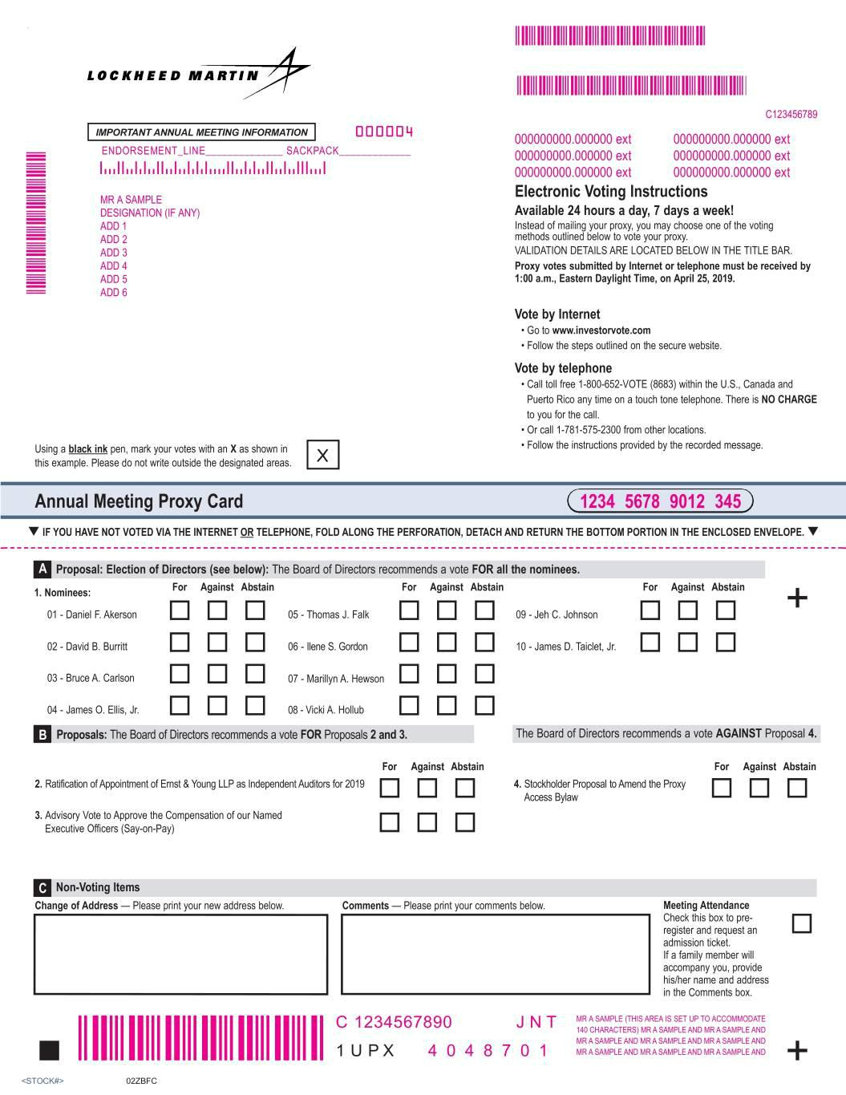

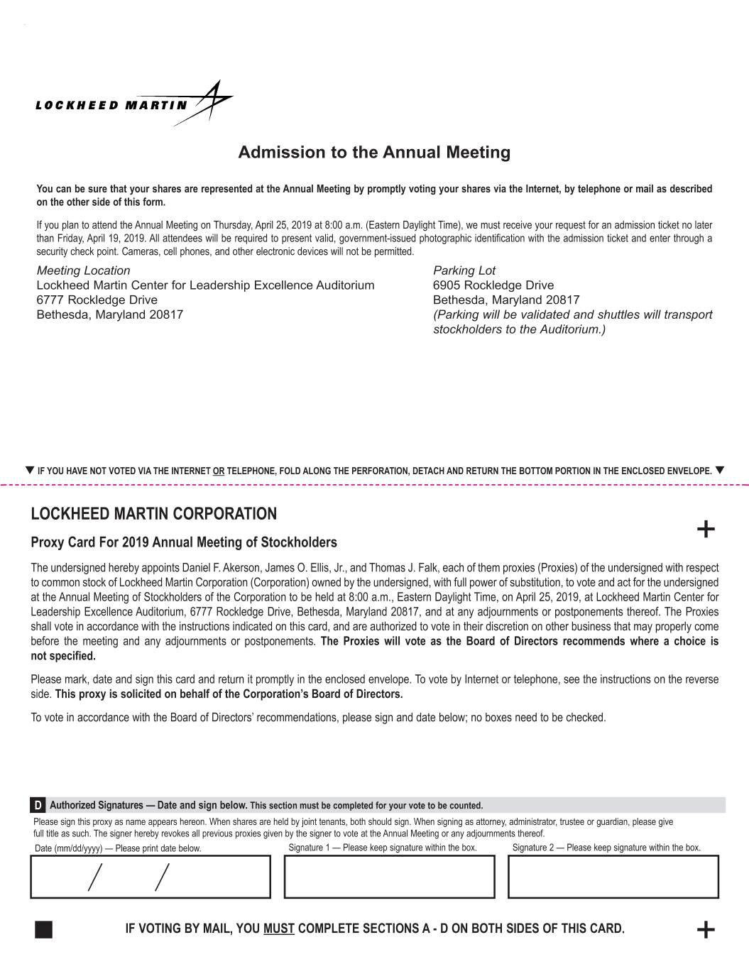

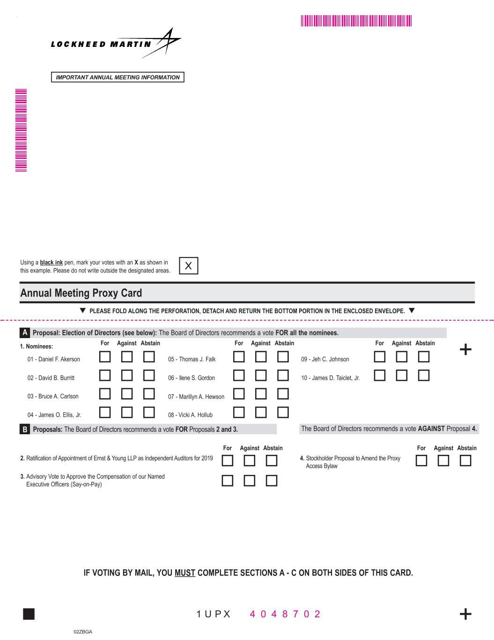

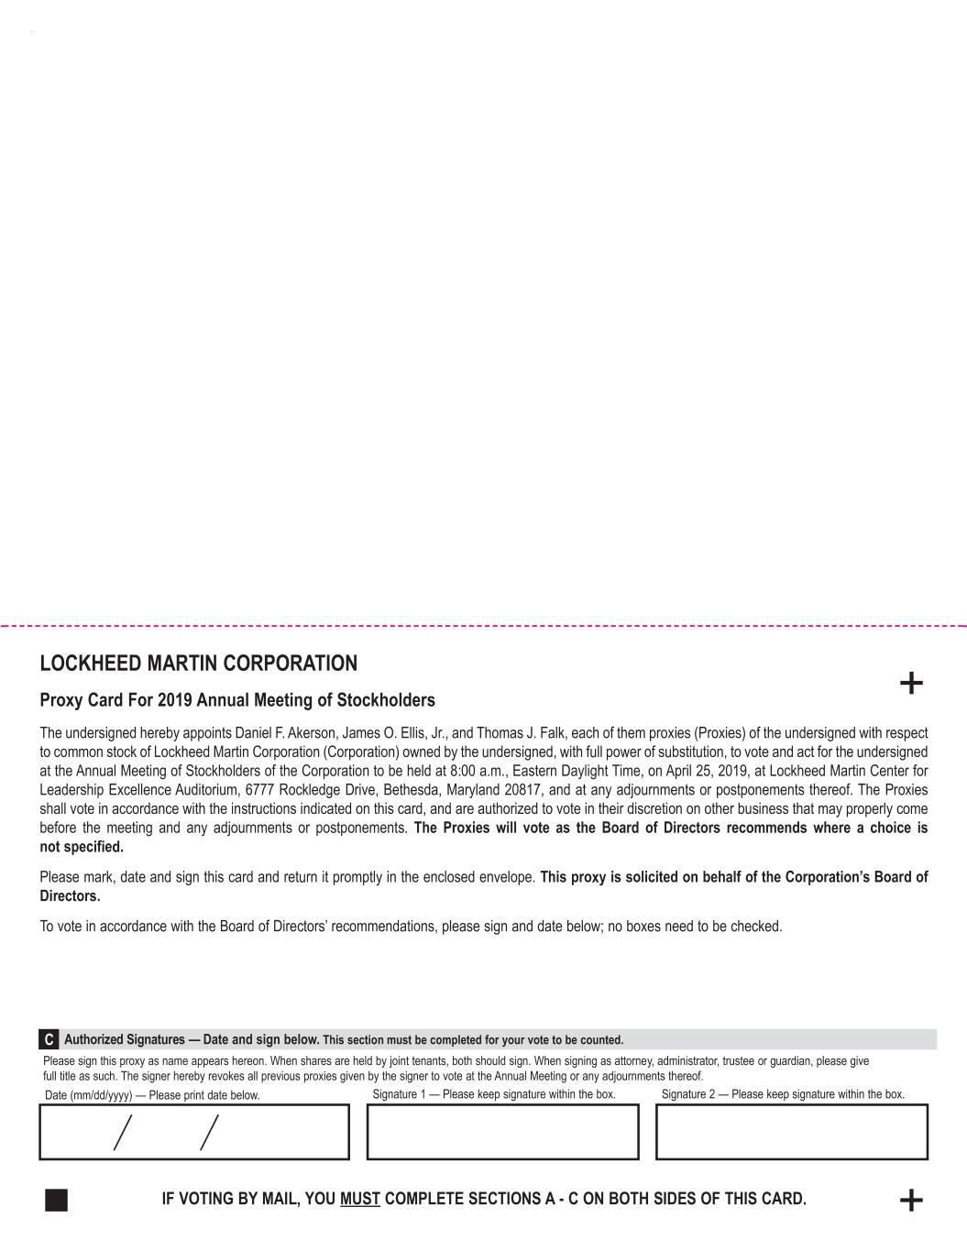

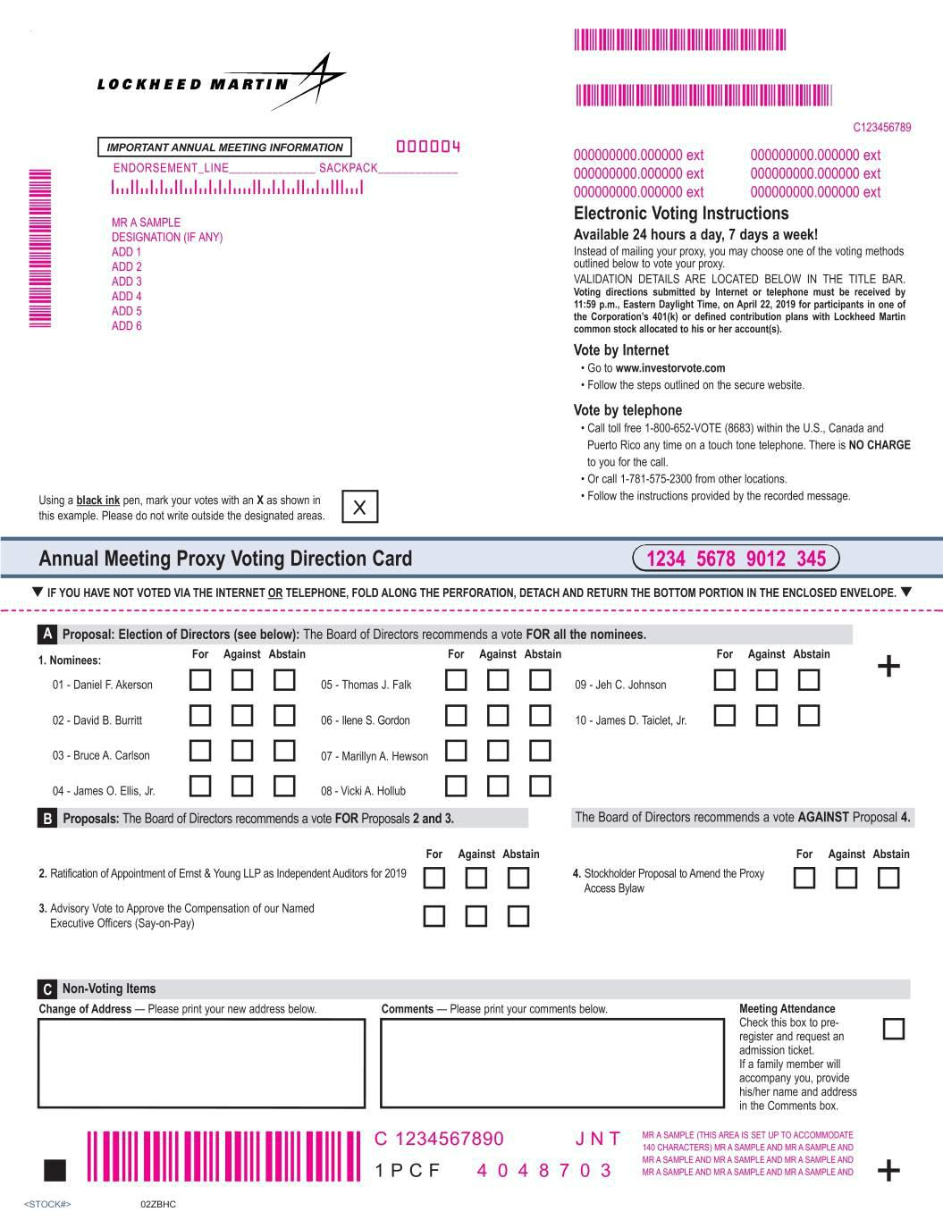

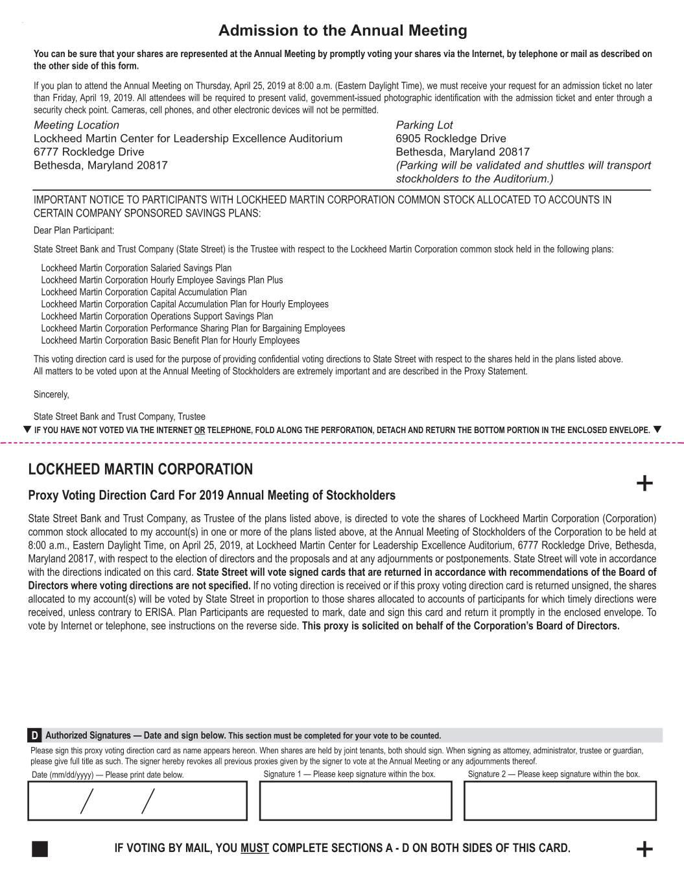

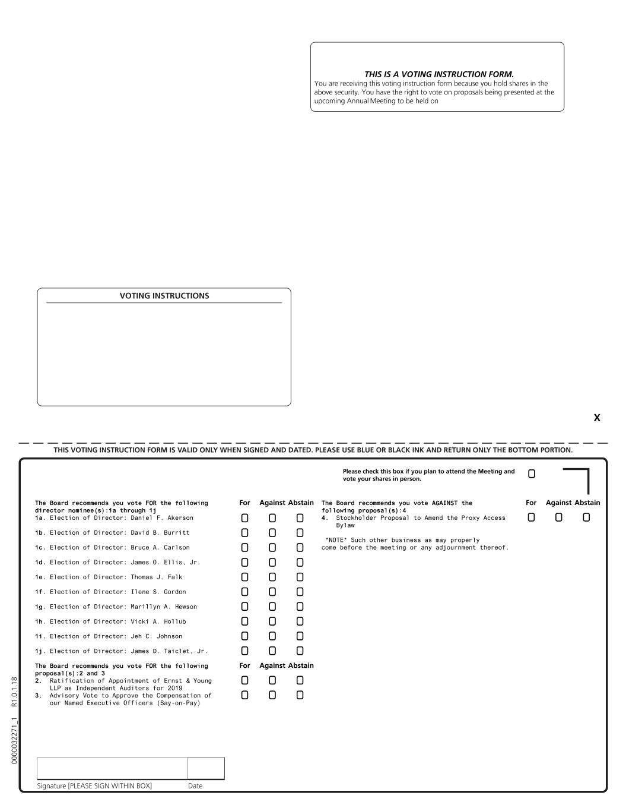


Memorandum

DATE:

March 18, 2019

TO:

Lockheed Martin Savings Plan Participants

FROM:

Maryanne R. Lavan, Senior Vice President, General Counsel and

Corporate Secretary

SUBJECT: Important Notice Regarding Availability of Lockheed Martin Proxy Materials

Lockheed Martin employees are the largest holders of our common stock (representing approximately 12 percent of our outstanding shares). As a Lockheed Martin savings plan participant, you are entitled to vote your shares held through the Lockheed Martin savings plans on the matters to be voted upon at the Corporation’s Annual Meeting of Stockholders on April 25, 2019.

Tomorrow, you will receive an email from Computershare Trust Company, N.A. (cpucommunications.com), our independent registrar and transfer agent, with a subject line of “Important Notice Regarding Availability of Lockheed Martin Proxy Materials.” The email will include a link to the Corporation’s 2018 Annual Report and 2019 Proxy Statement (together, the Proxy Materials). It will also contain information on how to vote your shares confidentially through the Internet or by telephone.

Your vote is very important. Please look for your email from Computershare and vote promptly. Note that you may receive multiple proxy packages and voting instructions (electronically and/or by mail). These materials may not be duplicates as you may hold shares of Lockheed Martin stock in multiple accounts. Please be sure to vote all of your shares in each of your accounts in accordance with the directions on the proxy card(s) and/or voting instruction form(s) you receive.

A hard copy of the Proxy Materials can be requested by calling toll free 1-877-223-3863 or 1-267-468-0767, if outside the U.S. Requests will be fulfilled until 3:00 p.m. Eastern Daylight Time on April 15, 2019.

Please note: computer settings vary and unknown email addresses, such as those from Computershare, may sometimes be directed to your “Junk Email” folder. If you do not see the email from Computershare in your inbox, check your “Junk Email” folder.

Email to Employee Plan Participants (to be sent 03/19/19)

Email subject will be:

Important Notice Regarding Availability of Lockheed Martin
Proxy Materials

Annual Report, Proxy Statement and Voting Instructions for the Lockheed Martin Corporation Annual Meeting of Stockholders on April 25, 2019

Proxy Login Control Number:

To: Lockheed Martin Corporation Savings Plan Participants

You are receiving this email because you are a participant in a Lockheed Martin Corporation savings plan. Instead of receiving your 2018 Annual Report and 2019 Proxy Statement (Proxy Materials) by mail, you can conveniently access your Proxy Materials and vote online at www.investorvote.com. To view the Proxy Materials and cast your vote, enter the Proxy Login Control Number above (without any spaces) and follow the on-screen instructions.

To obtain a hard copy of Proxy Materials (free of charge):

- Call 1-877-223-3863 within the U.S.
- Call 1-267-468-0767 from outside the U.S.
- Requests must be received by 3:00 p.m., Eastern Daylight Time, on April 15, 2019

Voting deadline:

- 11:59 p.m., Eastern Daylight Time, on Monday, April 22, 2019

Please note that you may receive multiple proxy packages and voting instructions (electronically and/or by mail). These materials may not be duplicates as you may hold shares of Lockheed Martin stock in multiple accounts. Please be sure to vote all of your shares in each of your accounts in accordance with the directions on the proxy card(s) and/or voting instruction form(s) you receive.

Please cast your vote today!

Computershare Trust Company, N.A.

Independent Registrar and Transfer Agent for Lockheed Martin Corporation

Email Reminder to Employee Plan Participants (to be sent 04/02/19 and 04/11/19)

Email will have date when sent

Email subject will be:

Reminder Notice - Important Notice Regarding Availability of Lockheed Martin
Proxy Materials

Annual Report, Proxy Statement and Voting Instructions for the Lockheed Martin Corporation Annual Meeting of Stockholders on April 25, 2019

Proxy Login Control Number:

To: Lockheed Martin Corporation Savings Plan Participants

You are receiving this email because you are a participant in a Lockheed Martin Corporation savings plan. Instead of receiving your 2018 Annual Report and 2019 Proxy Statement (Proxy Materials) by mail, you can conveniently access your Proxy Materials and vote online at www.investorvote.com. To view the Proxy Materials and cast your vote, enter the Proxy Login Control Number above (without any spaces) and follow the on-screen instructions.

To obtain a hard copy of Proxy Materials (free of charge):

- Call 1-877-223-3863 within the U.S.
- Call 1-267-468-0767 from outside the U.S.
- Requests must be received by 3:00 p.m., Eastern Daylight Time, on April 15, 2019

Voting deadline:

- 11:59 p.m., Eastern Daylight Time, on Monday, April 22, 2019

Please note that you may receive multiple proxy packages and voting instructions (electronically and/or by mail). These materials may not be duplicates as you may hold shares of Lockheed Martin stock in multiple accounts. Please be sure to vote all of your shares in each of your accounts in accordance with the directions on the proxy card(s) and/or voting instruction form(s) you receive.

Please cast your vote today!

Computershare Trust Company, N.A.

Independent Registrar and Transfer Agent for Lockheed Martin Corporation



